0012 Understand the principles and techniques of statistics
- Apply random sampling techniques to collect representative data.

Q1. To study the mean head size of all athletes in his school, Kenneth obtains a list of the athletes and collects data from every 6th person on the list. Which type of sampling method is used?

Q2. To study the mean head size of all athletes in his school, Kenneth randomly selects a proportionate number of athletes from each grade. He then collects data from the sample. What type of sampling method is used?

Q3. To study the highest level of education for all adults in his city, Kenneth sits outside the library and collects data from everyone who enters. What type of sampling method is used?

Q4. To study the mean head size of all athletes in his school, Kenneth surveys all athletes from the second grade. What type of sampling method is used?

Q5. To study the mean head size of all athletes in his school, Kenneth randomly picks 100 people from the list of all the athletes and collects data from them. What type of sampling method is used?

Q6. To study the highest level of education for all adults in his neighborhood, Kenneth sends a mail to each household and collects data from the responses he received. What type of sampling method is used?

- Select appropriate data displays for a given situation (e.g., table, scatter plot).

Q1. Which data display should we choose, if we wish to show the proportional distribution of the data?

Q2. In a relative frequency distribution, what should the relative frequencies add up to?

Q3. Which data display should we choose, if we wish the bars are in descending order in a bar graph?

Q4. Kenneth wishes to use a histogram to show people’s favorite ice cream flavor, but his classmate Sam told him that he cannot do so. Can you explain to Kenneth why a histogram won’t work and what will be a better choice?

Q5. Vivian wishes to use a graph to visualize her data set, but at the same time, she wishes to keep her raw data in the graph since her data set is small, which graph should she choose?

Q6. Determine whether the following statement is true or false.
Stem-and-leaf plots are useful for large data sets.

Q7. Which data display should we choose, if we wish to show the change in the temperature over time?

- Interpret data in a variety of graphic formats (e.g., circle graphs, box plots, histograms).

Q1. The following graph represents the result of a survey, in which a random sample of adults in a certain country was asked if a certain action was morally wrong in general. What percentage of the respondents believe the action is morally acceptable? If there are 272 million adults in the country, how many believe that the action is morally acceptable?

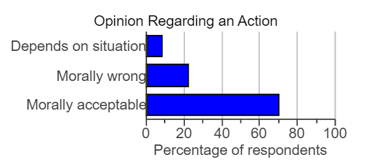

Q2. Determine the original set of data

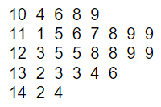
Key: 6|7 represents 6.7

Q3. The pie chart below shows the beverage sizes customers choose in a fast food restaurant.
- What is the most popular size?
- What is the degree for the small-size beverage?
- If there are 150 customers on a given day, how many medium size beverages will be sold, based on the pie chart?
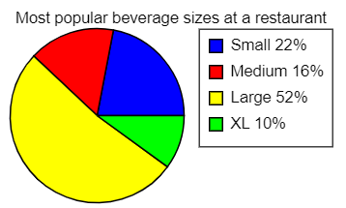

Q4. Given the following histogram for a set of data, how many values in the data set are between 5.5 and 7.5?

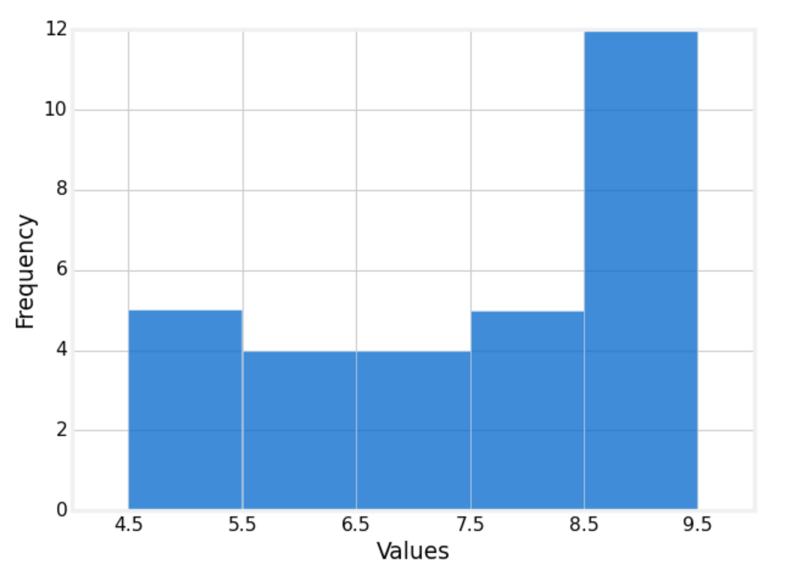

Q5. The dot plot below shows the number of televisions in households. Calculate the mean for the number of televisions.
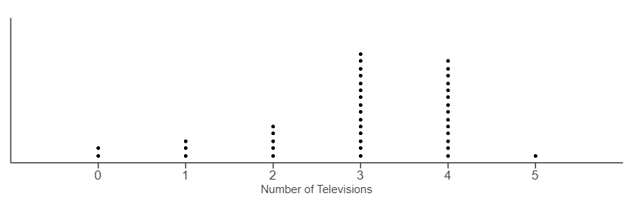

Q6. The line graph below shows the number of total rounds of golf Horace has played over time. How many rounds did Horace play from week 1 to week 3?

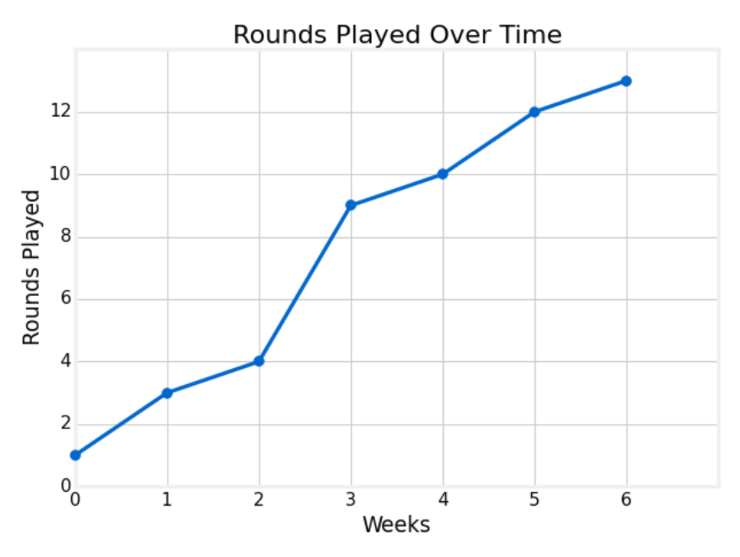

Q7. The line graph below shows the total amount of money Julie saved over time. At what month did Julie’s savings reach $2300?

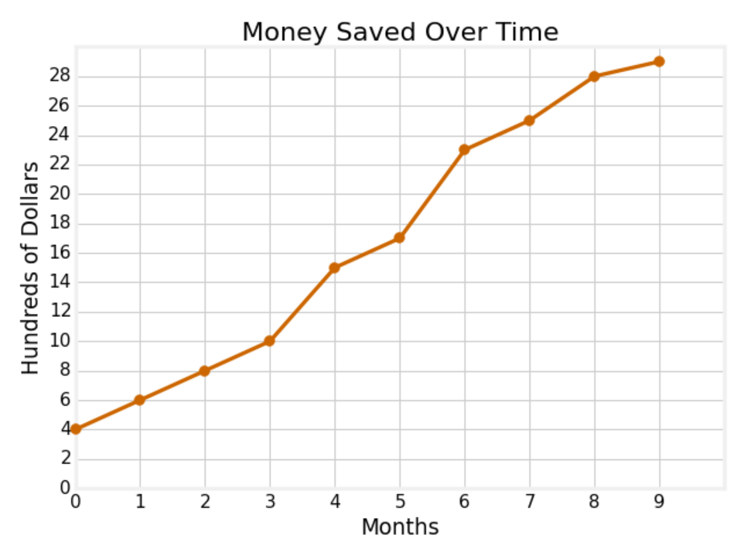

Q8. Given the box plot below,
- What is the five-number summary?
- What is the range of this data set?
- What is the interquartile range?
- What are the lower and upper fences?
- Is -1 an outlier for this data set?
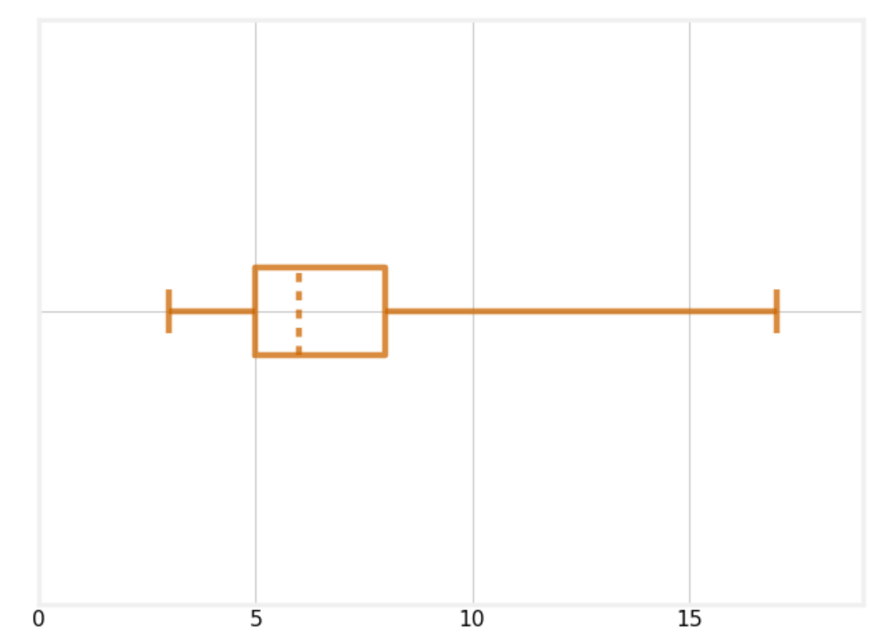

- Analyze patterns in bivariate data and two-way frequency tables

Q1. Which of the following case indicates a strong negative correlation?
- The hours spent studying for a math exam and the final grade of the math exam
- The temperature and the sales of ice cream
- The absence from a course and the final grade from the course
- The height of a person and the shoe size

Q2. Which of the following number is an appropriate correlation coefficient for the graph?
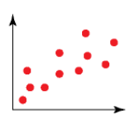

A. $r= -2$
B. $r=0$
C. $r=0.3$
D. $r=0.9$

Q3. A tennis player keeps track of the amount of time they spend practicing their tennis serve and the number of aces he gets in their match each week. Construct a scatter plot for the table below.
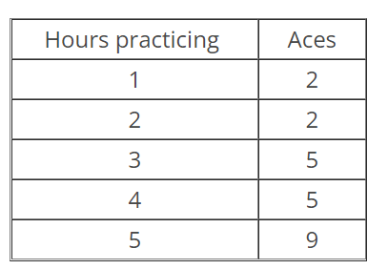

Q4. The scatter plot below shows the cost of a certain watch between 2000 and 2015. The least squares regression line is $\hat{y}= -4815+3.765x$.
- What is the y-intercept and is it feasible?
- What is the slope and how do you interpret the slope?
- What will be the value of the watch in 2030?
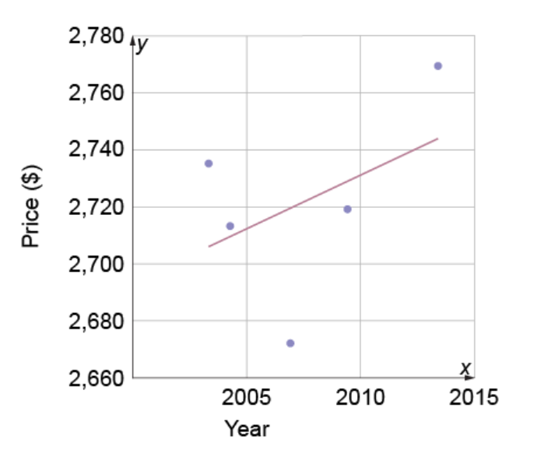

Q5. For the scatter plot below, which point is more likely to be an outlier?
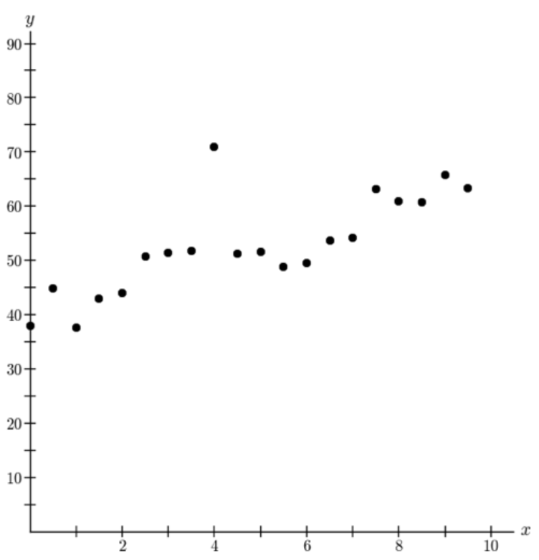

Q6. Which of the following scatter plot has one or more outliers?

A. B.
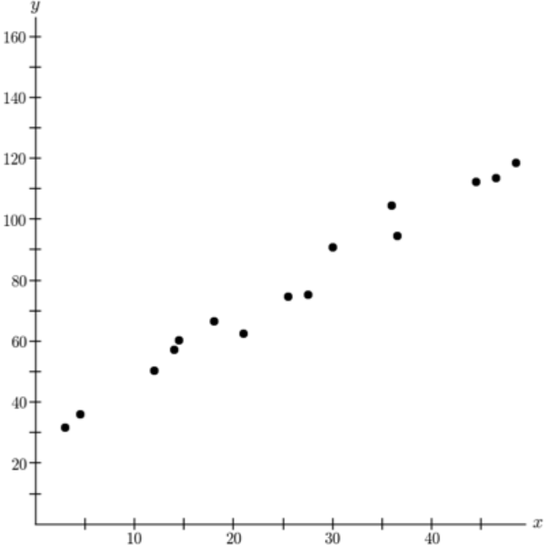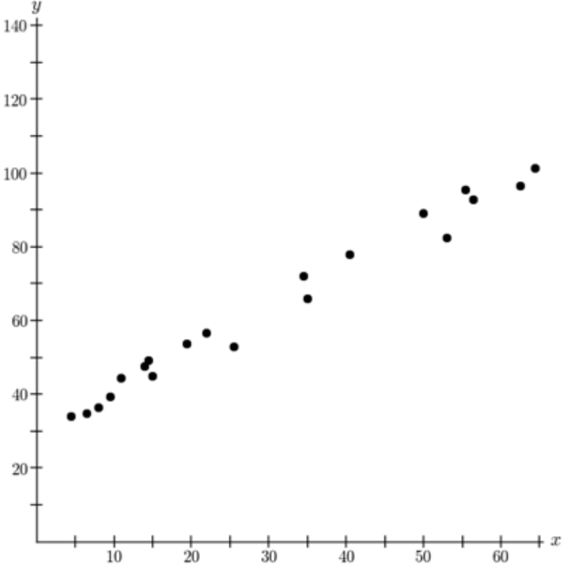

C. D.
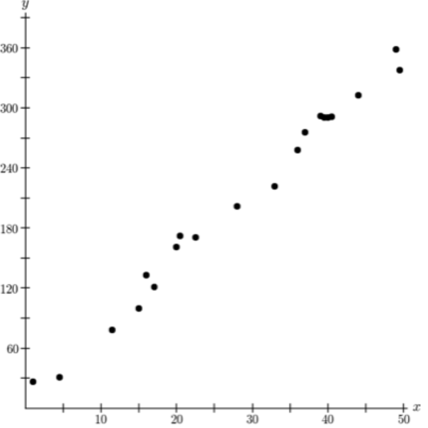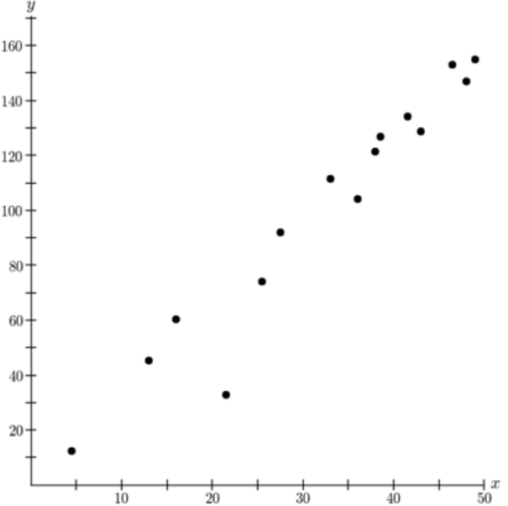

Q7. Complete the two-way frequency table below and find the number of students who don’t go to the beach and don’t go to the mountains.

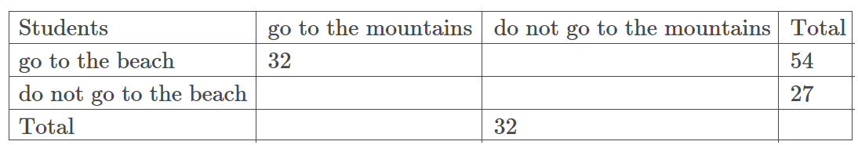

Q8. Complete the two-way frequency table below and find the number of students who both have a dog and a cat.

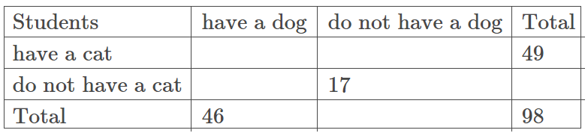

Q9. A group of 155 students at a private university was asked if they are full-time or part-time and if they have gym memberships. The results are shown in the table below. Given that a randomly selected survey participant is part-time, what is the probability that this student has a gym membership?

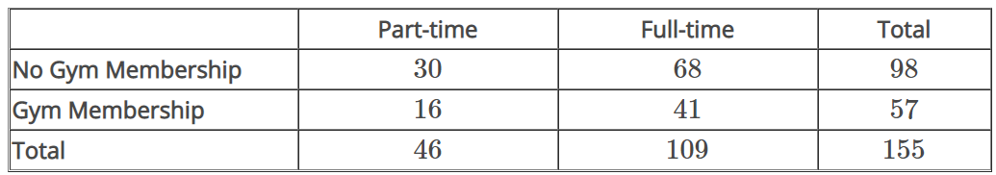

Q10. 135 fitness center members were asked if they run and if they lift weights. The results are shown in the table.
- Given that a randomly selected survey participant does not run, what is the probability that the participant lifts weights?
- Given that a randomly selected survey participant lifts weights, what is the probability that the participant does not run?
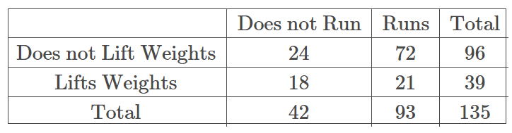

- Apply knowledge of measures of central tendency (e.g., mean, median), dispersion (e.g., interquartile range, standard deviation), and shapes of data distributions.
Measures of central tendency and dispersion are covered in “0002 Understand college statistics”, so we will not repeat them here. However, the question below combines measures of central tendency with shapes of data distributions.

Q1. Use the boxplot below to answer the question that follows.
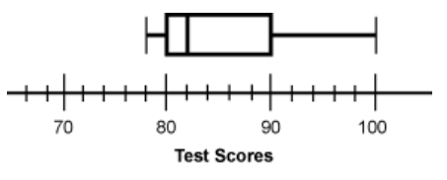
After a recent test, a teacher created a boxplot to display the scores of the 20 students in the class. Based on the information in the boxplot, which of the following measures has the highest value for the set of test scores? (This question is from the ILTS Study Guide, http://www.il.nesinc.com/Content/STUDYGUIDE/IL_SG_SRI_202.htm#obj12)

A. Mean
B. Median
C. Range
D. Standard Deviation

Q2. Find the five-number summary for the following data set.
2, 5, 7, 7, 9, 9, 9, 10, 10, 11, 12

Q3. Find the interquartile range for the following data set.
2, 5, 7, 7, 9, 9, 9, 10, 10, 11, 12

Q4. Find the range for the following data set.
2, 5, 7, 7, 9, 9, 9, 10, 10, 11, 12

Q5. Given the five-number summary below, decide if 118 is an outlier.
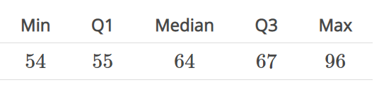

Q6. Which measure of central tendency is more resistant to extreme values?

Q7. For the histogram below, which measure of central tendency is a better choice to describe the “center” of the distribution?
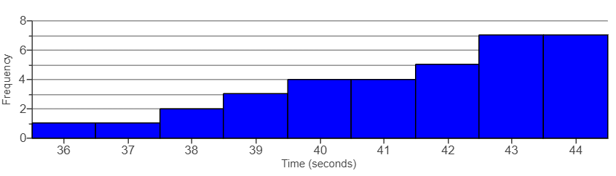

Q8. For the histogram below, which measure of central tendency is a better choice to describe the “center” of the distribution?
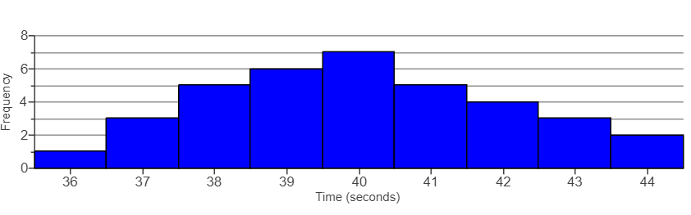

Q9. In a local store, the monthly salary of the manager is $10,000, while the salary for the remaining employees are $1,500, $1,800, $2,000, $2,100, $2,200, $2,500,$2,800.
- If you were the store owner, which measure of central tendency will you use to convince the public that employees in your store are making enough money and a strike is unnecessary?
- If you were the employee, which measure of central tendency will you use to show the public you are not being paid well?

Q10. If a distribution is skewed to the right, which value is larger, mean or median?

Q11. For the distribution below,
- Which letter represents the mode?
- Which letter represents the median?
- Which letter represents the mean?
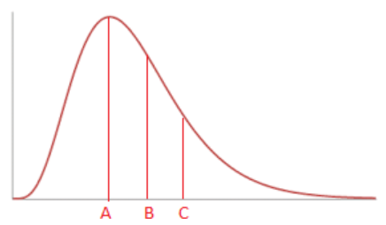

Q12. If the standard deviation of a data set is 11, what is the variance?

Q13. Which data set has larger dispersion?
- A data set with the standard deviation to be 5.5
- A data set with the variance to be 20

Q14. Which of the following histogram has a higher standard deviation?

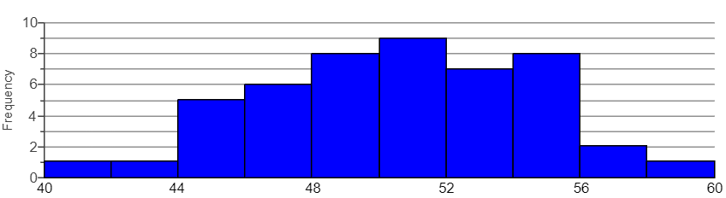

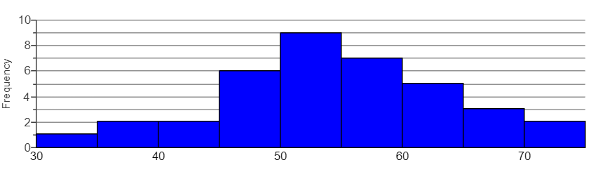

Q15. If all the values are the same in a data set, what is the standard deviation equal to?

Q16. Can the standard deviation be negative?

Q17. Decide if the following box plot is symmetric, skewed to the left, or skewed to the right.
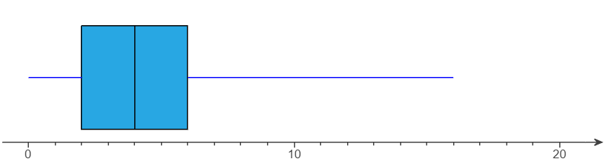

Q18. For the box plot below, which one has larger dispersion? Why?
