0012 Understand the principles and techniques of statistics
- Apply random sampling techniques to collect representative data.
Q1. Systematic sampling
Q2. Stratified sampling
Q3. Convenience sampling
Q4. Cluster sampling
Q5. Random sampling
Q6. Voluntary response sampling

- Select appropriate data displays for a given situation (e.g., table, scatter plot).
Q1. Pie chart
Q2. 1
Q3. Pareto​ chart
Q4. Ice cream flavor is qualitative data and cannot be used in a histogram, since histogram only works for quantitative data. A bar graph will be a better choice.
Q5. Stem-and-leaf plot
Q6. False
Q7. Time series graph (line graph)

- Interpret data in a variety of graphic formats (e.g., circle graphs, box plots, histograms).
Q1. 70% 190.4 million adults
Q2. {10.4, 10.6, 10.8, 10.9, 11.1, 11.5 11.6, 11.7, 11.8, 11.9, 11.9, 12.3, 12.5, 12.5, 12.8, 12.8, 12.9, 12.9, 13.2, 13.3, 13.3, 13.4, 13.6, 14.2, 14.4}
Q3. 1. Large 2. $360°∙0.22=79.2°$ 3. $150∙.16=24$
Q4. 8
Q5. $\left(0∙2+1∙3+2∙5+3∙15+4∙14+5∙1\right)÷40=2.975≈3$ The average number of televisions is 3.
Q6. 6
Q7. Month 6
Q8.
- Five-number summary is 3, 5, 6, 8, 18
- Range = max – min = 18 – 3 = 15
- IQR = Q3 – Q1 = 8-5 = 3
- Lower fence = Q1 – 1.5IQR = 3 – 1.5(3) = -1.5 & Upper fence = Q3 + 1.5 IQR = 8 + 1.5(3) = 12.5
- -1 is not an outlier

- Analyze patterns in bivariate data and two-way frequency tables.
Q1. C
Q2. C
Q3.
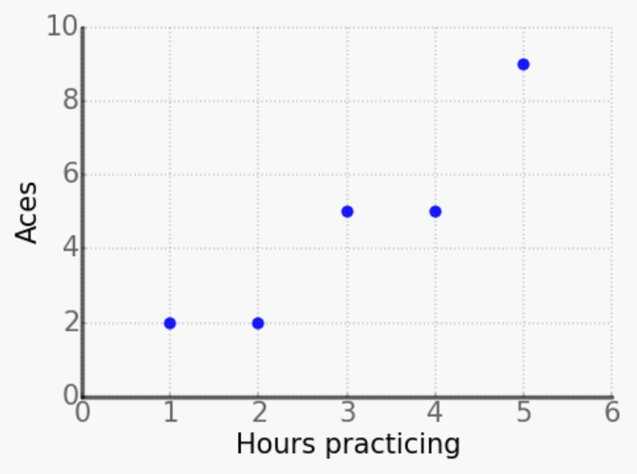
Q4.
- The y-intercept is −4815, which is not feasible because a product cannot have a negative cost.
- The slope is 3.765, which means the price of the watch increase by $3.765 per year.
- $\hat{y}= -4815+3.765\left(2030\right)=2827.95$ The price of the watch will be $2827.95 in 2030.
Q5. (4,70)
Q6. D
Q7.
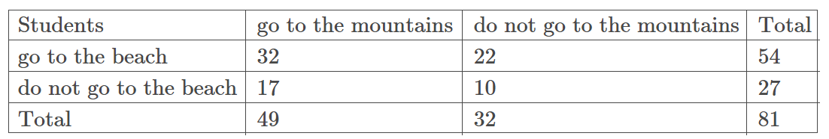
10 students don’t go to the beach and don’t go to the mountains
Q8.
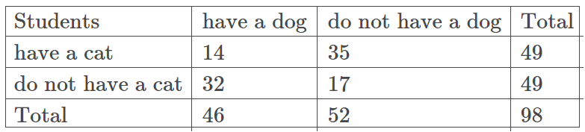
14 students both have a dog and a cat.
Q9. 8/23
Q10. 1. 3/7 2. 6/13

- Apply knowledge of measures of central tendency (e.g., mean, median), dispersion (e.g., interquartile range, standard deviation), and shapes of data distributions.
Q1. A
Q2. 2, 7, 9, 10, 12
Q3. 3
Q4. 10
Q5. Yes, 118 is an outlier.
Q6. Median
Q7. Median
Q8. Mean
Q9. 1. Mean 2. Median
Q10. Mean is larger
Q11. 1. A 2. B 3. C
Q12. 121
Q13. A
Q14. B
Q15. 0
Q16. No, the standard deviation cannot be negative
Q17. Skewed to the right
Q18. y, since it has a larger interquartile range

