0011 Understand the principles and techniques of probability.
For example:
- Apply methods of counting, including the difference between combinations and permutations, to represent and solve problems.

  - Determine the number of integers between 1 and 1 000 000 that end with the number 2022.

    - $1,000$
    - $100$
    - $10,000$
    - $10$

  - How many distinct ways can you write the expression$x^{4}yz^{5}$without the exponents?

    - $\frac{9!}{\left(4!\right)\left(5!\right)}$
    - $\frac{10!}{\left(4!+5!\right)}$
    - $\frac{9!}{\left(4!+5!\right)}$
    - $\frac{10!}{\left(4!\right)\left(5!\right)}$

  - Bill’s Ice Cream Parlor offers$10$ different flavors of Ice Cream,$8$ different flavors of gelato, and$5$ different flavors of frozen yogurt. If a customer can choose any number of unique scoops of ice cream in one bowl, how many ice cream bowl combinations are possible?

    - $100$
    - $3,628,800$
    - $32$
    - $1024$

  - Anthony is making an unordered playlist of $175$ songs for an upcoming flight. He is choosing from a list of $300$ songs he has saved. How many different playlist combinations could Anthony make?

    - $\frac{300!}{175!}$
    - $\frac{300!}{125!}$
    - $\frac{300!}{(125!)(175!)}$
    - $175!$

  - A university lacrosse team has $22$ players on its roster, and $2$ people from that team are selected as co-captains. How many different ways can the coach select co-captains from the team?

    - $462$
    - $44$
    - $231$
    - None of the above

  - How many ways can $8$ horses finish in a race?

    - $64$
    - $40,320$
    - $256$
    - $5,040$

  - How many distinct ways can you rearrange the letters in the word hummus?

    - $360$
    - $180$
    - $720$
    - None of the above

  - There are eight students running for three positons in the university student board. How many different ways can these positions be filled?

    - $120$
    - $512$
    - $336$
    - $6720$

- Identify theoretical or experimental probabilities of simple, compound, independent, and conditional events using a variety of approaches (e.g., addition and multiplication rules).

  - Tommy owns and operates his own bike shop. Tommy’s Bike Shop is open Monday through Friday for repairs. A customer calls Tommy asking for two separate repair appointments on different days. Assuming Tommy selects the two days at random, what is the probability that both appointments are on a Monday, Tuesday, or Thursday?

    - $\frac{3}{10}$
    - $\frac{6}{25}$
    - $\frac{3}{5}$
    - $\frac{1}{2}$

  - You pick a card randomly from a standard deck of$52$cards. What is the probability that you pick a face card or a heart?

    - $\frac{3}{52}$
    - $\frac{5}{26}$
    - $\frac{25}{52}$
    - $\frac{11}{26}$

  - Given $P\left(E\right)=\frac{1}{4}, P\left(F\right)=\frac{23}{27}, P\left(G\right)=\frac{4}{11}$ are the probabilities of events $E,F,$ and $G$ respectively, determine the probability that at least one of these events occurs.

    - $\frac{23}{297}$
    - $\frac{92}{99}$
    - $\frac{274}{297}$
    - $\frac{7}{99}$

  - A clothing factory is producing a limited edition run of 55 new t-shirts. A printing error caused seven of the t-shirts to have defects. Quality control is responsible for randomly reviewing five of the t-shirts. Find the probability that all but one of the chosen t-shirts reviewed have no defect.

    - $\frac{55*54*53*52*7}{55*54*53*52*51}=\frac{7}{51}$

    - $\frac{48*47*7*46*45}{55*54*53*52*51}=\frac{30268}{386529}$

    - $\frac{48*47*46*45*1}{7*55*54*53*52}=\frac{4324}{53053}$

    - $\frac{7*6*5*4*48}{55*54*53*52*51}=\frac{112}{1159587}$

  - Given the integers from$1$to$25$, inclusive, what is the probability that a randomly chosen integer is a multiple of $3?$

    - $\frac{8}{25}$
    - $\frac{4}{13}$
    - $\frac{17}{25}$
    - $\frac{8}{17}$

  - You roll a $20$-sided die with the numbers $1$ to $20$ on the faces. What is the probability that you roll a $4$, and then a$5$?

    - $\frac{1}{400}$
    - $\frac{1}{20}$
    - $\frac{1}{40}$
    - $\frac{1}{200}$

  - Which pair of events are independent given the following probabilities?

$$P\left(A\right)=0.22$$ | $$P\left(A | B\right)=0$$
$$P\left(B\right)= 0.71$$ | $$P\left(B | C\right)=0.71$$
$$P\left(C\right)=0.07$$ | $$P\left(C | A\right)= 0.22$$

    - $A$ and $B$
    - $A$ and $C$
    - $B$ and $C$
    - No pair of events are independent.

- Apply the concept of sample space and its role in determining probabilities.

  - A jar contains four balls numbered $1, 2, 3$and$4$. If two balls are drawn without replacement, what is the probability that the sum of the numbers is at least$6$?

    - $\frac{3}{8},$
    - $\frac{1}{3},$
    - $\frac{1}{4},$
    - $\frac{2}{3}$

  - A class of$27$ students are ranking their six favorite required summer readings. What is the probability that you get all six books ranked in the correct order?

    - $\frac{1}{5}$
    - $\frac{1}{25}$
    - $\frac{1}{729}$
    - $\frac{1}{720}$

  - A local skating rink is holding a roller derby with thirty contestants. Giselle and her two friends are all competing. The top three contestants go to state finals. What are the chances that Giselle, Wanda, and Erin are selected to go to the state finals in that order?

    - $\frac{1}{30*3}=\frac{1}{90}$
    - $\frac{1}{30*29*28}=\frac{1}{24360}$
    - $\frac{1}{{30}^{3}}=\frac{1}{27000}$
    - $\frac{3}{30*29*28}=\frac{1}{8120}$

  - Kathy has a bag containing 10 green marbles, 8 orange marbles, 5 blue marbles, 9 red marbles, and 3 pink marbles. She chooses eight marbles to show her friend. What is the size of the sample space in this experiment?

    - $\frac{35!}{27!}$
    - $35!$
    - $\frac{35!}{\left(27!\right)\left(8!\right)}$
    - $\frac{35!}{8!}$

  - You are the curator for a brand new art museum. You want to display several different pieces of artwork. The museum contains 3 floors, each floor has 15 different rooms with one piece of art in each room. There are 21 paintings, 10 sculptures, and 14 portraits to use for the entire museum. What is the probability that for the first floor you use 8 paintings, 3 sculptures, and 4 portraits?

    - $\frac{\left(21!\right)\left(10!\right)\left(14!\right)}{45!}$

    - $\frac{\left({21 \atop 8}\right)\left({10 \atop 3}\right)\left({14 \atop 4}\right)}{45!}$

    - $\frac{\left({21 \atop 8}\right)\left({10 \atop 3}\right)\left({14 \atop 4}\right)}{\left({45 \atop 15}\right)}$

    - $\frac{\left({45 \atop 21}\right)\left({45 \atop 10}\right)\left({45 \atop 14}\right)}{\left({45 \atop 15}\right)}$

  - What is the probability of not choosing a multiple of 7 for integers between 10 and 100, inclusive?

    - $\frac{6}{7}$
    - $\frac{1}{7}$
    - $\frac{77}{90}$
    - $\frac{13}{90}$

- Use and interpret a variety of representations of probabilities (e.g., Venn diagrams, tree diagrams).

  - The data form a survey of 720 college students on what they do on the weekend is displayed in the Venn diagram below.
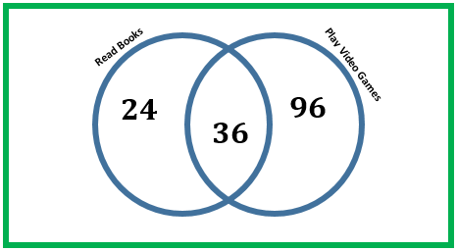

Use the diagram to determine the probability that a randomly selected student neither reads a book or play video games.

    - $\frac{47}{60}$
    - $\frac{13}{60}$
    - $\frac{37}{120}$
    - $\frac{41}{360}$

  - The Venn diagram pictured shows the data for class of seventh grade students on who plays in the band and who sings in the choir. What is the probability that a randomly chosen student plays in band and sings in choir?
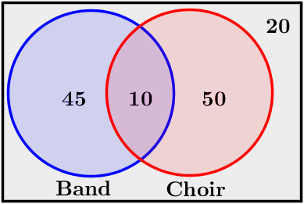
    - $\frac{21}{25}$
    - $\frac{4}{25}$
    - $\frac{19}{25}$
    - $\frac{2}{25}$

  - Human DNA is made of four nucleotides: Cytosine (C), Thymine (T), Adenine (A), and Guanine (G). Let us examine a nucleotide chain of three.

1 | 2 | 3
  A
  T
  G
  C
  A
  T
  G
  C
  A
  T
  G
  C

How many possible combinations are there of the four nucleotides in a chain of three?
    - $256$
    - $64$
    - $12$
    - $16$

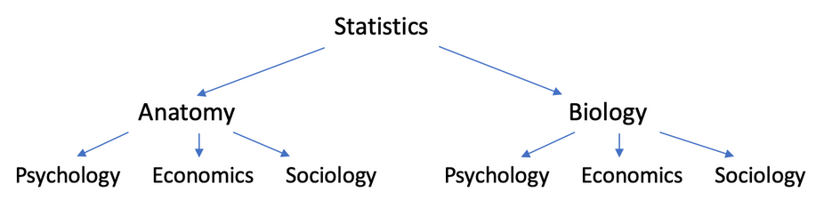
  - A nursing student is planning their schedule for next quarter. They need to take three courses, and one must be Statistics. For their other courses, they can choose one of two science classes and one of three social sciences classes. Illustrated below are all the possibilities for their schedule:

Using the tree diagram, what is the probability that a randomly chosen schedule has statistics, anatomy, and economics classes?

    - $\frac{1}{6}$
    - $\frac{1}{3}$
    - $\frac{1}{2}$
    - $\frac{1}{4}$

  - A local health clinic surveyed adults about who smokes cigarettes and who plays sports. The following Venn diagram shows the data collected.
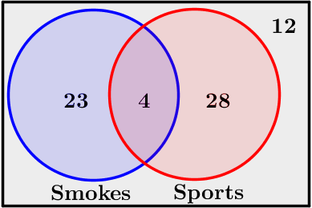
Given that a randomly selected person plays sports, what is the probability that the person also smokes?

    - $\frac{1}{8}$
    - $\frac{28}{55}$
    - $\frac{1}{7}$
    - $\frac{4}{55}$

