0010 Understand the principles of coordinate and transformational geometries

- Apply connections between geometric and algebraic properties (e.g., distance formula, midpoint formula, slope) to model and solve mathematical and real-world problems.

Q1. Find the distance between points (1,5) and (-2, 3).

Q2. Find the distance between the point (1,5) and the line $y=3x-2$.

Q3. If the diameter of a circle has endpoints to be (0,2) and (5,3). What is the radius of the circle?

Q4. A person lives at Point A. He stopped by the library (point B), before going to school (Point C). After he finished school, he went back home directly. If each unit in the graph represents 1km, how much did this person travel?

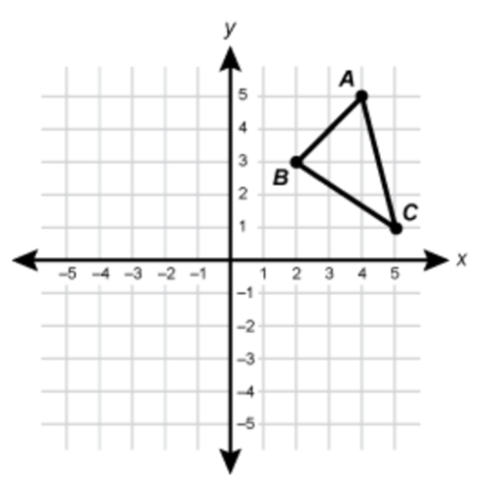

Q5. Find the midpoint for (1,5) and (-2,3).

Q6. If the midpoint for points M and N is (-1,7), and point M = (4,5). What are the coordinates for point N?

Q7. If the diameter of a circle has endpoints to be (0,2) and (5,3). What is the center of the circle?

Q8. For the parallelogram shown below, find the coordinates for point C.
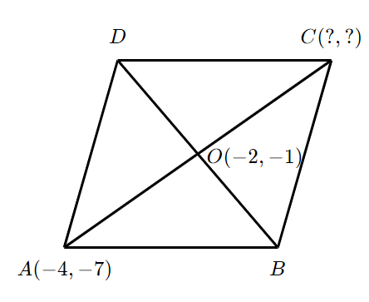

Q9. Point A is on the x-axis and is 5 units to the right of the origin. If point A is in the middle of points B and C, where B = (-3, -1). Find the coordinates for point C.

Q10. Determine whether the following rate of change is positive, zero, or negative.
- The change in a teenager’s height
- The change in the water level in a pond during a drought
- The change in the inventory of a restaurant during their busy hours
- The change in the amount of U.S. representatives

Q11. Find an equation of the line with slope $m= -2$ and y-intercept $b=5$.

Q12. Find the slope of the line pass through points (2,1) and (0,2).

Q13. Find an equation of the line pass through points (2,1) and (0,2).

Q14. Find an equation of the line parallel to $y=2x+1$ and pass through the point (0,2).

Q15. Find an equation of the line perpendicular to $y=2x+1$ and pass through the point (0,2).

Q16. Find the slope of the roof

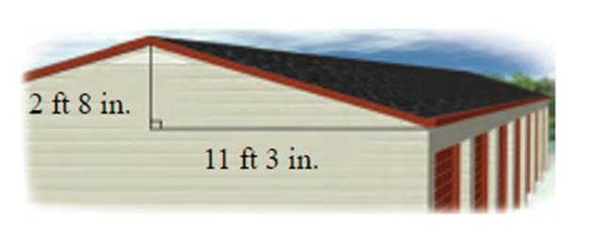

Q17. A moving company charges a fixed fee of $100 for using their service. Additionally, they charge $50 per hour for moving. Let $y$ represent the cost and $t$ represent the time, write an equation to describe the cost. If Ramon plans to use the moving service for 3 hours, how much does he need to pay?

Q18. A sunflower in Julia’s garden was 12 centimeters tall when it was first planted. Since then, it has grown approximately 0.6 centimeters per day. Write an equation expressing the sunflower’s height. How tall will the sunflower be after 30 days?

Q19. Dave is thinking of spending $60 to purchase a membership for using the swimming pool. With the membership, Dave will have to pay $1 per hour when using the swimming pool. Without the membership, he will have to pay $3 per hour. How many hours does he need to spend in the swimming pool in order to make the membership a good deal?

Q20. Runar’s dancing class charges $400 for 25 students and $300 for 15 students. Assume the cost, y, is a linear function of the number of students, x, write an equation for this function. What is the fixed cost of Runar’s dance class and how much will it be if there are 10 students?

- Use two- and three-dimensional coordinate systems to represent and analyze the characteristics of various geometric figures.

Q1. A rectangle ABCD is graphed in the coordinate plane. If the vertices are A = (3,2), B = (5,2), and C = (5,5). Find the coordinates for point D.

Q2. Find the area of the parallelogram below.

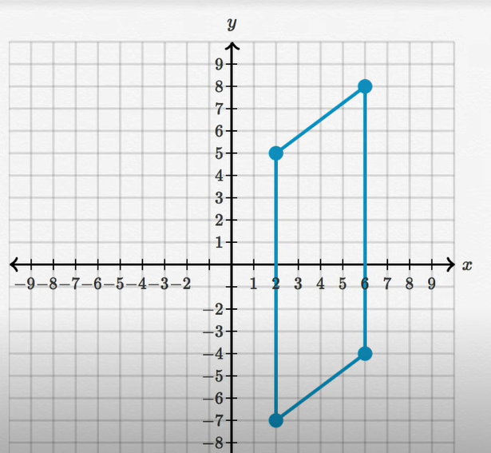

Q3. The coordinates of a rectangle are shown below. Find the value for x, y, and z.
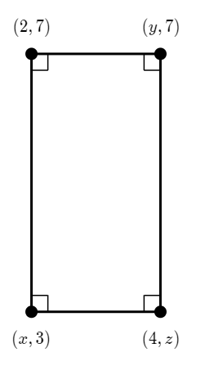
Q4. Find the center and radius of the following circle.
$${\left(x+2\right)}^{2}+{\left(y-3\right)}^{2}=25$$

Q5. Find the equation for the circle below. Then state the center and radius of the circle.

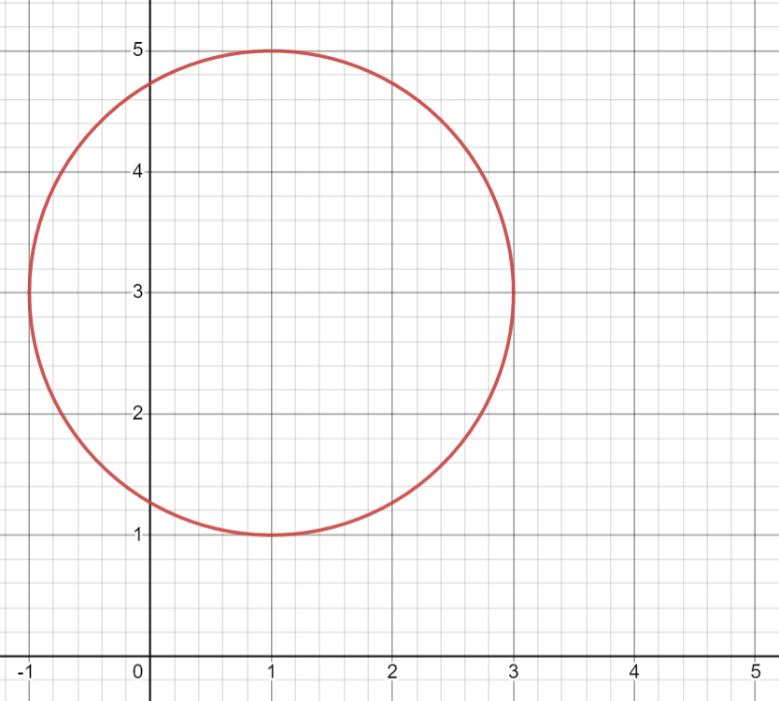

Q6. For the triangle below. The vertices are A = (4,5), B = (2,1), and C = (7,3). Find the area of the triangle.
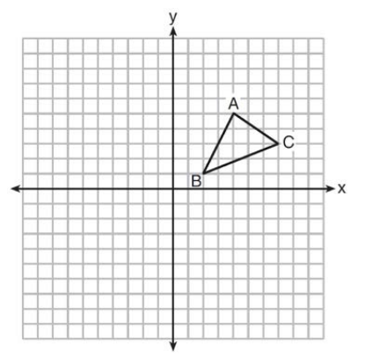

Q7. Triangle ABC has vertices with A = (2,3), B = (x,5), C = (-1,-2). Determine what value of x will make triangle ABC a right triangle.

Q8. The endpoints of one side of a regular pentagon are (-1, -2) and (5,3). What is the perimeter of the pentagon?

Q9. For the rhombus ABCD, the vertices are A = (1,2), B = (4,6), C = (7,2) and D = (4,-2). What is the area of rhombus ABCD?

Q10. What is the length of the red line shown below?

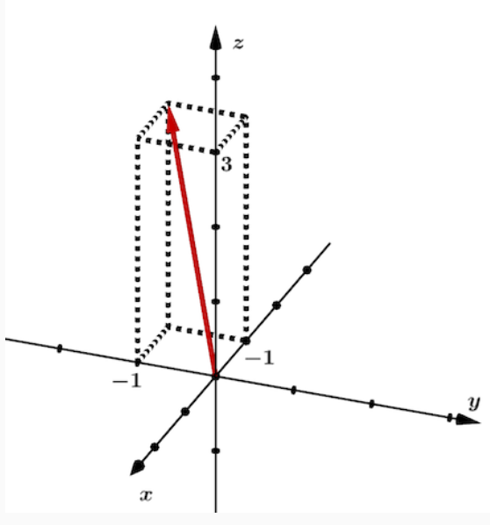

Q11. The cube below has a volume equal to V. What is the perimeter of triangle ABC?

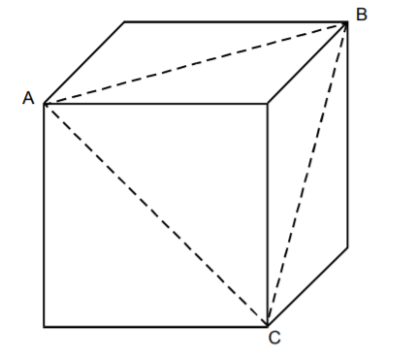
- Analyze geometric transformations (e.g., translations, reflections, dilations, rotations) in a coordinate plane and their effects on congruence and similarity.
(Most questions in this session are from this website, https://www.ck12.org/book/ck-12-algebra-i-honors/section/10.0/ )

Q1. Describe the translation of the figure below. Note that the triangle on the right is the original figure.
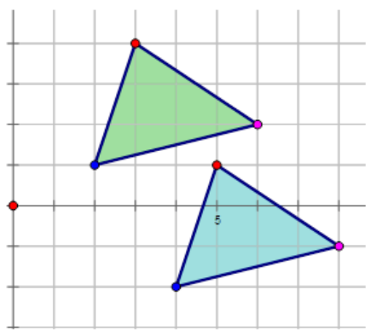

Q2. Describe the translation of the figure below. Note that the triangle on the left is the original figure.
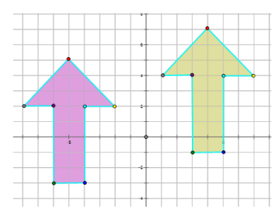

Q3. Line $\overline{AB}$ drawn from (–4, 2) to (3, 2) has been translated 3 units down and 7 units to the left. Draw the preimage and image and properly label each.

Q4. Triangle A is translated 5 units up and 3 units to the right. What are vertices after translation?
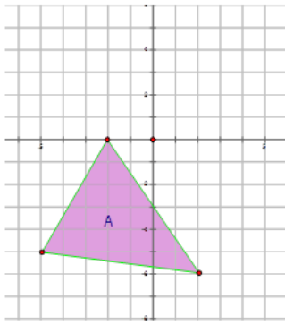

Q5. Describe the reflection of the figure below.

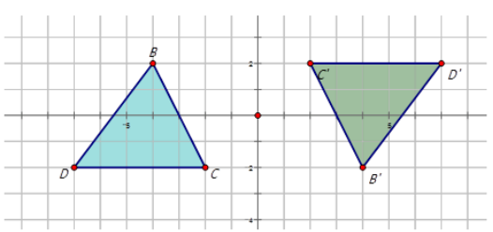

Q6. Describe the reflection of the figure below.
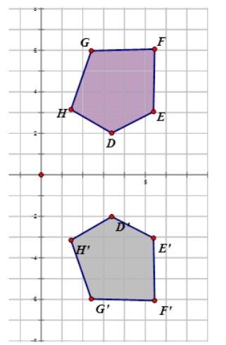

Q7. Describe the reflection of the figure below.
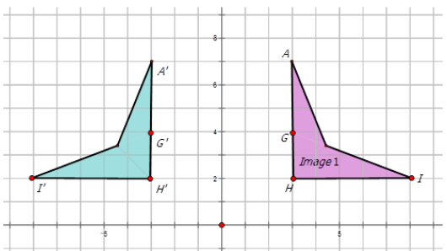

Q8. Describe the reflection of the figure below.

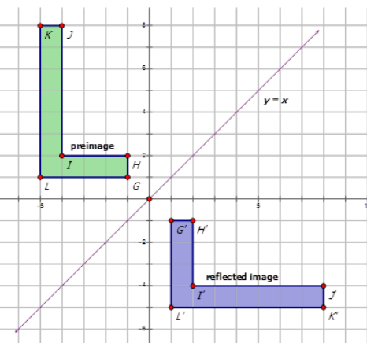

Q9. Describe the reflection of the figure below.

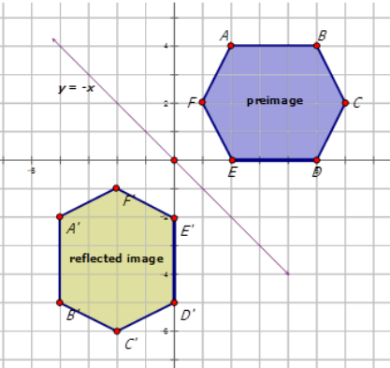

Q10. The vertices for triangle A are E = (-5, -5), F = (2, -6), and G = (-2, 0). Draw the triangle on the Cartesian plane, reflect the image on the y-axis, and state the vertices of the resulting image.

Q11. Line $\overline{ST}$ is drawn from (-3, 4) to (-3, 8) has been reflected with respect to the line y = -x. Draw the preimage and image and properly label each.

Q12. Describe the rotation below. Note that triangle ABC is the original figure.
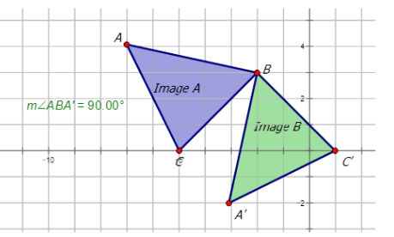

Q13. Describe the rotation below. Note that triangle BCD is the original figure.
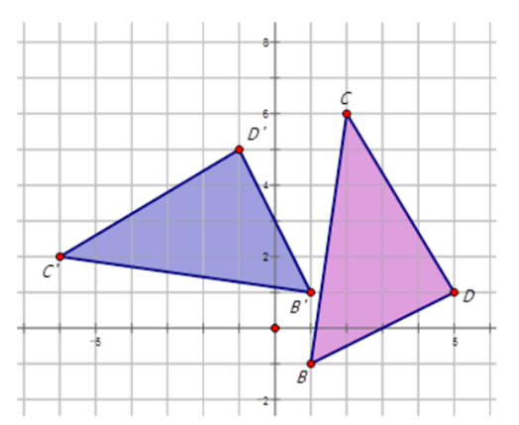

Q14. Describe the rotation below.
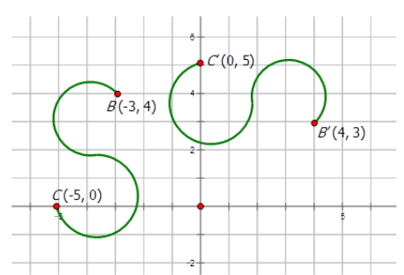

Q15. For point A = (5,-2), find
- the coordinates of the rotated points, if point A was rotated about the origin with a $180°$ counter-clockwise rotation.
- the coordinates of the rotated points, if point A was rotated about the origin with a 90° clockwise rotation.
- the coordinates of the rotated points, if point A was rotated about the origin with a 270° clockwise rotation.

Q16. Line $\overline{AB}$ drawn from (-4, 2) to (3, 2) has been rotated about the origin at an angle of $90°$clockwise. Draw the preimage and image and properly label each.

Q17. Describe the dilation below.
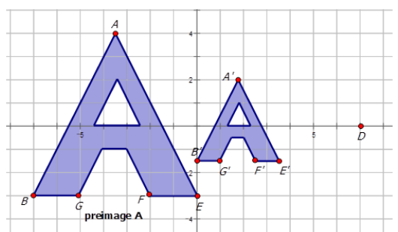

Q18. The triangle ABC is transformed using a translation 6 units down followed by a dilation with scale factor of 2 centered at the origin. What are the coordinates of the image point B? (this question is from the ILTS study guide, http://www.il.nesinc.com/Content/STUDYGUIDE/IL_SG_SRI_202.htm#obj7 )

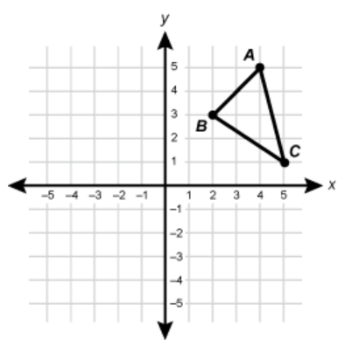

- Apply the properties of polygons (e.g., numbers and lengths of sides, measures of angles) to analyze and solve problems.

Q1. A nonagon is shown below. If the sum of all other interior angles is $1000°$, what is the value of $x$?
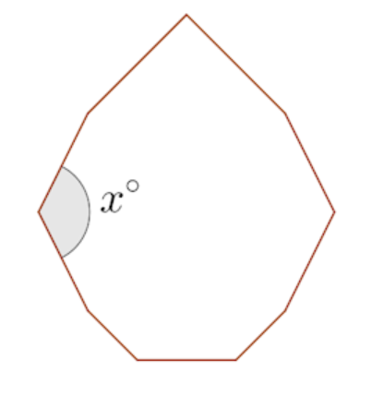

Q2. What is the measure of any interior angel in a regular decagon?

Q3. Suppose every interior angle in a regular polygon is approximately $128.57°$. What kind of polygon is this?

Q4. A heptagon is shown in the figure below. The two missing angles are equal and labeled with x. If the sum of all other interior angels is $675°$, what is the angle measure of x?
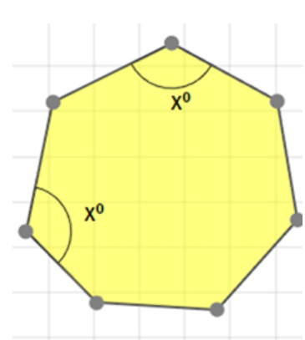

Q5. The sum of the interior angles of a regular polygon is $1800°$. How many sides does the polygon have?

Q6. If hexagons ABCDEF and GHIJKL, shown below, are similar, solve for x.

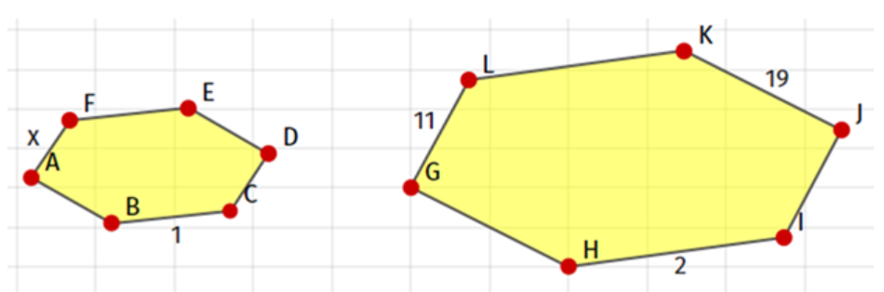

Q7. A right triangle has side 40 and hypotenuse 85. Use the Pythagorean Theorem to find the length of the third side.

Q8. A right triangle has sides 15 and 36. Use the Pythagorean Theorem to find the length of the hypotenuse.

