0008 Understand nonlinear functions.
For example:
- Distinguish between linear and nonlinear relationships in a variety of situations (e.g., tables, real world).
  - Let $f(x)$ be a real-valued function. The table below shows points on the graph of$f\left(x\right)$. What is the missing$x$and$y$-value so that$f(x)$ is a linear function?
$$x$$ | $$y=f(x)$$
$$-3$$ | $$-1$$
$$1$$ | $$1$$
$$?$$ | $$3$$
$$9$$ | $$?$$
- $x=5, y=5$
- $x=5, y=6$
- $x=6, y=5$
- $x=4, y=5$

  - What is the relationship between the volume of a cube and its side length?

      - The relationship between the volume and side length is linear.
      - The relationship between the volume and side length is non-linear and cubic.
      - The relationship between the volume and side length is non-linear and quadratic
      - None of the above

  - Use the table to determine the relationship between $x$ and$y.$
$$x$$ | $$y=f(x)$$
$$2$$ | $$-5$$
$$3$$ | $$-10$$
$$4$$ | $$-17$$
$$5$$ | $$-26$$

      - $x$and$y$have a positive linear relationship
      - $x$and$y$have a negative linear relationship
      - $x$and$y$have a quadratic relationship
      - The relationship cannot be determined

  - Which value(s) of$n$make the equation$ax^{n}+by=c$ linear?

    - $n=0$
    - $n=1$
    - $n=0, 1$
    - None of the above

  - A start-up company recently hired Denzel as a new employee. The company informed Denzel that his pay is $\$A$ a month. Which equation can Denzel use to calculate,$S,$ his yearly salary?

    - $S= 12A^{2}$
    - $A=\frac{S^{2}}{12}$
    - $S=A+12$
    - $S=12A$

  - Which of the following problem statements could use an exponential equation to solve?

    - You need a taxi to travel 15 miles from the airport to your hotel. The Taxi charges a flat rate of $10 and $0.20 for each mile you travel. How much will it cost you to travel to the hotel?
    - Suppose the population of a city is 927,000 in 1990. It is shrinking at the rate of 10% per year. What is the population in 1997?
    - Jennifer is planning an upcoming event. The space she rents cost $1150 and it will cost her $15.75 per person for food. How much will Jennifer need to budget for renting the space and paying for food if 120 people attend?
    - None of the situations above uses an exponential to solve them.

- Translate between different representations (e.g., tabular, algebraic, graphic) of quadratic and exponential functions.

  - Use the table to determine the equation for the function.
$$x$$ | $$y=f(x)$$
$$1$$ | $$4$$
$$2$$ | $$1$$
$$3$$ | $$0$$
$$4$$ | $$1$$
$$5$$ | $$4$$

    - $y=x^{2}+6x+9$
    - $y=x^{2}-6x+9$
    - $y=2^{x} – 3x$
    - None of the above

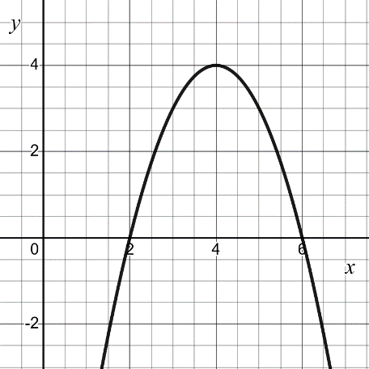
  - Determine the equation of the following parabola expressed in vertex form:

    - $y=-{\left(x+4\right)}^{2}-4$
    - $y=-{\left(x-4\right)}^{2}-4$
    - $y=-{\left(x+4\right)}^{2}+4$
    - $y=-{\left(x-4\right)}^{2}+4$

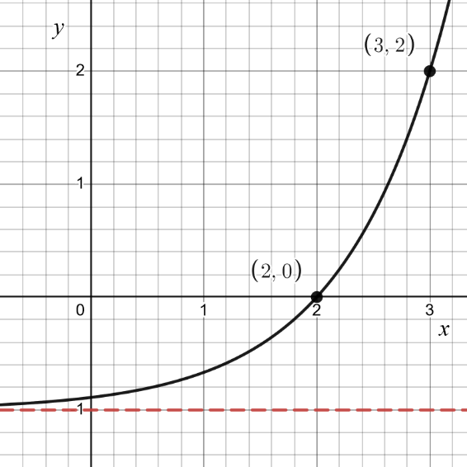
  - The graph below is an exponential function of the form$f\left(x\right)=a^{x-b}+c.$

Using the graph determine the values of $a,b,c.$

    - $a=2, b=3, c=1$
    - $a=3, b=2, c=1$
    - $a=2, b=3, c=-1$
    - $a=3, b=2, c=-1$

  - Determine the appropriate function using the following table

$$x$$ | $$y$$
$$-2$$ | $$ab^{2}$$
$$0$$ | $$a$$
$$2$$ | $$\frac{a}{b^{2 }}$$
$$4$$ | $$\frac{a}{b^{4}}$$

    - $y=a{\left(-b\right)}^{x}$
    - $y=ab^{-x}$
    - $y=ab^{x}$
    - $y={\left(ab\right)}^{-x}$

  - What type of graph does a quadratic function have?

    - S-Curve
    - Hyperbolic
    - Straight Line
    - Parabola

- Model and solve problems involving quadratic equations and inequalities using a variety of techniques (e.g., completing the square, factoring, graphing, quadratic formula).

  - What value of$k$completes the square for the expression$3x^{2}+8x+k$?

    - $k=\frac{4}{3}$
    - $k =\frac{4}{9}$
    - $k=\frac{16}{3}$
    - $k=\frac{16}{9}$

  - What is the x-value of the vertex of the parabola$y=-ax-bx^{2}+c,$
where$b≠0$?

    - $-\frac{b}{2a}$
    - $\frac{b}{2a}$
    - $-\frac{a}{2b}$
    - $\frac{a}{2b}$

  - If the discriminant of a quadratic function is less than$0$, how many solutions and what kind of solutions will the function have (if any)?

    - Two complex number solutions
    - Two real number solutions
    - One real number solution
    - No solutions

  - Find the solution of the inequality$3x^{2}+11x<4$.

    - $x<-4$or $x>\frac{1}{3}$
    - $-4<x<\frac{1}{3}$
    - $-\frac{1}{3}<x<4$
    - $x<-\frac{1}{3}$or $x>4$

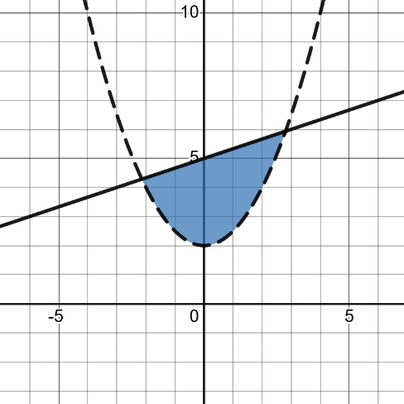
  - Which of the inequalities represents the following graph of quadratic functions?

    - $\frac{1}{2}x^{2}+2<y≤\frac{1}{3}x+5$
    - $\frac{1}{2}x^{2}+2≤y≤\frac{1}{3}x+5$
    - $\frac{1}{2}x^{2}+2≤y<\frac{1}{3}x+5$
    - $\frac{1}{2}x^{2}+2<y<\frac{1}{3}x+5$

  - Find all real number solutions (if any) of the equation$-9x^{2}+4x-2=0$

    - $x=\frac{-4±\sqrt{88}}{-18}$
    - $x=\frac{-4±\sqrt{48}}{18}$
    - $x=\frac{-4±\sqrt{56}}{-18}$
    - No real solutions

  - What is the perimeter, $P,$ of a rectangle with a given area$x^{2}+23x+132$?

    - $P=2x+23$
    - $P=4x+132$
    - $P=4x+46$
    - $P=4x+56$

- Model and solve problems involving exponential equations.

  - Use the data in the table to write a function on the number of emails received after any number of days. Use your function to predict the number of people who received the e-mail after one week.
Email Forwarding
Days | Number of Emails Received
$$0$$ | $$6$$
$$1$$ | $$12$$
$$2$$ | $$24$$
$$3$$ | $$48$$

    - $y = 6x^{2}, 294$ emails sent after one week
    - $y = 2x^{6}, 235298$ emails sent after one week
    - $y = 6{\left(2\right)}^{x}, 768$emails sent after one week
    - $y = x(2^{6}), 448$emails sent after one week

  - What is the base of this exponential function $y=3e^{x}$

    - $x$
    - $3e$
    - $3e^{x}$
    - $e$

  - Which of the following statements are true for the function$f\left(x\right)=k^{x}$, where$k>0$?

      - The domain is $(-∞,∞)$
      - The range is $\left(0,∞\right)$
      - The graph has a $y$-intercept at the point $(0,1)$

- I is true
- I and II are true
- II and III are true
- I, II, and III are true.

  - Solve the equation $2e^{x+7}-4=0$

    - $x=-7$
    - $x=-7+\ln{2}$
    - $x=\ln{2}$
    - No solution

  - Solve the equation $e^{x^{2}-4x-77}+1=0$

    - $x=-4,7$
    - $x=-1+ln{4},-1+\ln{7}$
    - $x=\ln{4},\ln{7}$
    - No solution

  - Amber deposited $\$P_{0}$ into a new savings account. The account has an interest rate of 4% compounded continuously. Assuming she makes no other deposits, how many years will it take Amber’s money to double?

    - $\frac{\ln{2}}{0.04}≈17$ years
    - $4\ln{2}≈3$ years
    - $-\frac{\ln{0.04}}{\ln{2}}≈5$ years
    - Not enough information

  - Let$f\left(x\right)=a{\left(b\right)}^{x}$. If$0<b<1$, what values of$x$ will cause$f\left(x\right)$ to exhibit exponential decay?

    - $x>0$
    - $0<x<1$
    - $-1<x<0$
    - $x<0$

