Analyze the relationship between the equation of a line and its graph in mathematical and real-world contexts.

- Consider the following graph:
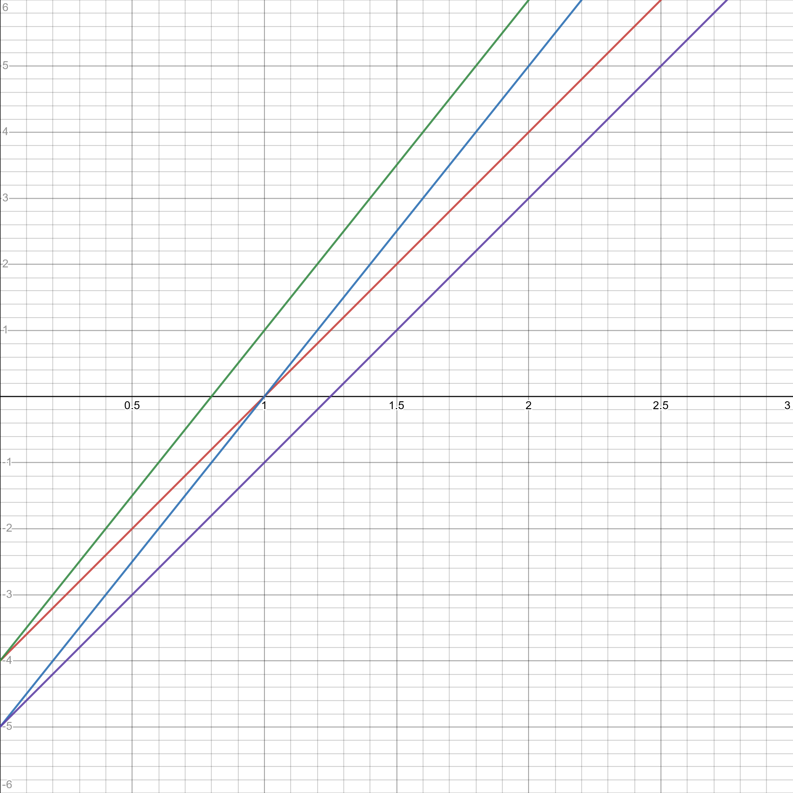
Which of the lines above corresponds to the equations $y=5x-4$?

  - Green
  - Red
  - Blue
  - Purple

- At a certain restaurant, the tip that a customer is expected to leave, $T$, can be estimated based on their bill amount, $A$, by the equation $T=0.17A+0.15$. If the bill amount rises by $\$1$, how much will the customer’s expected tip increase?

  - $0.15
  - $0.17
  - $0.32
  - $1.00

- A certain researcher is investigating the relationship between dog-years and human-years. He is building a linear model that assumes that 1 human-year is equivalent to 5 years of dog development. Which of the following curves could represent the researcher’s model?
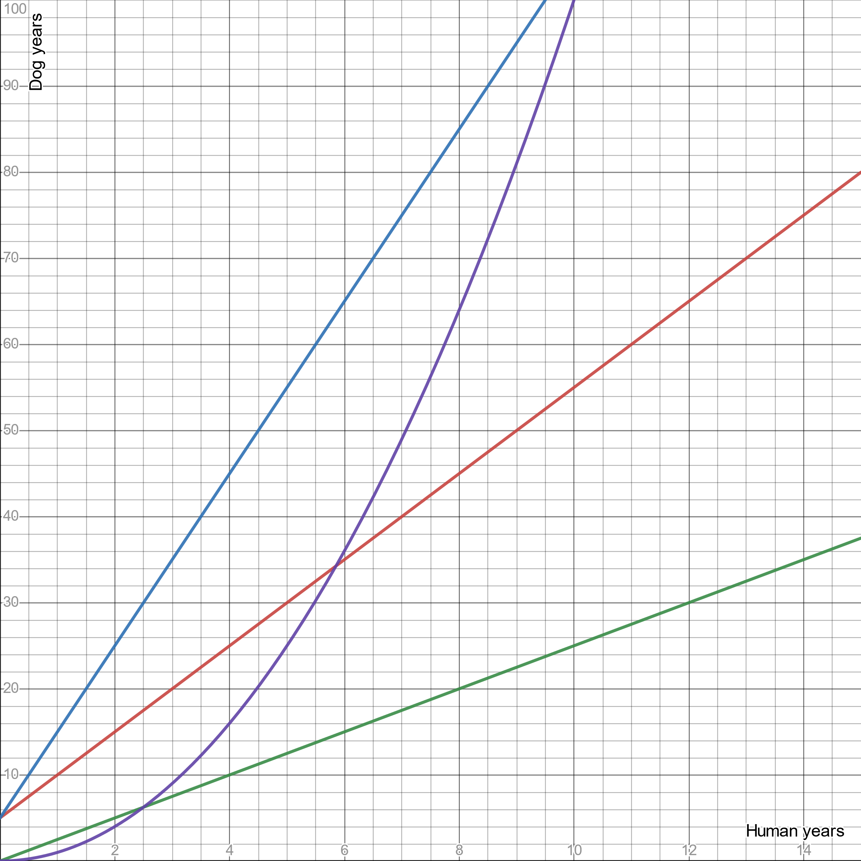

  - Blue line
  - Red line
  - Green line
  - Purple line

- Which of the following lines could represent the equation $y=13-7x$?
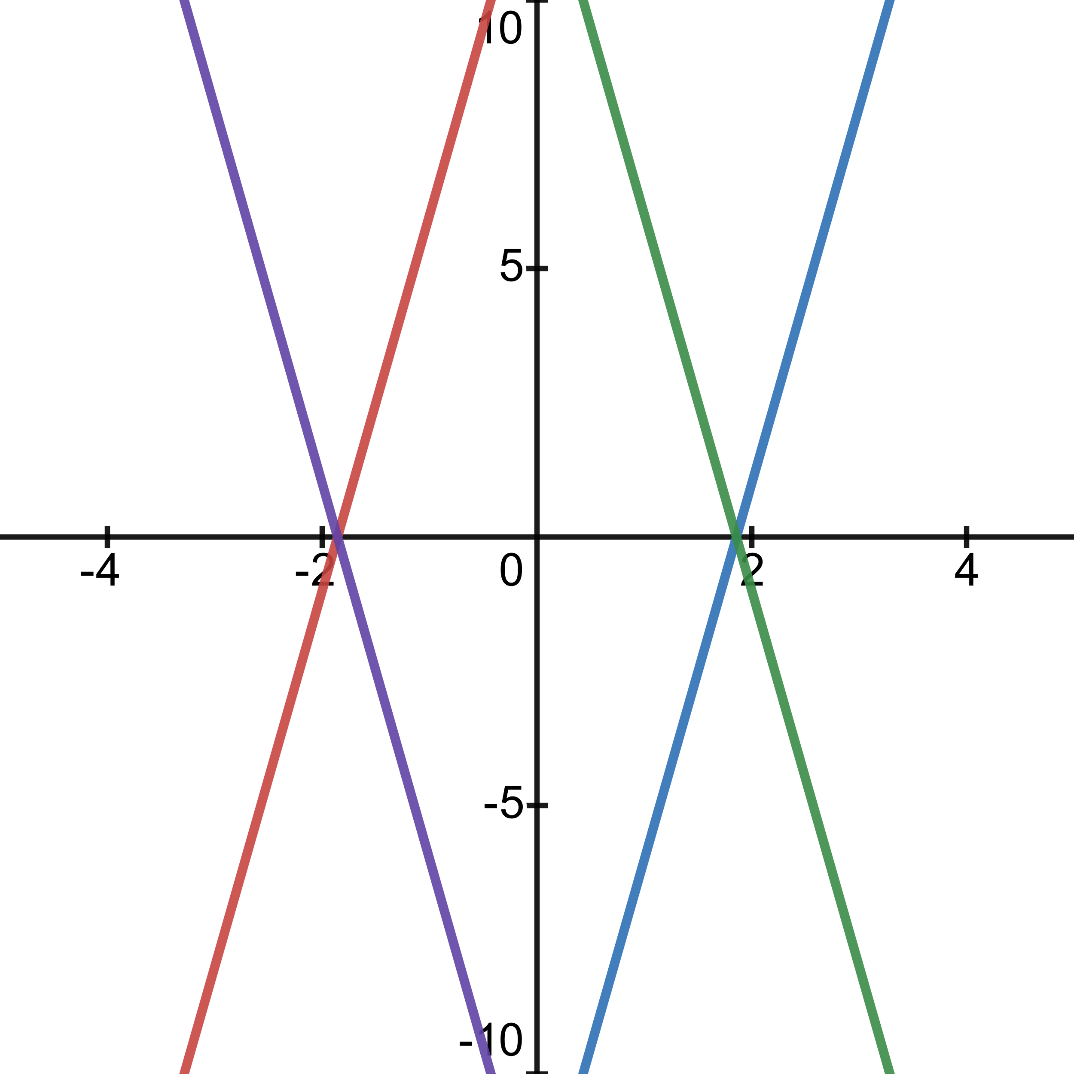

  - Red line
  - Purple line
  - Blue line
  - Green line

- What is the slope of the following line?
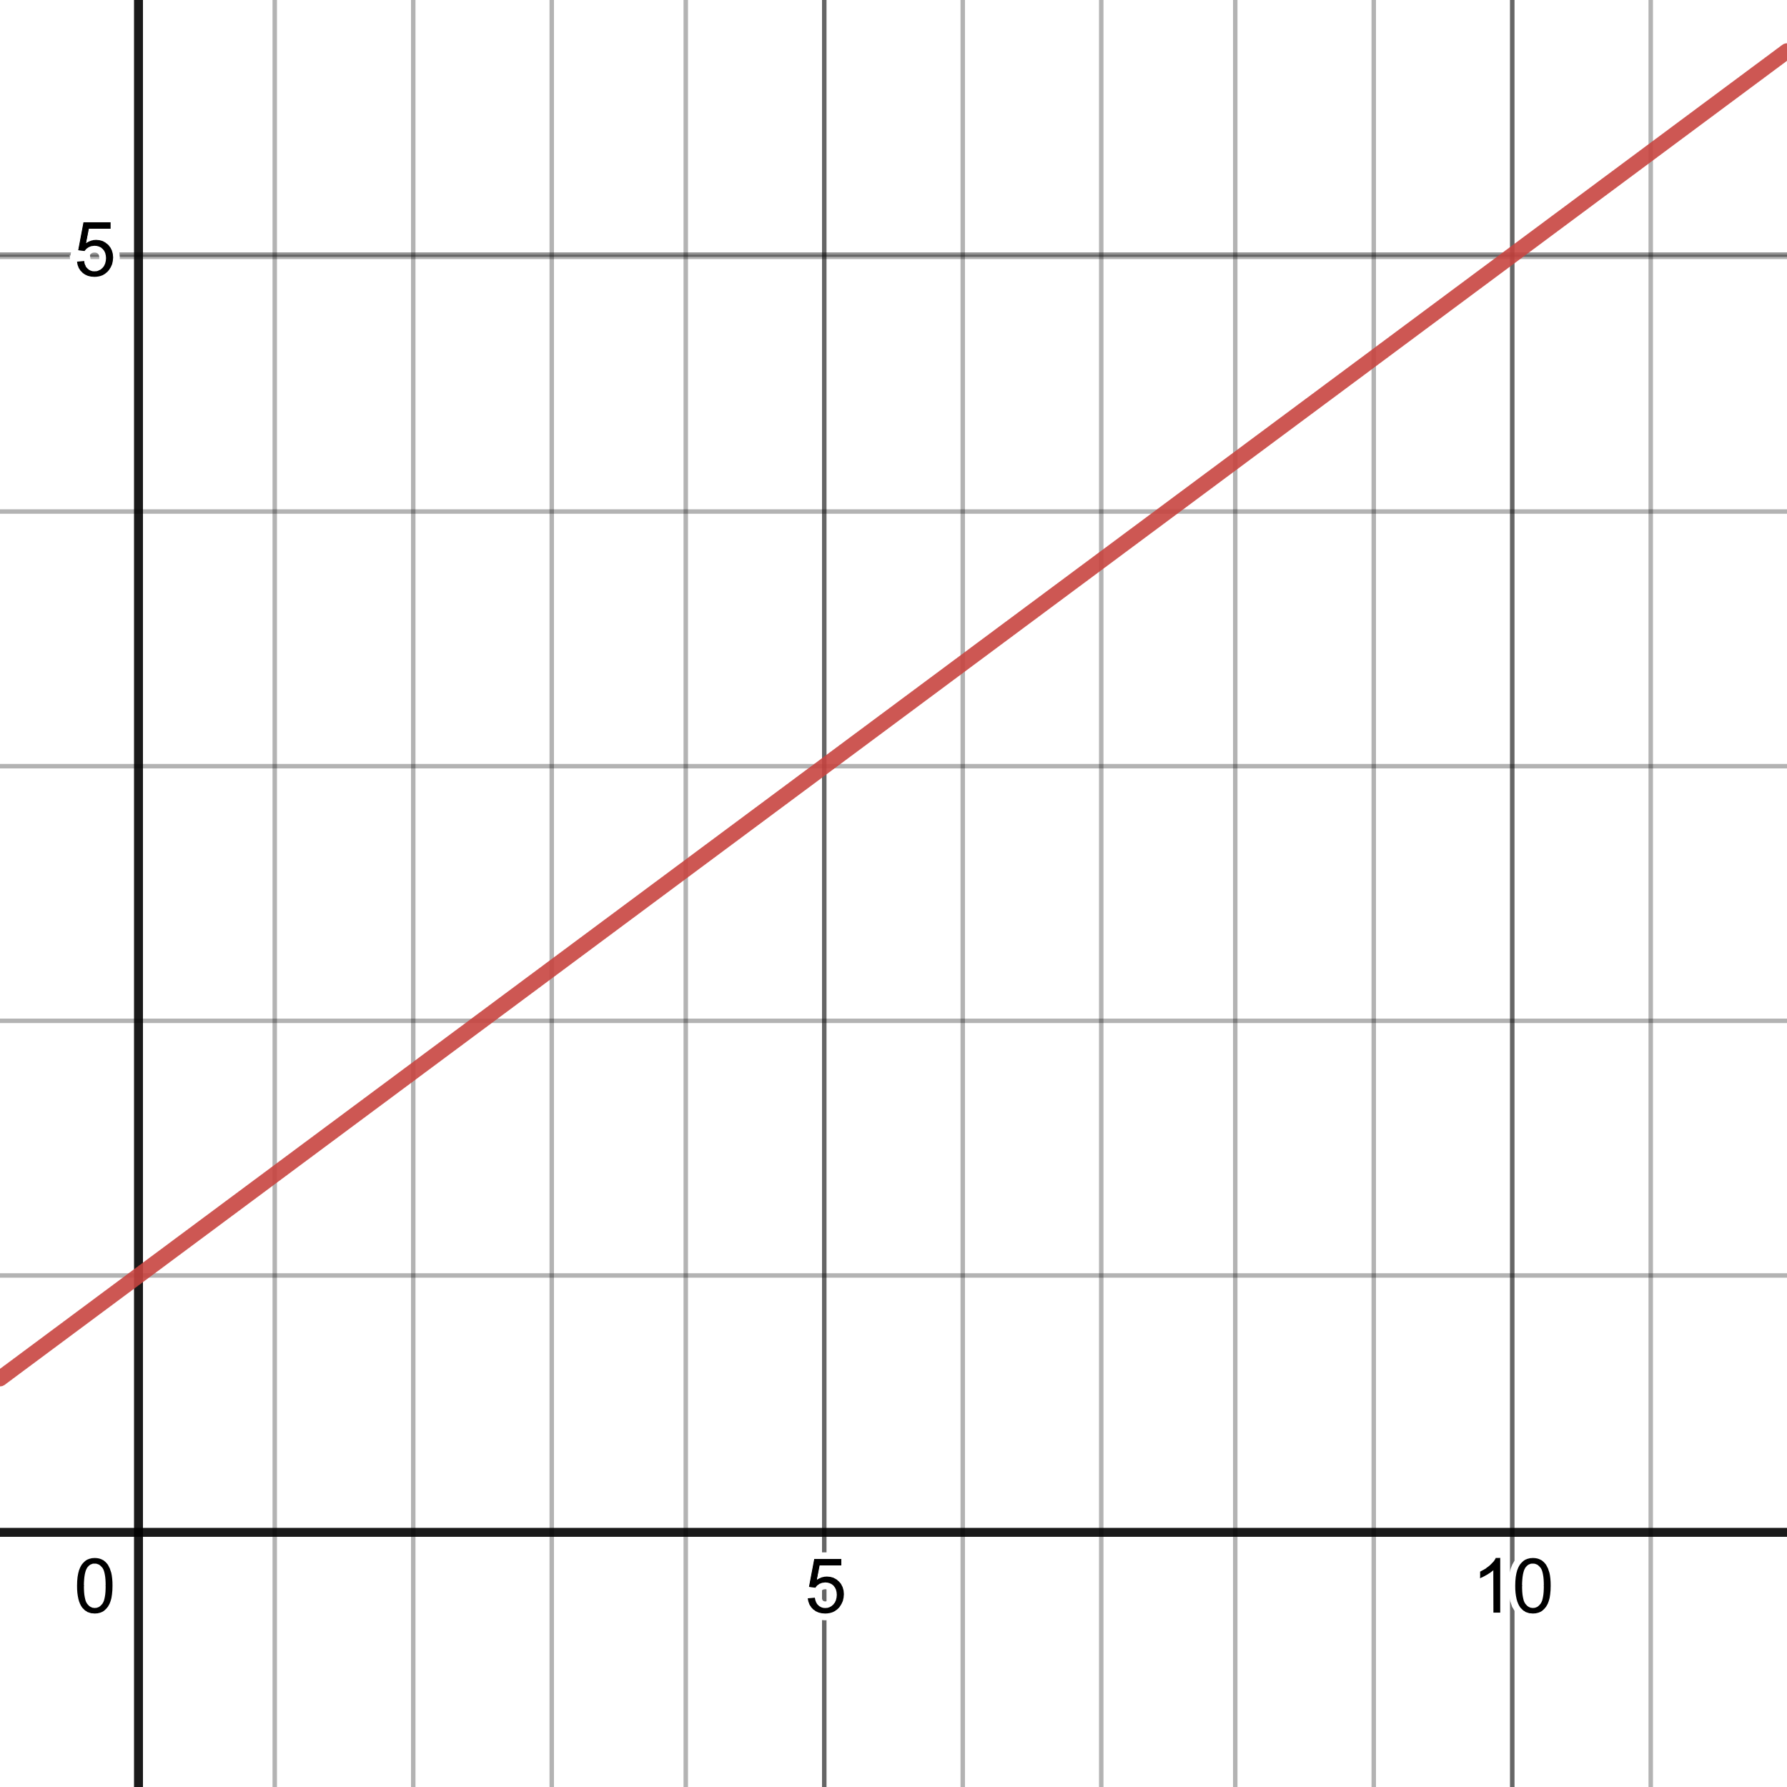

  - $0.8$
  - $1.0$
  - $2.5$
  - $5.0$

- Ahmed is planning a road trip to deliver a package and return home. The graph below shows Ahmed’s distance from home throughout the day.
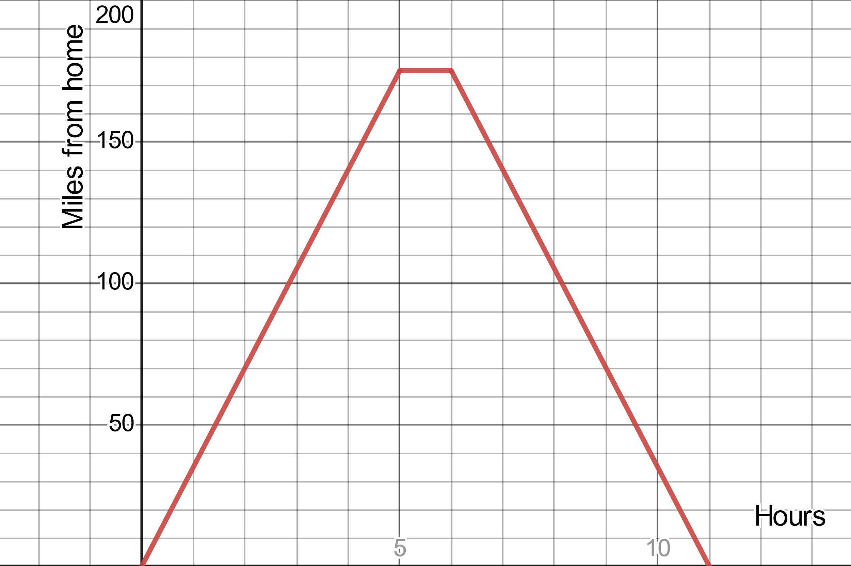
Assuming Ahmed drives at a constant speed, what is the speed of Ahmed’s car?

  - 20 mph
  - 35 mph
  - 50 mph
  - 175 mph

- Determine the equation of the following line in slope-intercept form:
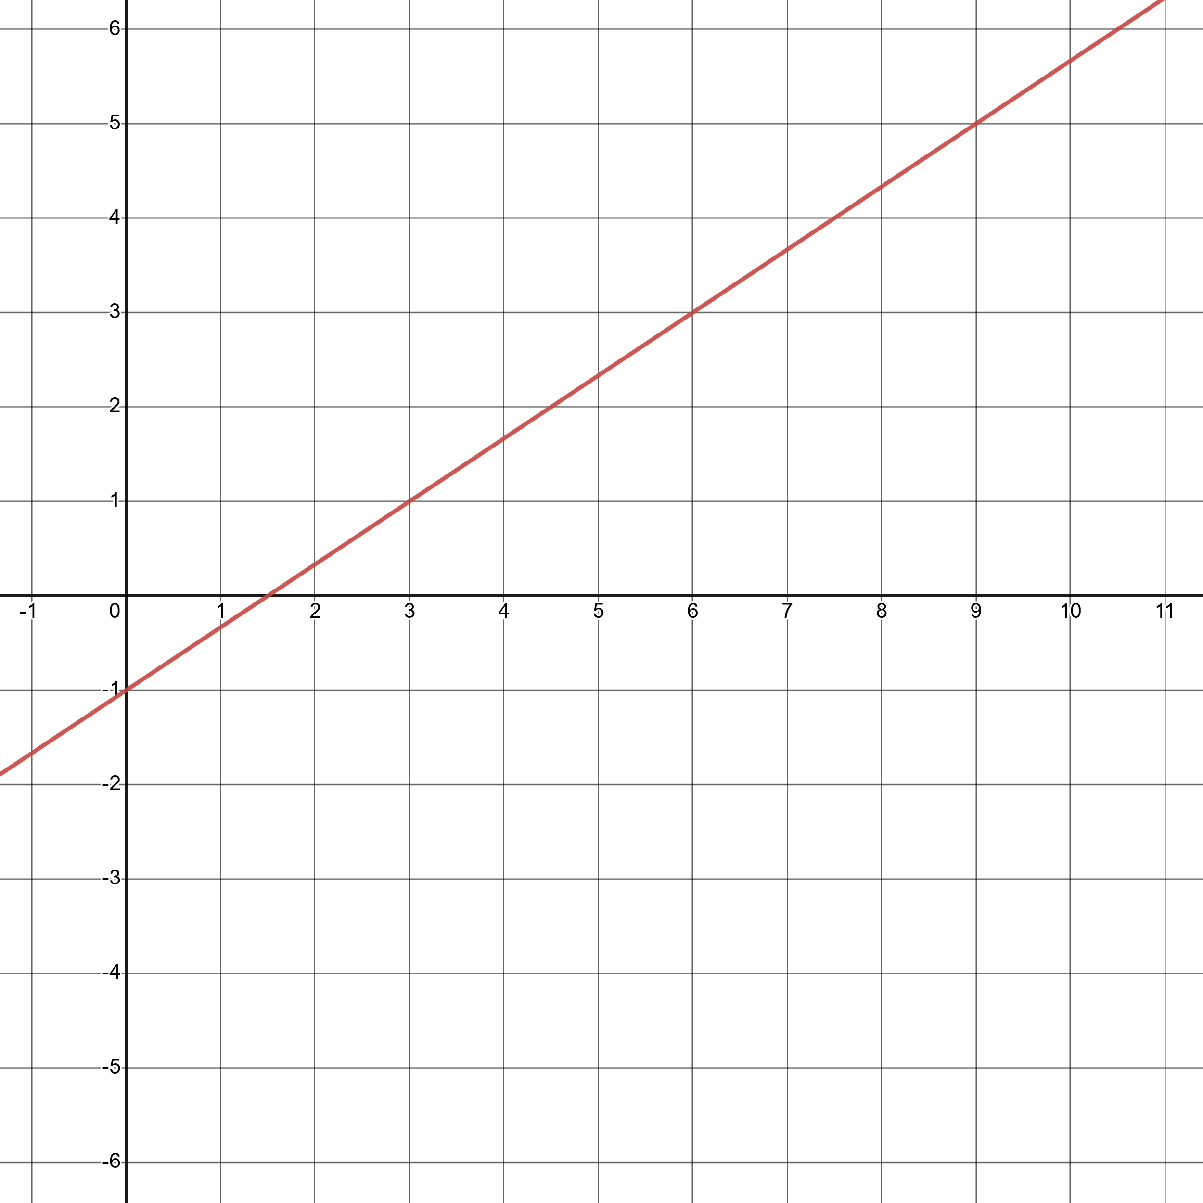

  - $y=\frac{2}{3}x-1$
  - $y=\frac{2}{3}x+\frac{3}{2}$
  - $y=\frac{3}{2}x+\frac{3}{2}$
  - $y=\frac{3}{2}x-1$

- Determine the equation of the following line in Standard Form:
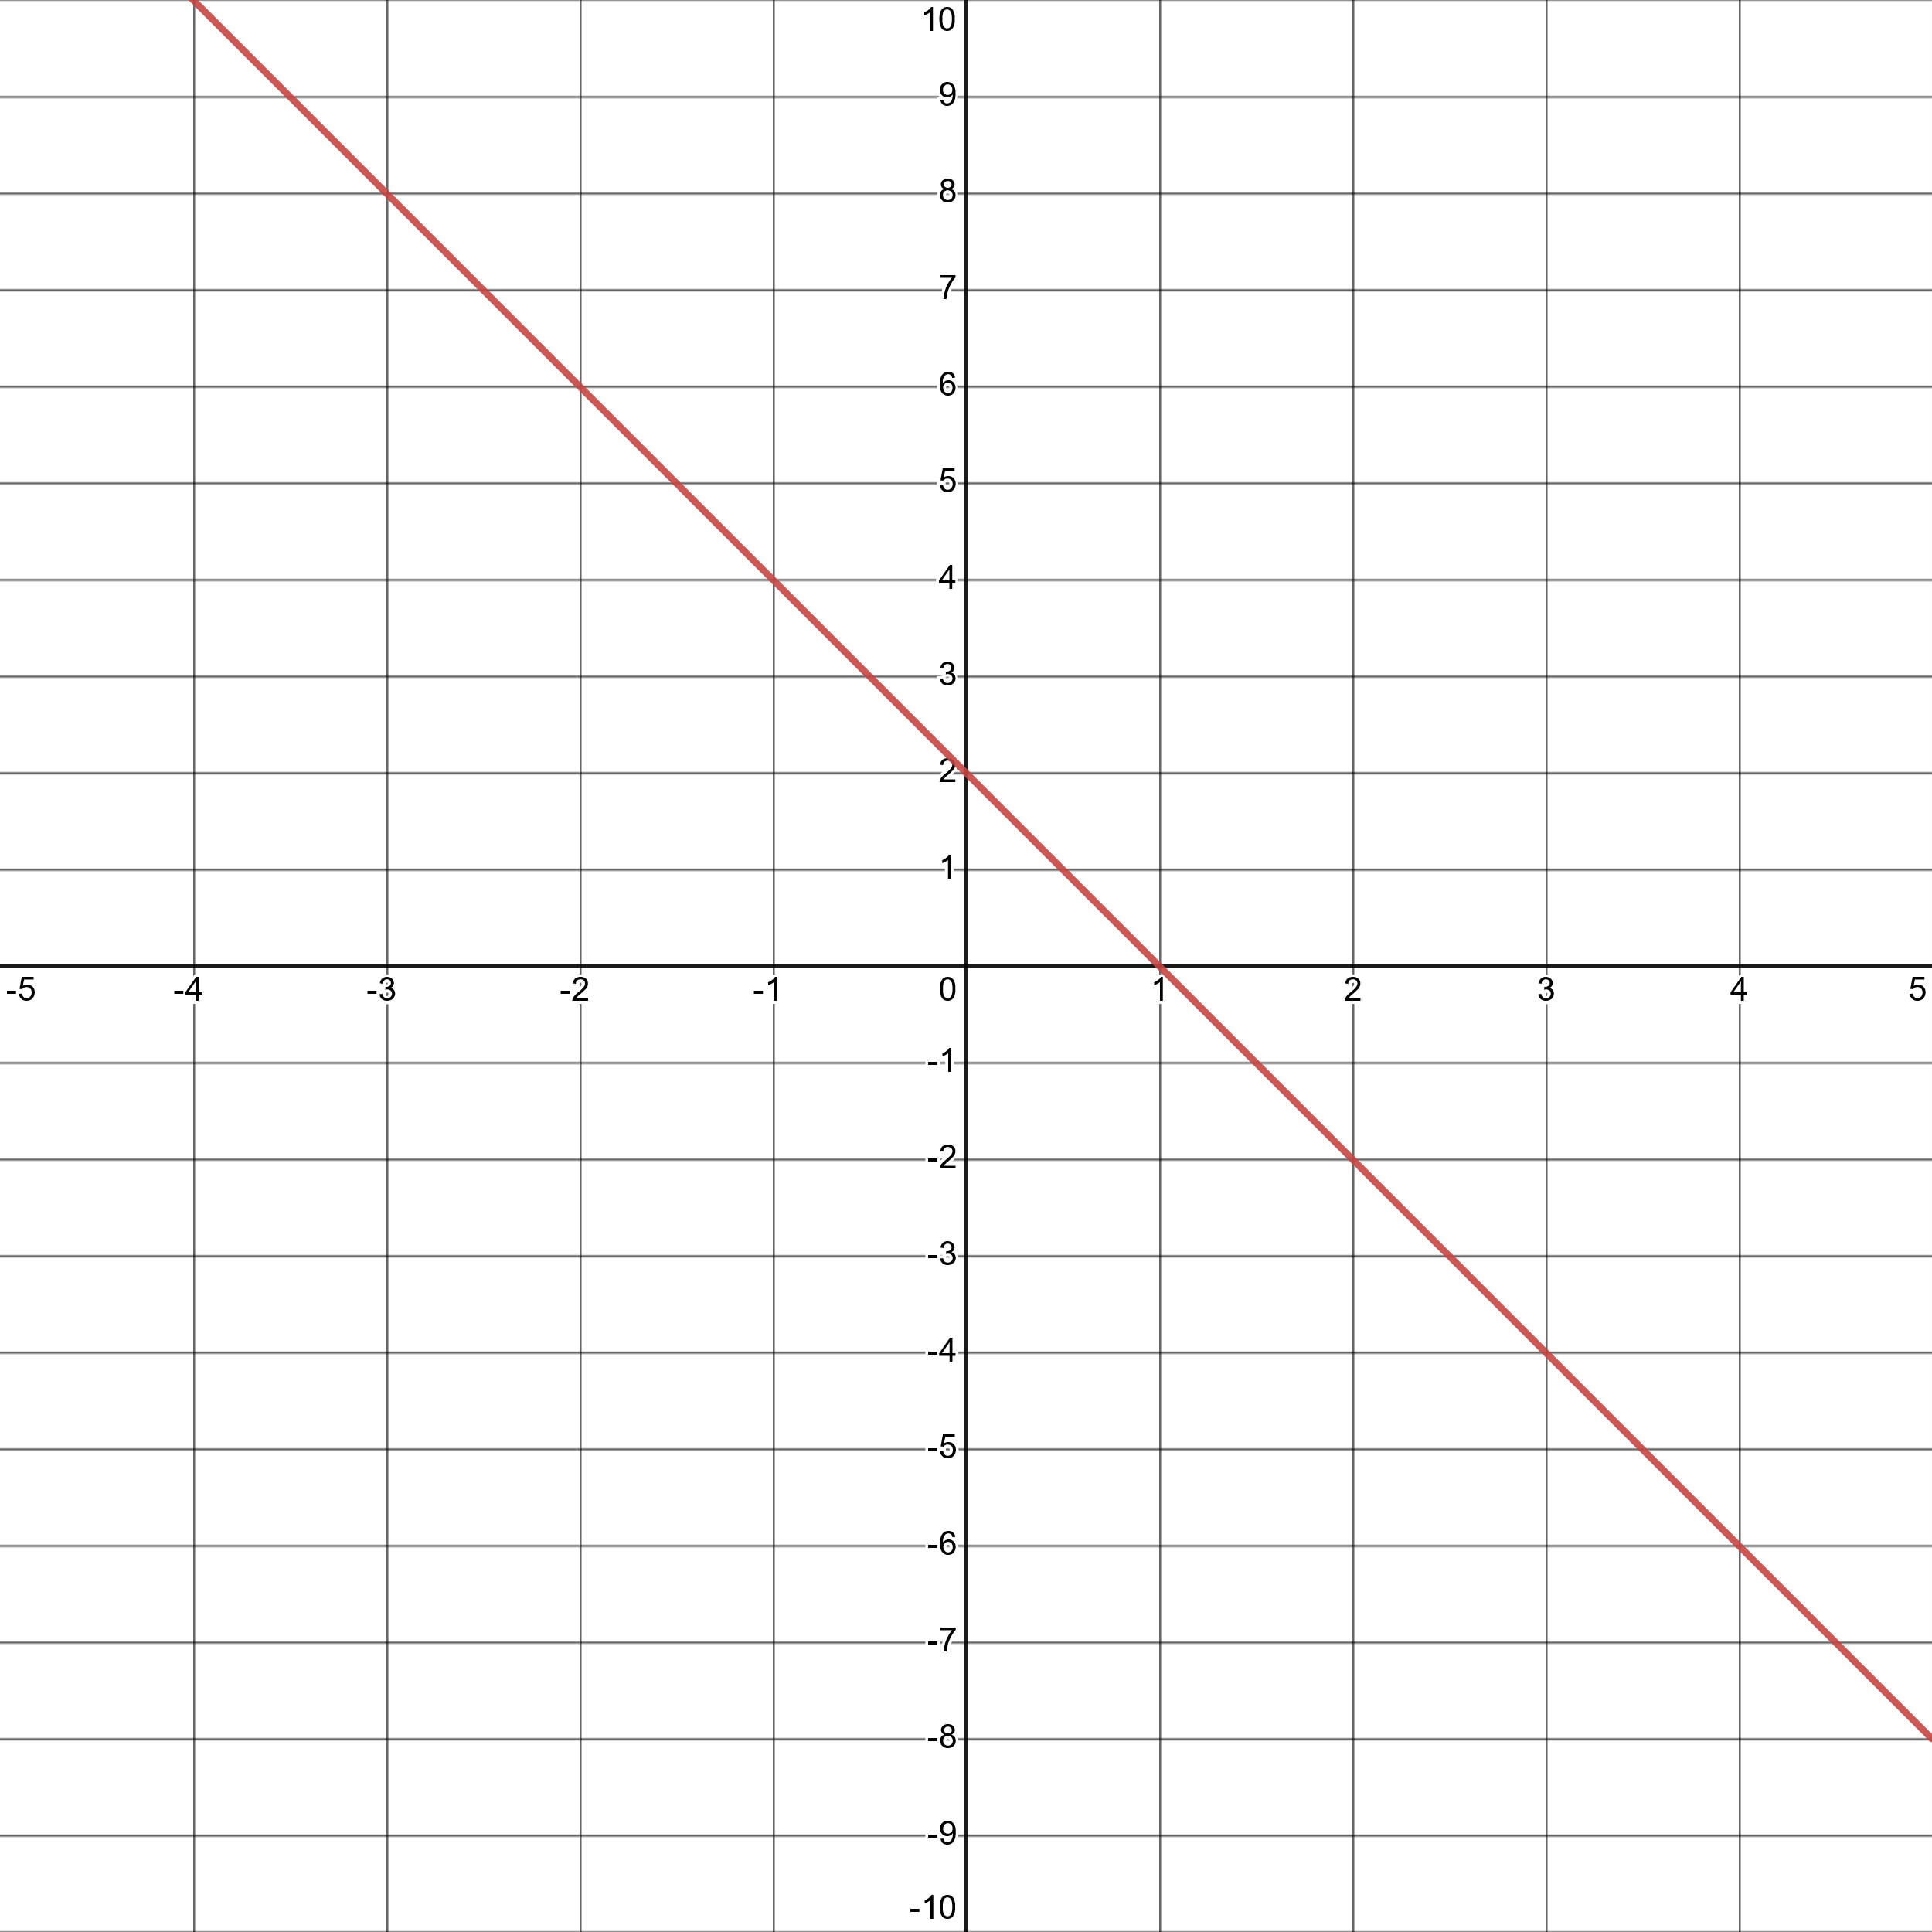

  - $2y+2x=2$
  - $y+\frac{1}{2}x=2$
  - $y+2x=0$
  - $y+2x=2$

Determine the equation of a line using different types of information (e.g., two points, slope and one point).
- Given that $0℃=32℉$ and $100℃=212℉$, determine the formula to convert from Fahrenheit to Celsius.

  - $℃=(℉-32)×\frac{9}{5}$
  - $℃=\frac{5}{9}℉-32$
  - $℃=\frac{9}{5}℉-32$
  - $℃=\left(℉-32\right)×\frac{5}{9}$

- At the local library, patrons are charged a flat fee for an overdue book, plus an additional fee every day that the book is not returned. A book which is 10 days overdue is charged a late fee of $3.75 and a book which is 20 days overdue is charged a late fee of $7.25. What is the balance due on a book that is 90 days overdue?

  - $31.50
  - $31.75
  - $32.63
  - $33.75

- Determine the equation of a line passing through the points $(5,-22)$ and $(20,-19)$.

  - $y=-2x-12$
  - $y=\frac{1}{5}x-23$
  - $y=\frac{4}{5}x-26$
  - $y=2x-32$

- Determine the equation of a line passing through the points $(-10,-4)$ and $(12,7)$.
  - $y=\frac{1}{2}x+1$
  - $y=2x+16$
  - $y=2x-2$
  - $y=x+6$
- Which of the following lines is perpendicular to the line depicted in the graph below?
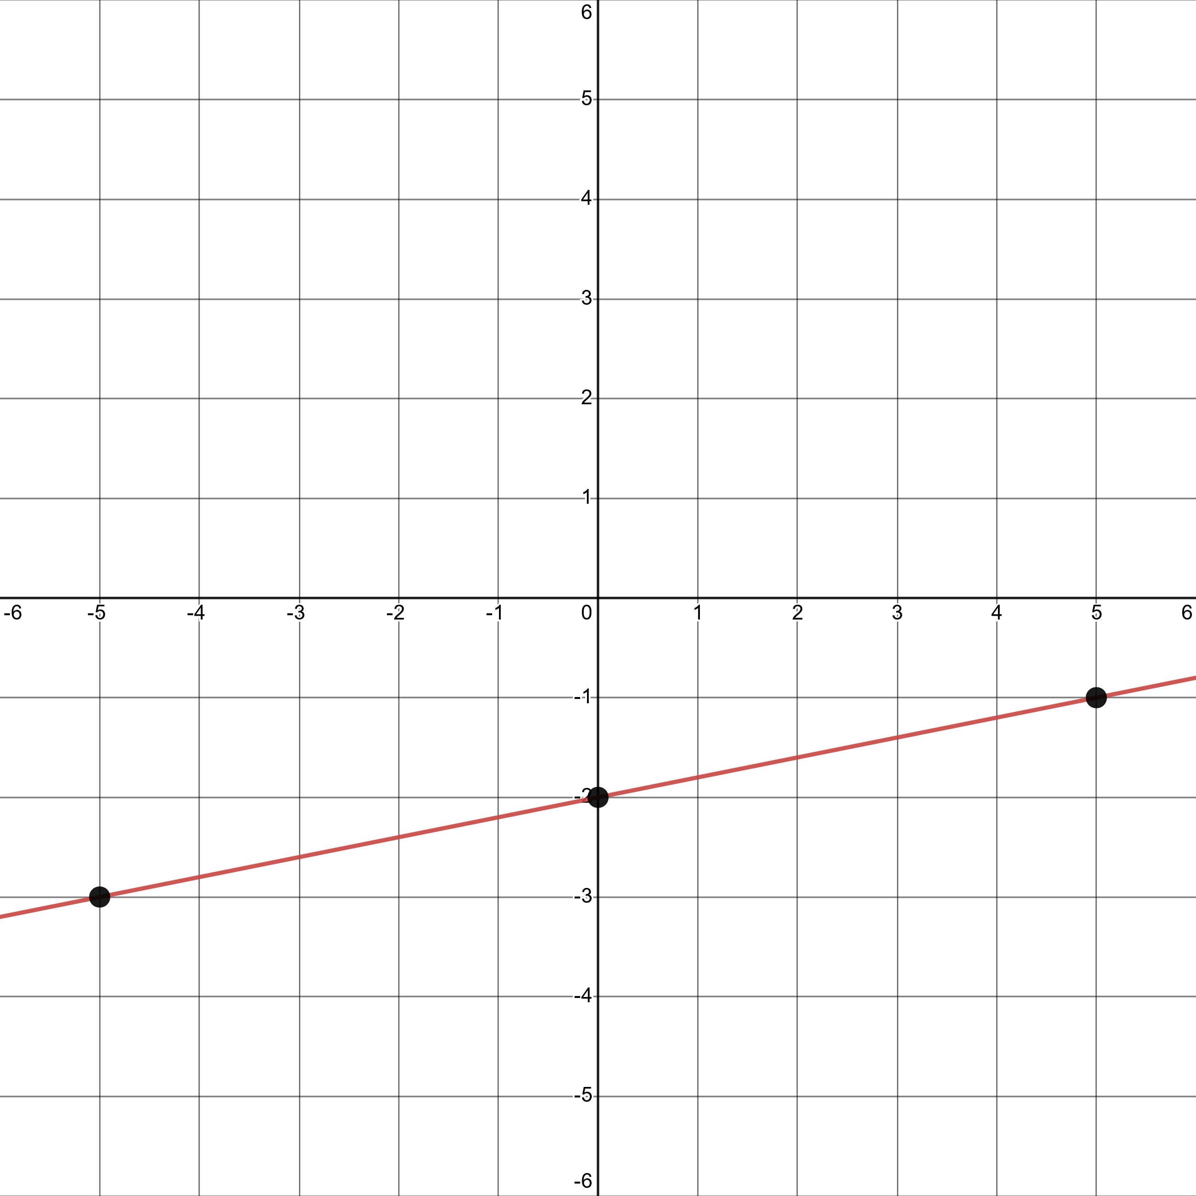

  - $y=-\frac{1}{5}-2$
  - $y=\frac{1}{5}x-2$
  - $y=-5x+16$
  - $y=5x-1$

- Which of the following lines is parallel to the one depicted in the graph below and passes through the point $(1,100)$?
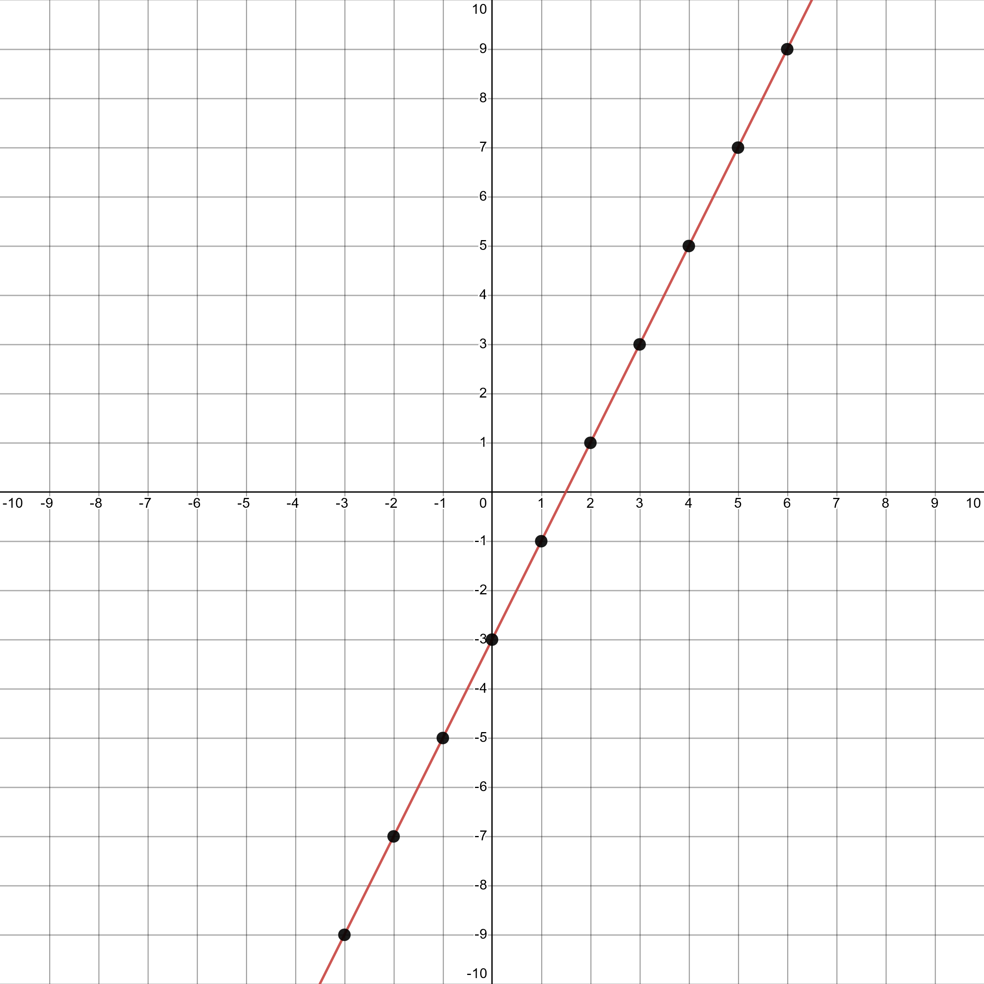

  - $y=-\frac{1}{2}x+\frac{201}{2}$
  - $y=100x$
  - $y=2x+98$
  - $y=2x-3$

- Determine the equation of a line with a slope of 2 and a y-intercept of 3

  - $y=2x+2$
  - $y=2x+3$
  - $y=3x+2$
  - $y=3x+3$

- Determine the equation of a line with a slope of 3 and an x-intercept of 4.

  - $y=\frac{3}{4}x$
  - $y=3x+4$
  - $y=3x-4$
  - $y=3x-12$

- Determine the slope of the line $3x-4y=12$.
  - $\frac{3}{4}$
  - $\frac{4}{3}$
  - $3$
  - $4$

- Determine the slope of the line $y-14=2(x-1)$.
  - $-2$
  - $-\frac{1}{7}$
  - $1$
  - $2$

- Determine the y-intercept of the same line from the previous problem: $y-14=2(x-1)$.

  - -1
  - 12
  - 14
  - 15

- Determine the x-intercept of the same line from the previous problem: $y-14=2(x-1)$.

  - -14
  - -6
  - -2
  - -1

Identify the connection between proportional and linear relationships.
- Albert runs a lemonade stand and will donate $15\%$ of his proceeds to charity. Which of the following best describes the relationship between Albert’s proceeds and donations?

  - Linear, but not proportional
  - Proportional, but not linear
  - Both proportional and linear
  - None of the above

- Given that $1 \text{mile}=1.6 \text{km}$ and that $1\text{g water}=1cm³\text{ water}$, determine the weight of the water in a lake which contains $0.5$ mile³ of water.

  - $80 kg$
  - $205 kg$
  - $800,000,000,000 kg$
  - $2,048,000,000,000 kg$

- Saffron costs $368.00 per ounce. How much can you purchase with $15.00? (HINT: There are 16 ounces in one pound. There are 2.2 pounds in one kilogram.)

  - $0.041 g$
  - $1.158 g$
  - $11.151 g$
  - $696.970 g$

- John has owned and operated his own taco shop for the past 35 years. Each hour, John serves 200 tacos. John works 8 hours a day and 5 days a week. John is paid every 2 weeks, with a paycheck of $840.34. How many tacos must John prepare in order to make 1 million dollars? Round to the nearest thousand tacos.

  - $95,000 tacos$
  - $238,000 tacos$
  - $19,040,000 tacos$
  - $79,968,000 tacos$

- Given that quadrilateral $PQRS$ is similar to $TUVW$, find the length of $\overline{PS}$.
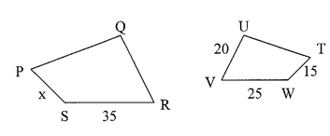

  - $10.7$
  - $14.3$
  - $21$
  - 28

- On a certain day, a $5 ft$ man casts a shadow that is $4.5 ft$ long. An adjacent building has a shadow that is $180 ft$ long. How tall is that building?

  - $162 ft$
  - $200 ft$
  - $200.5 ft$
  - $222.2 ft$

- Central Park in New York City covers an area of $1.317 sq mi$. Watering the foliage in the park costs the Park District $10¢$ per square meter. Given that $1 mile=1.6 km$, what is the cost of watering the entire park?

  - $\$337.15$
  - $\$210.72$
  - $\$210,720$
  - $\$337,152$

- Solve for $x$:
$$\frac{x}{x+1}=\frac{3}{5}$$

  - $3/2$
  - $5/2$
  - $3$
  - 5

Model and solve problems using different representations of linear equations and inequalities, and systems of linear equations and inequalities.

- Zena visits her school bookstore where pens are sold for $15¢$ each and pencils are sold for $10¢$ each. Zena spends exactly $\$3$ on $28$ items. What is the number of pens multiplied by the number of pencils? (That is, determine the number of pens and the number of pencils. Multiply the two values you’ve computed before selecting your answer choice.)
  - $54$
  - $96$
  - $144$
  - $196$

- Every month, Lisa has $200 in taxes on her paycheck. After taxes, one quarter of the remaining amount is deposited into Lisa’s 401(K) retirement savings account. Which of the following best represents the relationship between Lisa’s initial salary, $S$, and the amount contributed to her 401(k) account, $A$.

  - $A=\frac{1}{4}(S-50)$
  - $A=\frac{1}{4}S-200$
  - $A=\frac{1}{4}S-50$
  - $A=S-50$

- A certain town has less than 50 barbers but no fewer than 35. Which inequality represents this situation, where $b$ represents the number of barbers in town.

  - $35<b≤50$
  - $35≤b<50$
  - $35≤b≤50$
  - $b<35;b≥50$

- Which of the following graph shows the region represented by the equations $y≥2x+1$ and $y≤x+1$?

  - 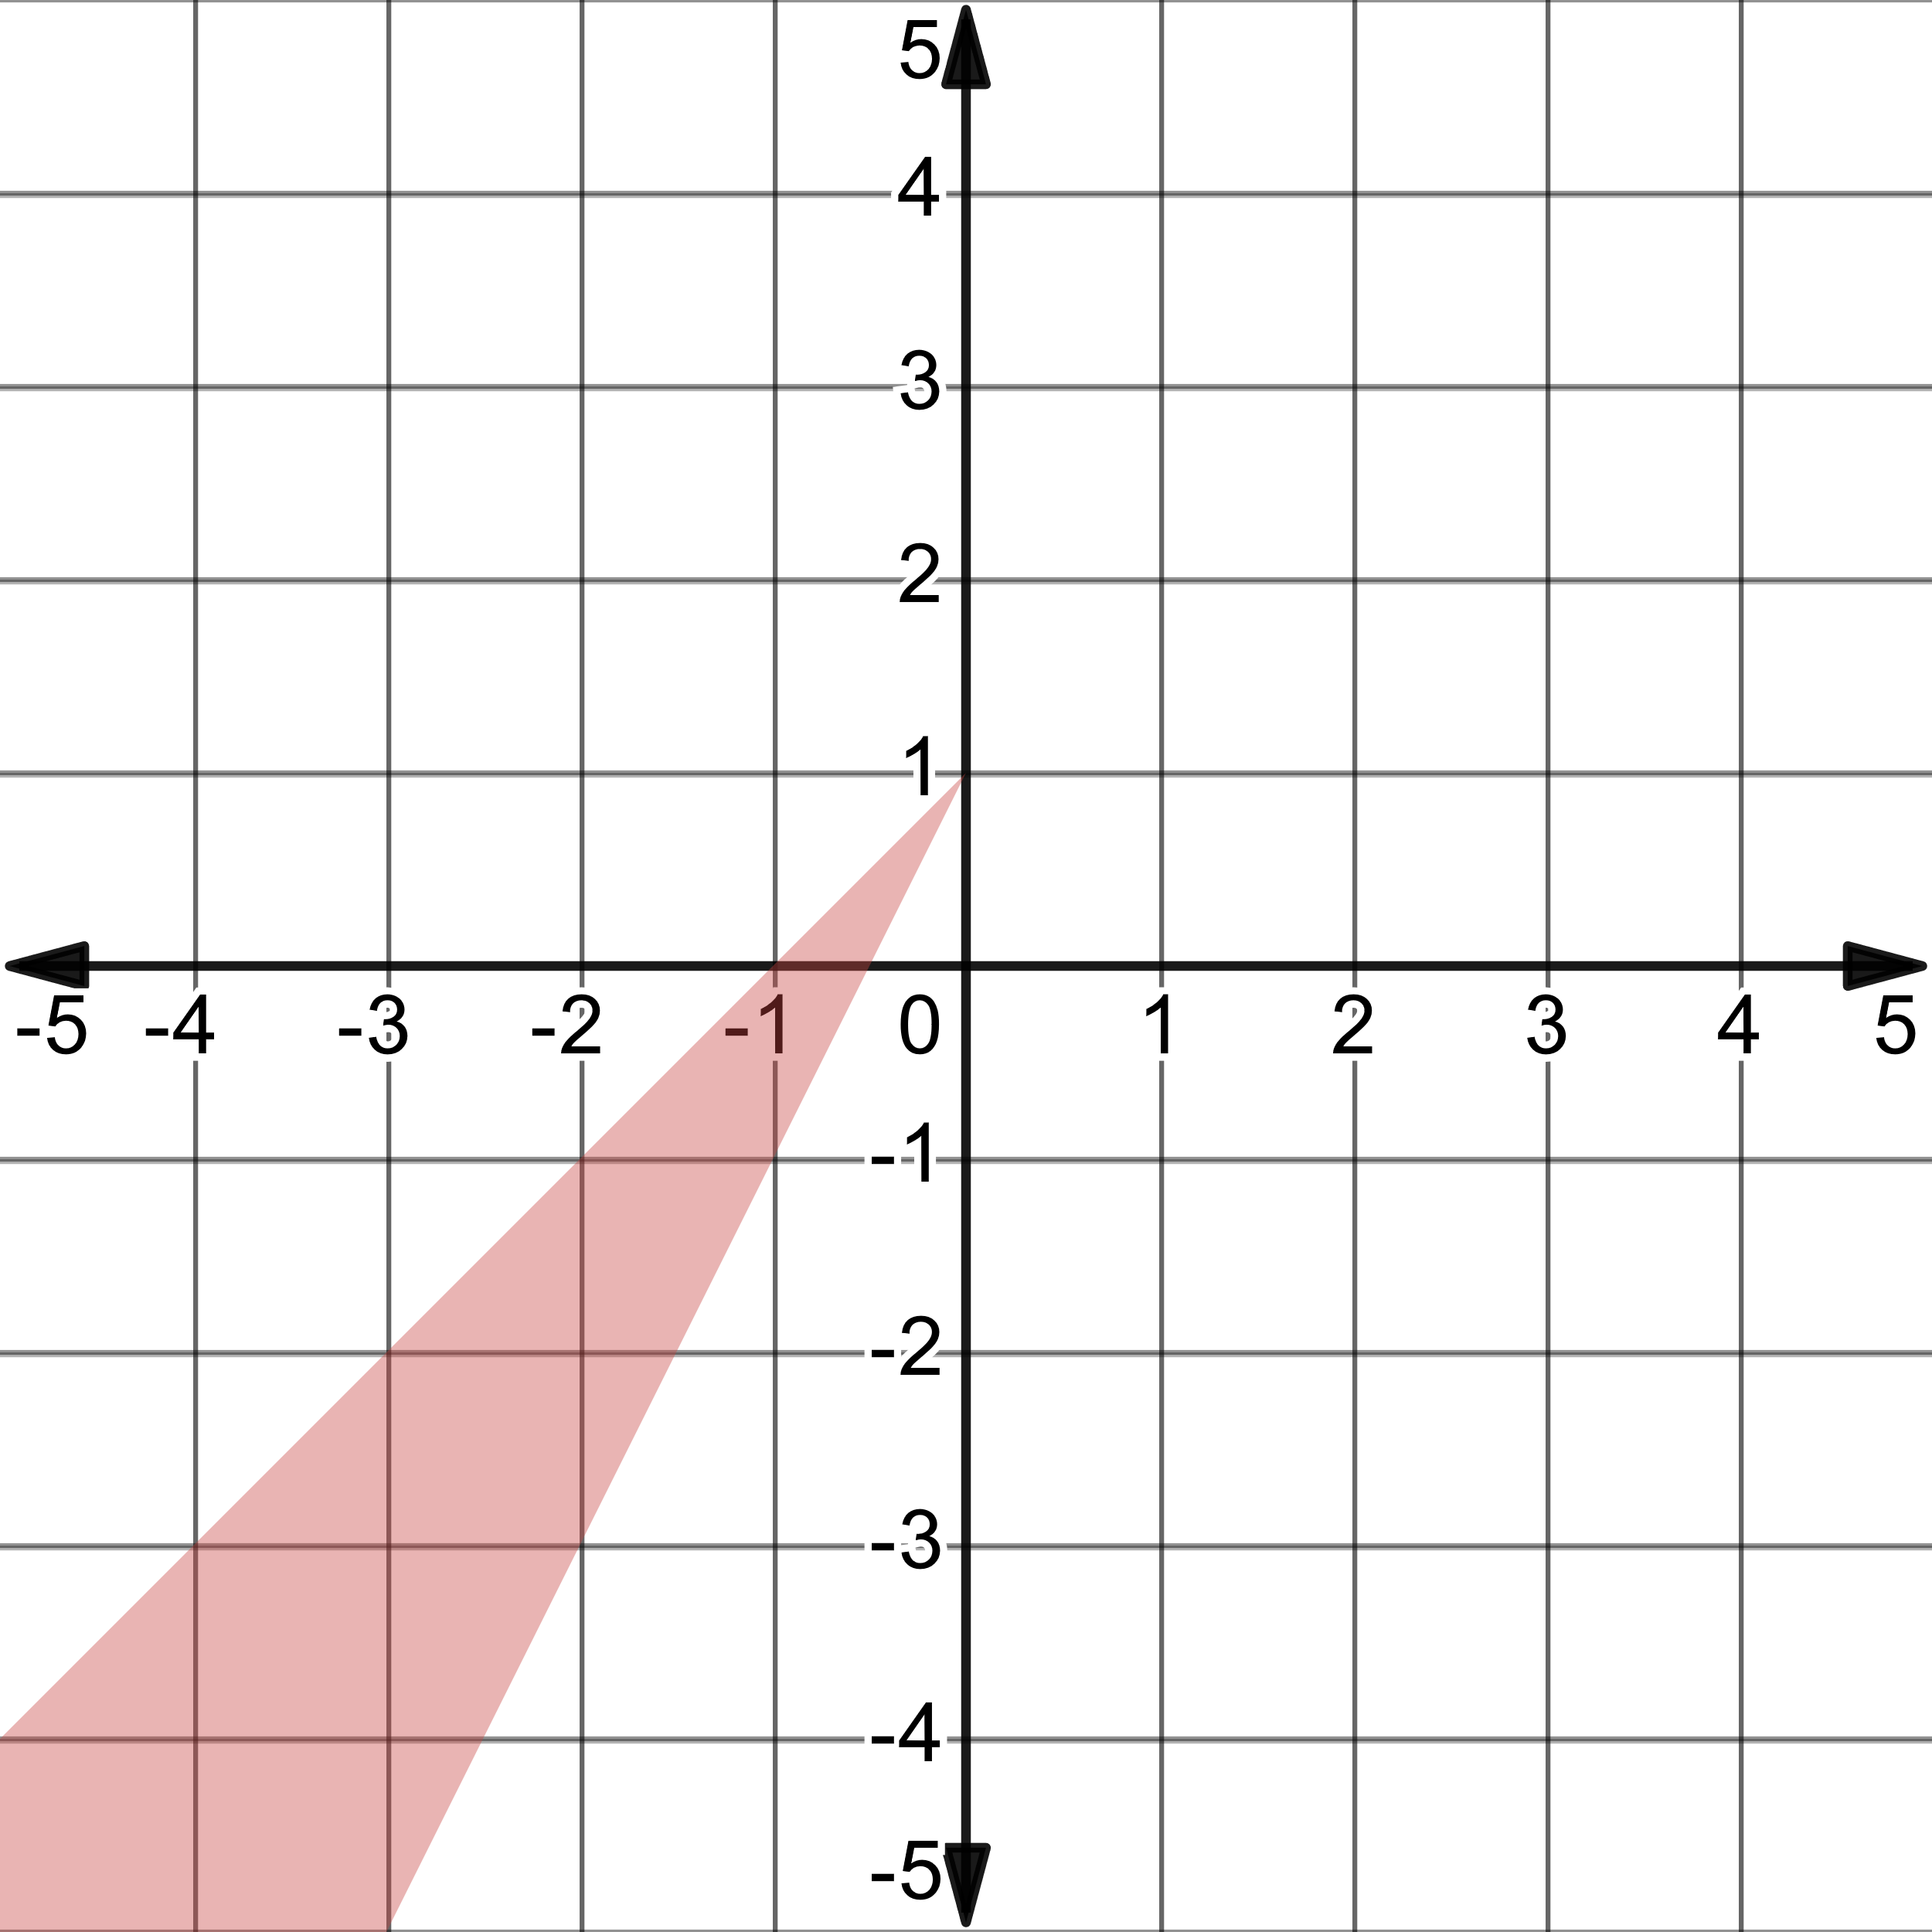
  - 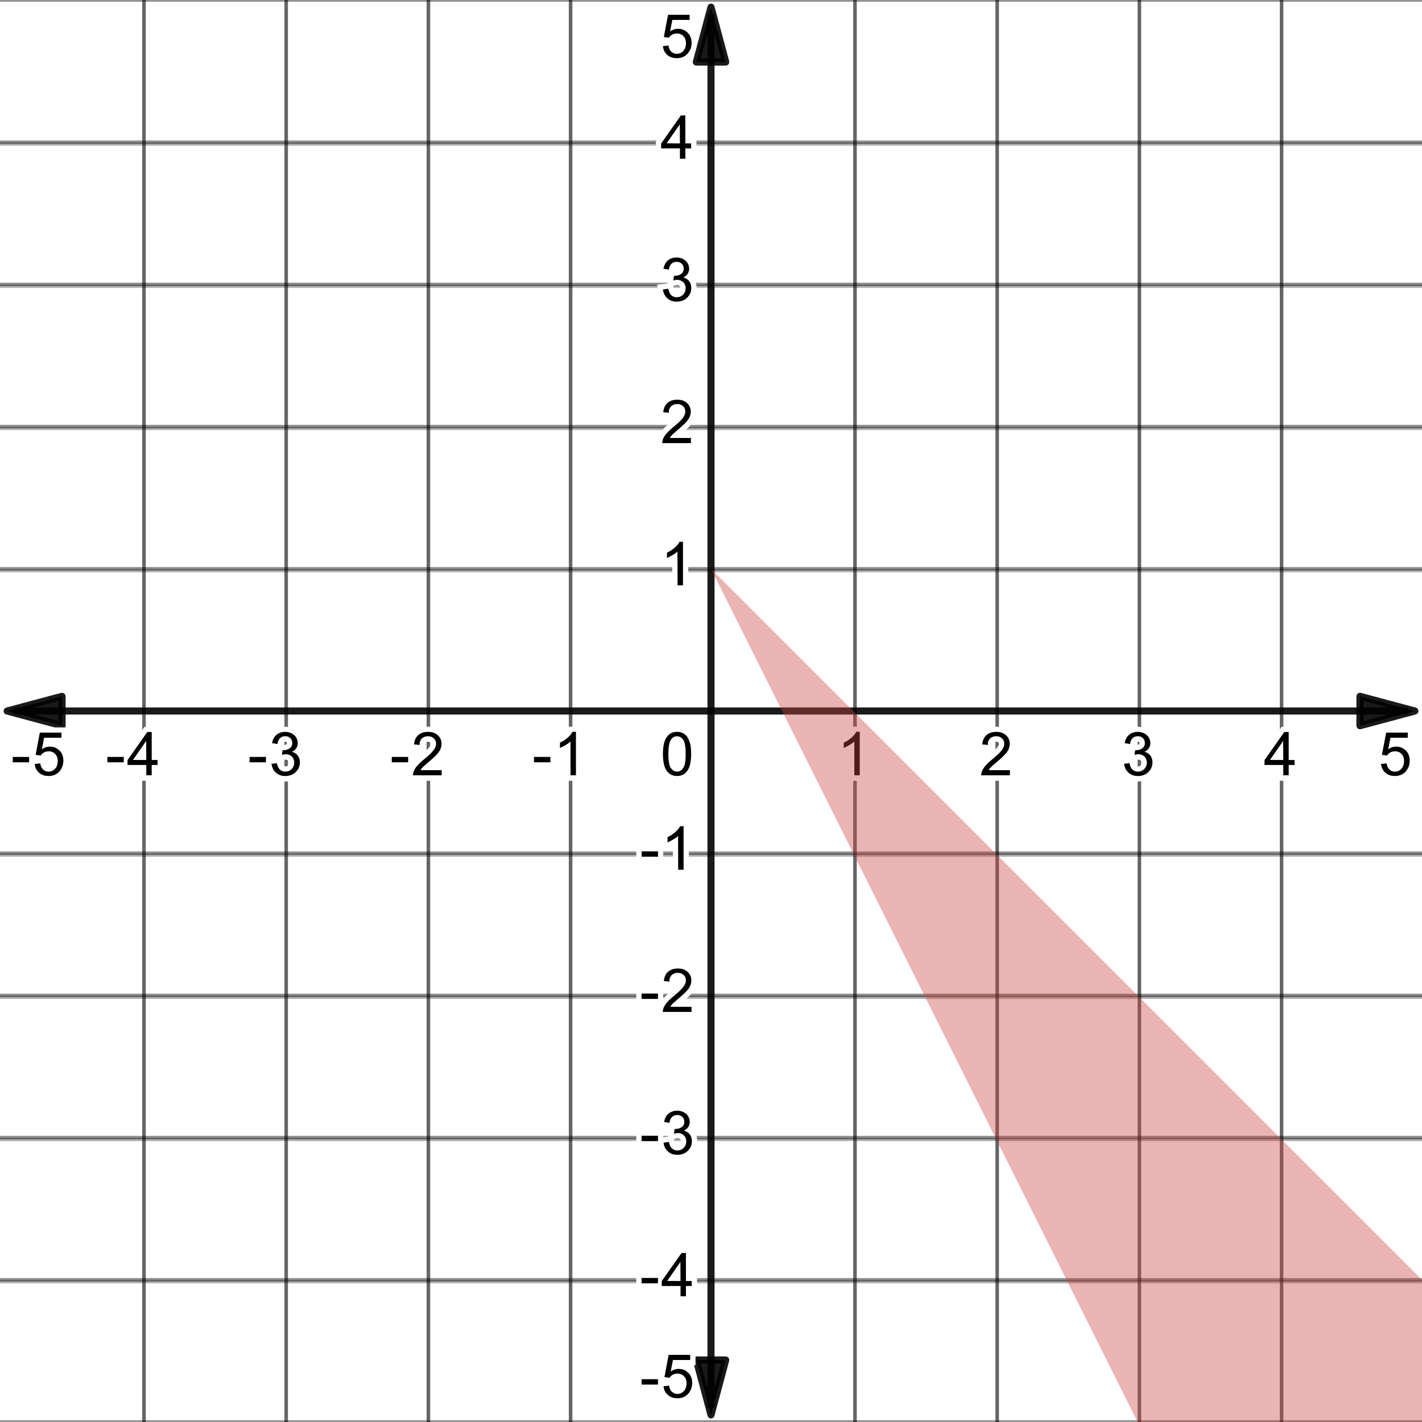
  - 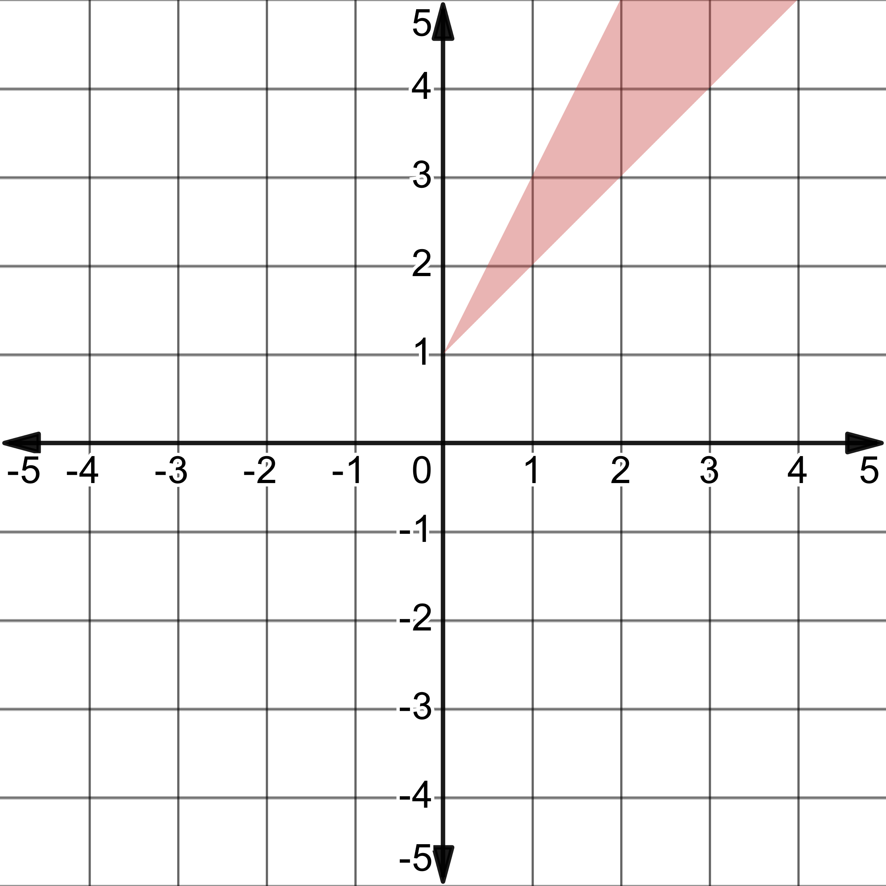
  - 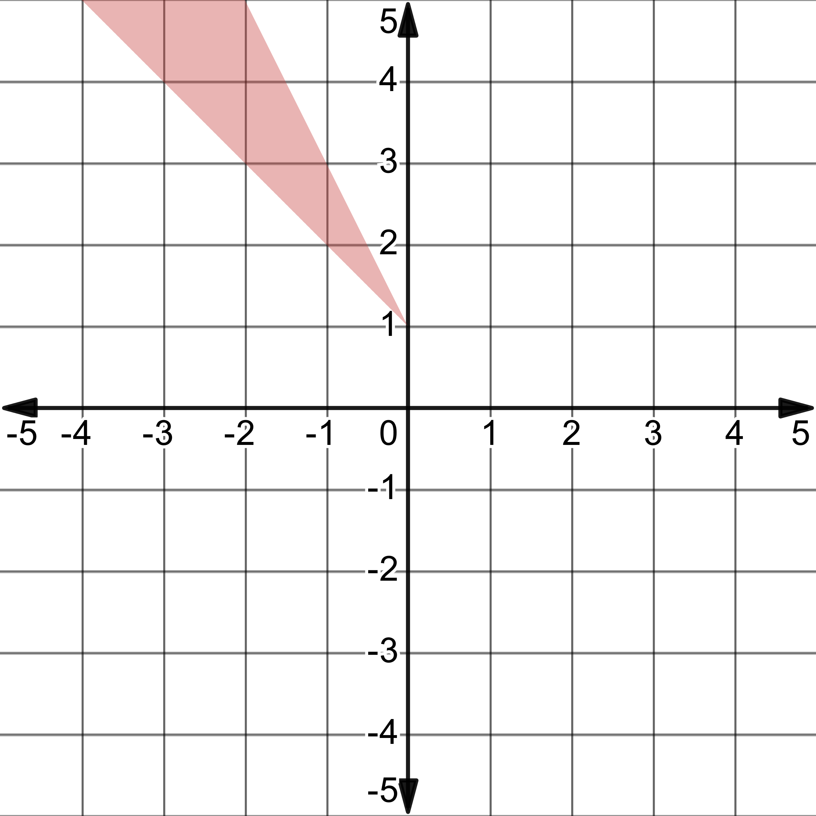

- Charlie has $500 in a savings account at the beginning of the summer. He wants to have at least $200 in the bank at the end of the summer. He withdraws $19 per week for food, clothing, and movie tickets. How many weeks can Charlie withdraw money from his account?

  - 15 weeks
  - 16 weeks
  - 19 weeks
  - 26 weeks

- A certain rectangular wooden plank has a perimeter of 30 feet. The length of the plank is 5 less than 4 times its width. What is the area of the plank?
  - $20 sq ft$
  - $30 sq ft$
  - $44 sq ft$
  - There is insufficient information to determine the area of the plank.

