Analyze the relationship between the equation of a line and its graph in mathematical and real-world contexts.
- A, green line
- B, $\$0.17$
- B, Red line
- D, Green line
- A, $0.8$
- B, 35 mph
- A, $y=\frac{2}{3}x-1$
- D, $y+2x=2$

Determine the equation of a line using different types of information (e.g., two points, slope and one point).
- D, $℃=\left(℉-32\right)×\frac{5}{9}$
- B, $31.75
- B, $y=\frac{1}{5}x-23$
- A, $y=\frac{1}{2}x+1$
- C, $y=-5+16$
- C, $y=2x+98$
- B, $y=2x+3$
- D, $y=3x-12$
- A, $\frac{3}{4}$
- D, $2$
- B, $12$
- B, $-6$

Identify the connection between proportional and linear relationships.
- C, Both proportional and linear
- D, $2,048,000,000,000 kg$
- B, $1.158 g$
- C, $19,040,000 tacos$
- C, 21
- B, $200 ft$
- D, $\$337,152$
- A, $3/2$

Model and solve problems using different representations of linear equations and inequalities, and systems of linear equations and inequalities.
- B, 4 pens and 24 pencils give a product of $96$.
- C, $A=\frac{1}{4}S-50$
- B, $35≤b<50$
- A, 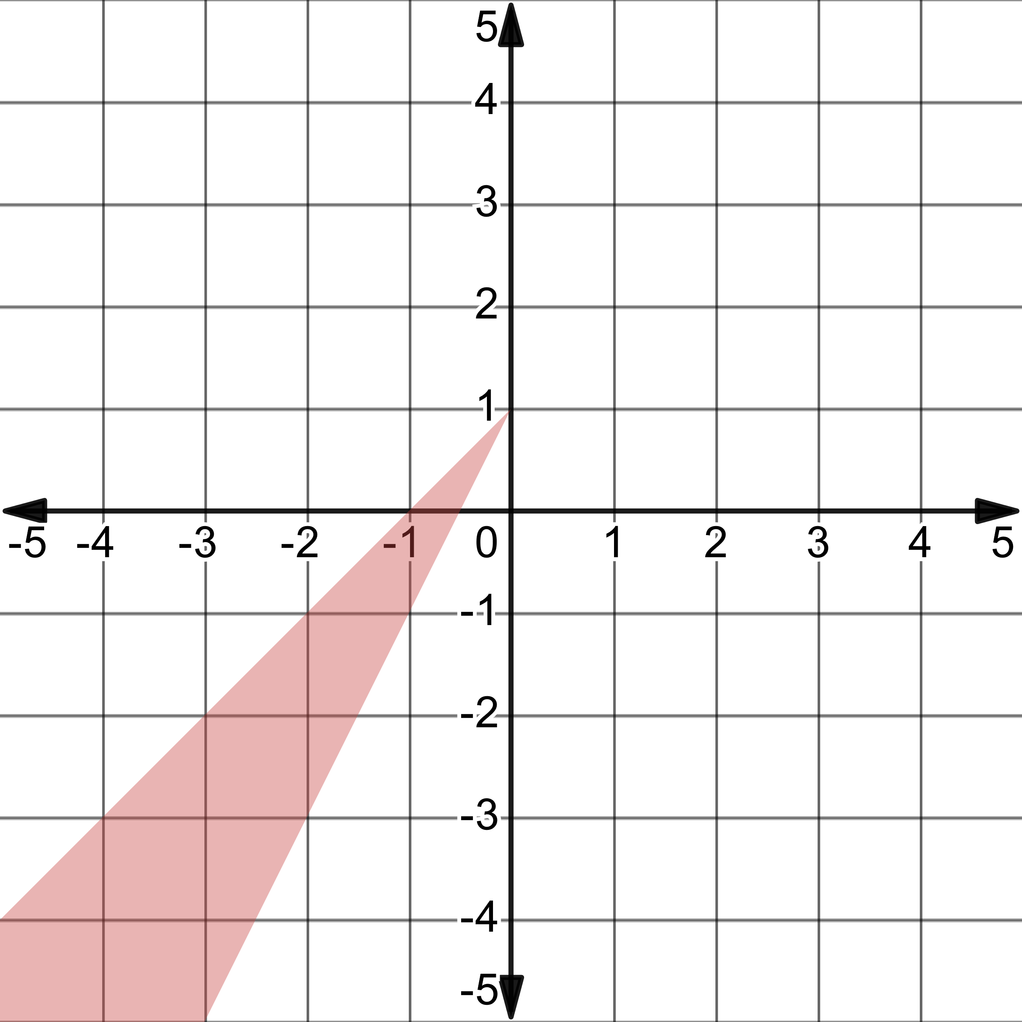
- A, 15 weeks
- C, $44 sq ft$

