0006 Understand relations and functions
- Distinguish between relations and functions using a variety of representations.

Q1. Determine if the following correspondence is a function or a relation.
- The correspondence that assigns the height to a person
- The correspondence that assigns the perimeter of a rectangle to its area
- The correspondence that assigns the GPA to a student

Q2. Determine if the following ordered pairs represents a function.

(0,0), (1,1), (1,-1), (4,2), (4,-2), (9,3), (9,-3), (16,4), (16,-4)

Q3. Determine if the following correspondence is a function or a relation.

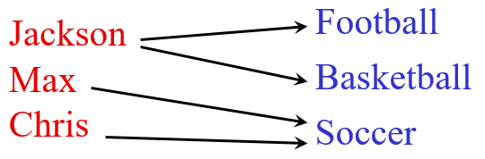

Q4. Determine if the following correspondence is a function or a relation.

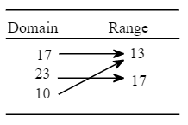

Q5. Determine if the following correspondence is a function or a relation.

- $y=x^{2}-1$
- $y^{2}=x$
- $y=|x+3|$

Q6. Determine if the following graph represents a function or a relation.

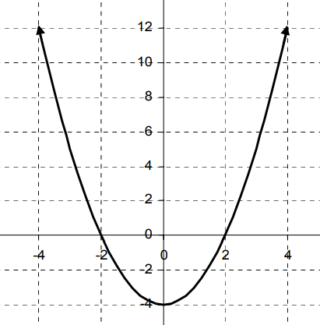

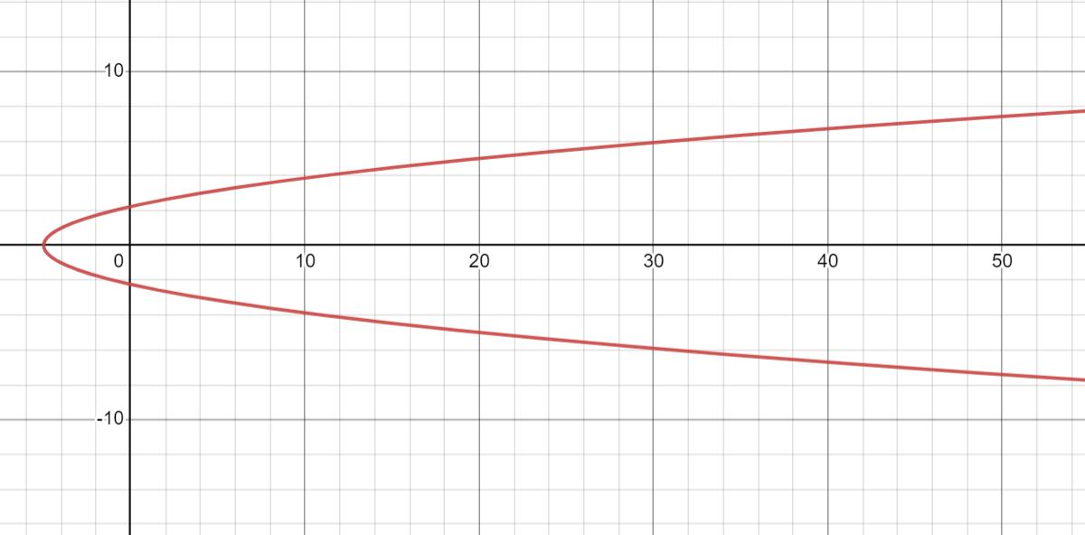

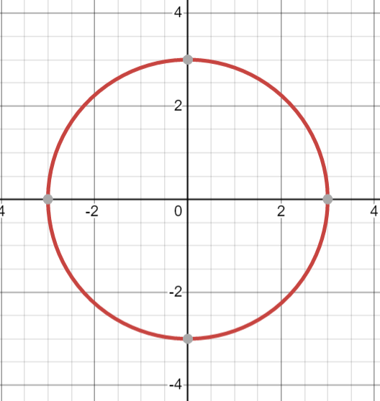

- Analyze various representations (e.g., tabular, algebraic, graphic) of functions with respect to their characteristics (e.g., domain, intercepts, maxima and minima).

Q1. Find the domain of the following function
$$f\left(x\right)= \frac{x+5}{x-5}$$

Q2. Find the domain of the following function
$$f\left(x\right)= \frac{5}{x+6}$$

Q3. Find the domain of the following function
$$f\left(x\right)= \frac{x+5}{(x-5)(x+2)}$$

Q4. Find the domain of the following function
$$f\left(x\right)= \frac{x+5}{x^{2}-x-2 }$$

Q5. Find the domain of the following function
$$f\left(x\right)= \frac{x+5}{{\left(x-8\right)}^{2}}$$

Q6. Find the domain of the following function
$$f\left(x\right)= \frac{x+5}{x^{2}-9}$$

Q7. Find the domain of the following function
$$f\left(x\right)= \frac{2x}{\sqrt{x-1}}$$

Q8. Find the domain and range of the following function
$$f\left(x\right)= \frac{1}{\sqrt{x+3}}$$

Q9. Find the domain and range of the following graph

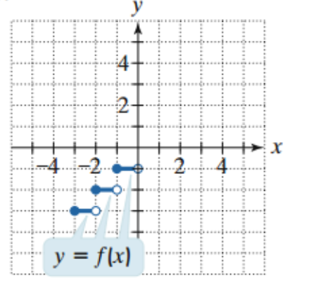

Q10. Find the domain and range of the following graph

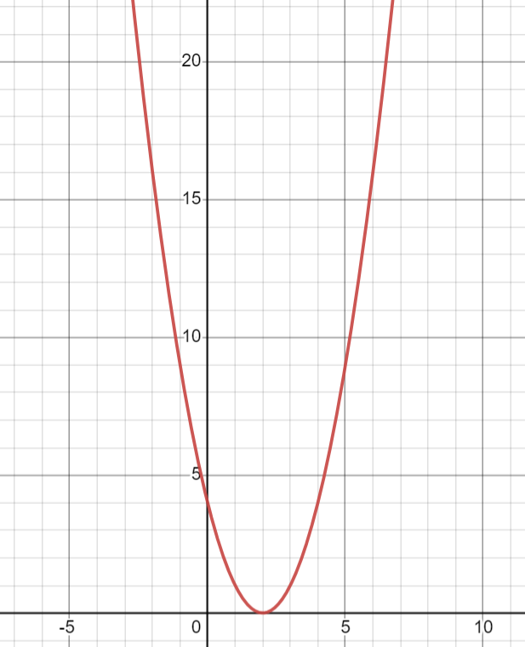

Q11. Find the domain and range of the following graph

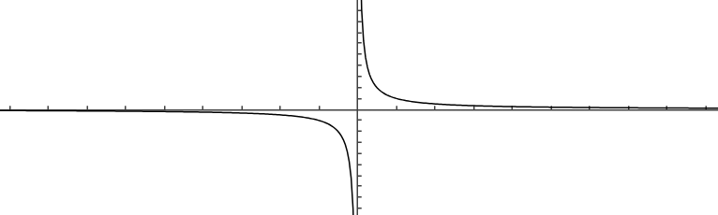

Q12. Find the slope and y-intercept from the following table.

x | y
-2 | 8
0 | 7
2 | 6
4 | 5

Q13. Find the x- and y-intercept from the following table.

x | y
-3 | -10
-2 | 0
-1 | 0
0 | -4
1 | -6
2 | 0

Q14. What is the x-intercept, y-intercept, maxima, and minima of the following graph?
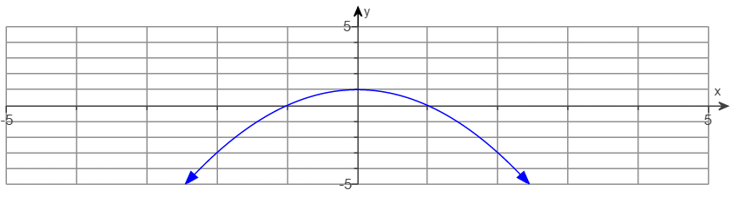

Q15. What is the x-intercept, y-intercept, maxima, and minima of the following graph?
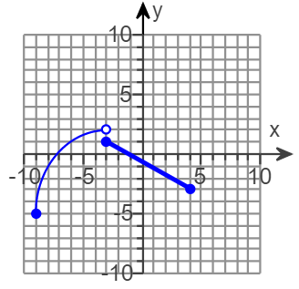

Q16. What is the x-intercept, y-intercept, maxima, and minima of the following graph?

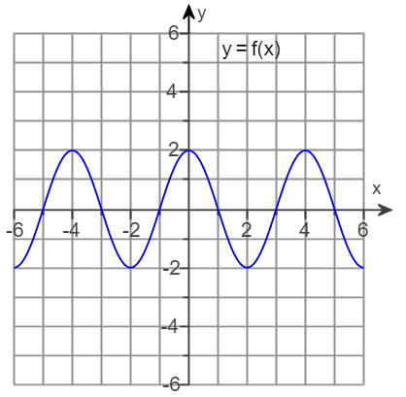

Q17. Find the interval(s) where the following function is increasing.

Q18. Find the interval(s) where the following function is consistent
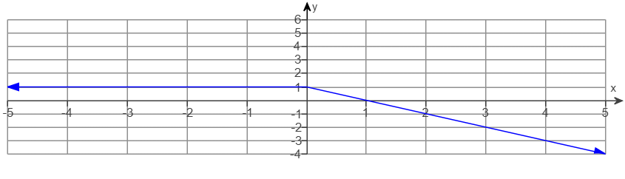

Q19. Which of the following graph is not a function? (These graphs are constructed using desmos graphing calculator)

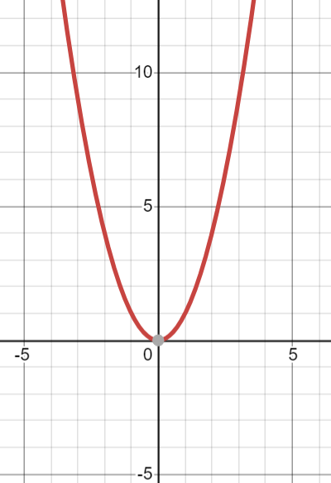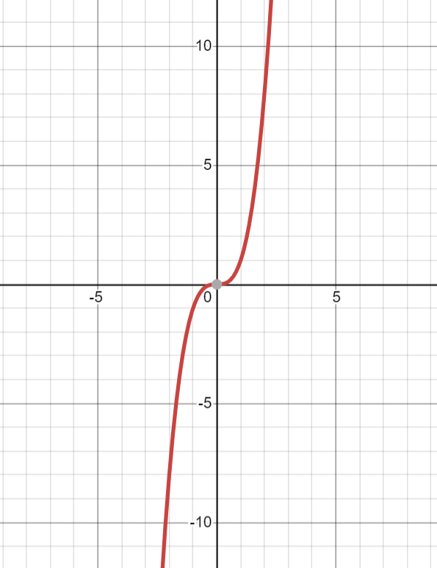
B
A

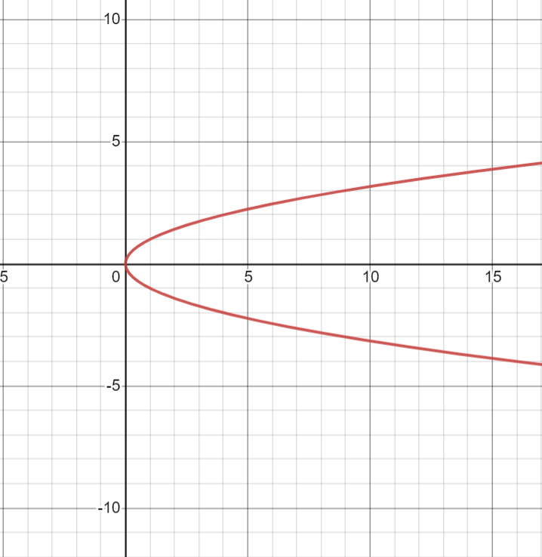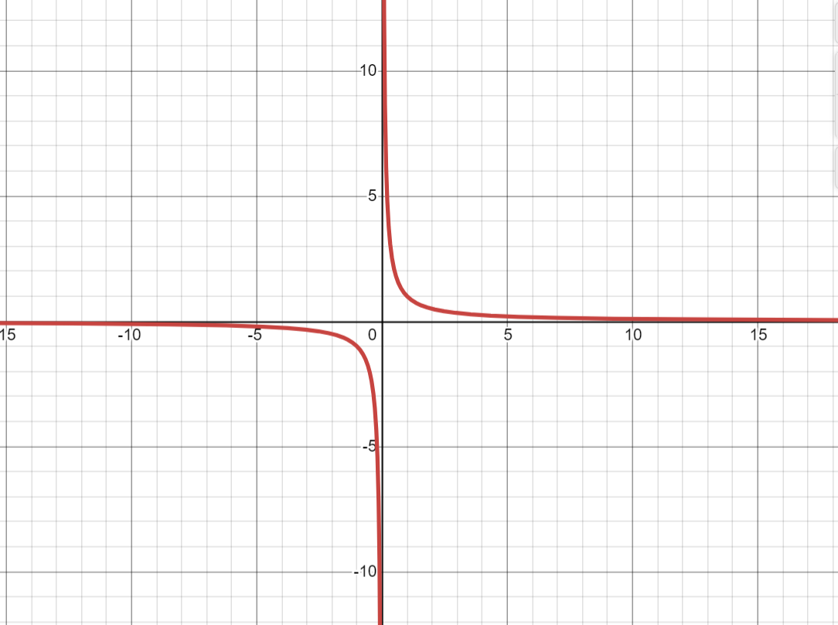
C
D

Q20. Decide if the following function is symmetric with respect to the x-axis, the y-axis, the origin, or none of these.
- $y=x^{2}-5$
- ${(x+1)}^{2}+{\left(y-2\right)}^{2}=9$
- $y=\sqrt{x+8}$
- $m= -2n+5$
- $-3=y^{2}-4x$

Q21. Decide if the following function is even, odd, or none of these.
- $y=x^{3}-5$
- $y=x^{5}+4x^{3}-x$
- $y=x^{6}-x^{4}+x^{2}-1$
- $y= \sqrt{x^{6}-5}$
- $y=x\sqrt{x^{8}+x^{2}}$
- $y=x^{3}-x^{2}$

- Translate between representations of graphs, tables, and real-world situations or equations.

Q1. At a certain time of a sunny day, a 68-inch tall person will have a shadow of 50 inches. What will be the length of a tree next to this person, if the shadow of the tree is 70 inches?

Q2. A recipe for chocolate chip muffins makes 2 dozen muffins, with 375 calories per muffin. You instead decide to make mini-muffins, and the same recipe will make 40 mini-muffins. If you eat 4 mini-muffins, how many calories will you consume?

Q3. Antonio is planning a birthday party for his daughter. SkateWorld charges a flat fee of $50 plus $3 per child. Roller Land charges $5 per child. If Antonio's daughter wants to invite 21 friends from school and five friends from her basketball team, which rink should Antonio use and how much would he save by doing so?

Q4. The table below shows the cost of gasoline in a certain gas station. What is the average rate of change in those 5 days? How would you interpret your answer?

Day | Price
1 | $$\$5.29$$
2 | $$\$5.34$$
3 | $$\$5.46$$
4 | $$\$5.43$$
5 | $$\$5.52$$

Q5. The table below shows the cost of gasoline in a certain gas station. What is the average rate of change in those 7 days? How would you interpret your answer?

Day | Price
1 | $$\$5.29$$
2 | $$\$5.34$$
3 | $$\$5.46$$
4 | $$\$5.43$$
5 | $$\$5.52$$
6 | $$\$5.39$$
7 | $$\$5.22$$

Q6. The table below shows the cost of gasoline in a certain gas station. What is the average rate of change in those 5 days? How would you interpret your answer?

Day | Price
1 | $$\$5.29$$
2 | $$\$5.34$$
3 | $$\$5.46$$
4 | $$\$5.43$$
5 | $$\$5.29$$

Q7. Use the graph below to answer these questions.
- Which day has the highest temperate?
- What is the range of the temperate?
- What is the average rate of change from Tuesday to Saturday?
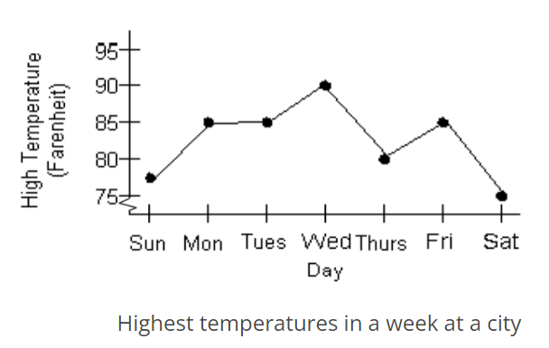

Q8. The graph below shows the percentage of a country’s adults on weight-loss diets.
- Find an equation that best describes the graph below
- What is the percentage on diets (%) in 2007?
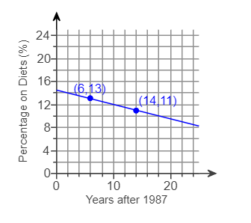

Q9. The graph below shows the test score from a class. How many students got higher than 80?

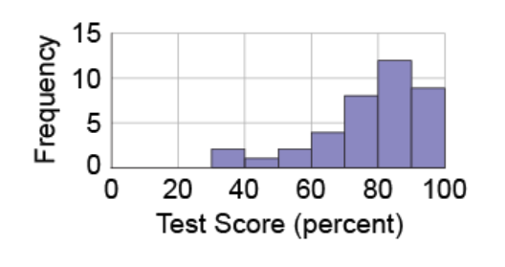

Q10. The graph below shows the income of the families of the students in a statistics class. How many families have a lower than $\$40,000$ income?

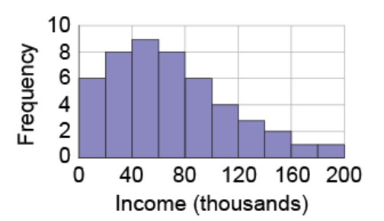

Q11. The graph below shows the total number of employees working at Renee’s company over time. How many employees did Renee hire from month 2 to month 4?

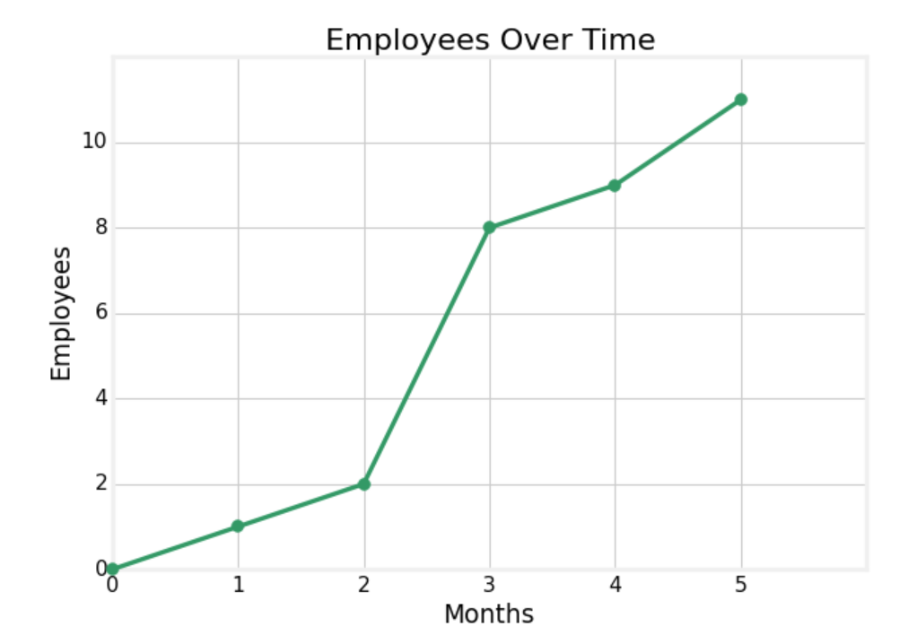

Q12. The graph below shows the total amount of money Julie has saved over time. At what month did Julie’s savings reach $\$2300$?

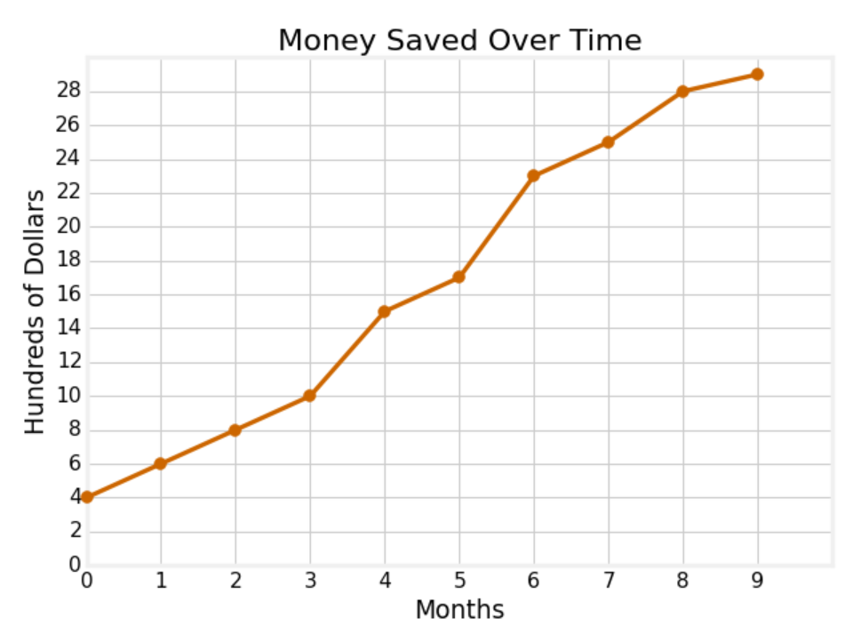

Q13. The target heart rate for an 18-year-old is 165 beats per minute and is 135 beats per minute for a 50-year-old. Assume the relationship between age and target heart rate is linear. Find an equation for this relationship and what is the target heart rate for a 60-year-old?

Q14. The perimeter of a rectangle with length L and width W is $P=2L+2W$. Find the perimeter if the length is 10 cm and the width is 8 cm.

Q15. The area of a circle with radius r is $A= πr^{2}$. Find the area if the radius of a circle is 5 cm.

Q16. The area of an equilateral triangle with side S is $A= \frac{{\sqrt{3}S}^{2}}{4}$. Find the area if the side of an equilateral triangle is 2 cm.

- Identify the effects of transformations such as f(x + k), f(x) + k, and k(f(x)) on the graph of a function.

Q1. The graph of $f\left(x\right)=5x+2$ is shown below, use transformation rules to find
- The graph of $y=5x-3$
- The graph of $y= -5x+2$
- The graph of $y=5(x-4)+2$
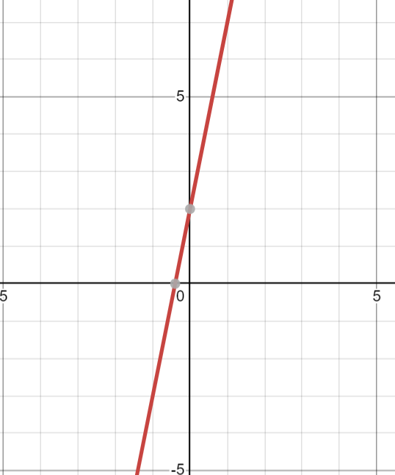

Q2. State what are the needed transformations to graph $h\left(x\right)=2{\left(x+4\right)}^{2}+2$ using $f\left(x\right)=x^{2}$

Q3. State what are the needed transformations to graph $h\left(x\right)=2{\left(x-4\right)}^{2}-2$ using $f\left(x\right)=x^{2}$

Q4. State what are the needed transformations to graph $h\left(x\right)=\frac{1}{2}{\left(x-4\right)}^{2}+2$ using $f\left(x\right)=x^{2}$

Q5. State what are the needed transformations to graph $h\left(x\right)=-2{\left(x-4\right)}^{2}+2$ using $f\left(x\right)=x^{2}$

Q6. The graph for $f\left(x\right)=x^{2}$ is shown below. Use transformation rules to find
- The graph of $h\left(x\right)=x^{2}+2$
- The graph of $h\left(x\right)=x^{2}-3$
- The graph of $h\left(x\right)={(x+2)}^{2}$
- The graph of $h\left(x\right)={4x}^{2}$
- The graph of $h\left(x\right)= -x^{2}$
- The graph of $h\left(x\right)={4(x+2)}^{2}-3$

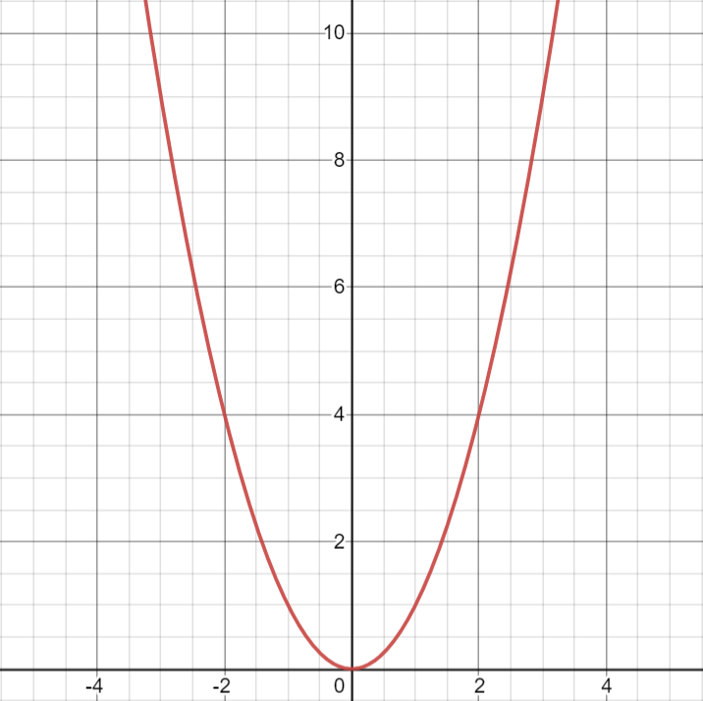

Q7. The following graph is a transformation from $y= \sqrt{x}$. Write an equation for this graph.

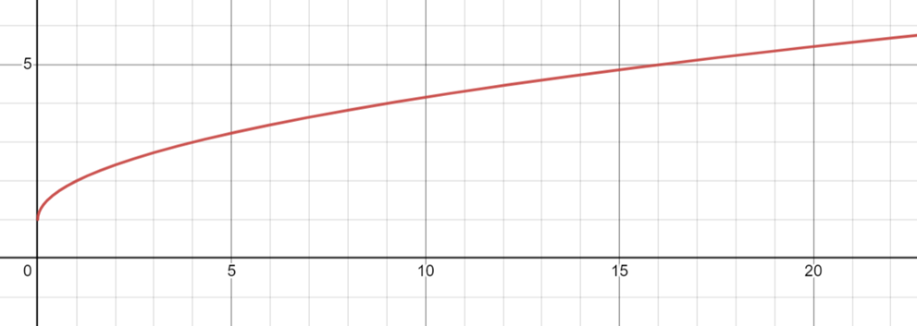

Q8. The following graph is a transformation from $y= \sqrt{x}$. Write an equation for this graph.
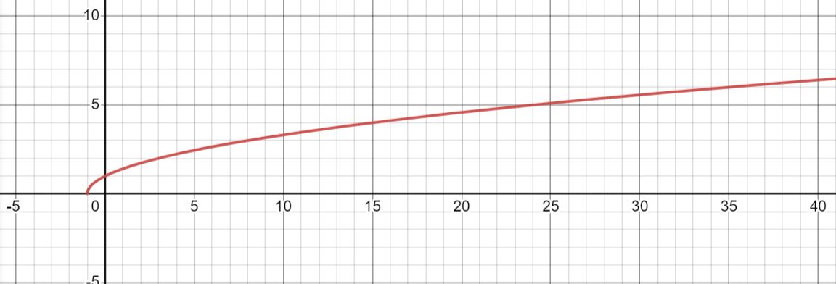

Q9. The graph on the right side, $h(x)$, is a transformation based on the graph on the left side, $f(x)$. Given the original function is $f(x)=x^{2}$, find $h(x)$.

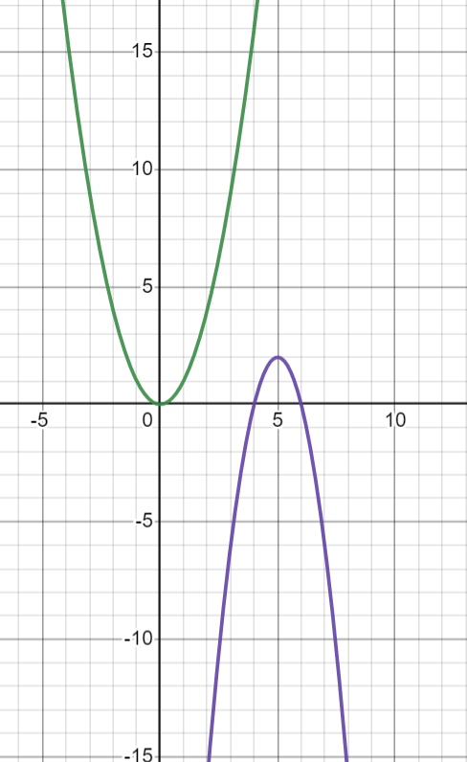
- Identify patterns of change in proportional, linear, inversely proportional, quadratic, and exponential functions and the types of real-world relationships that these functions can model.

Q1. Determine if the table below represents a proportional, linear, inversely proportional, quadratic, or exponential function.
x | y
-2 | 4
-1 | 7
0 | 10
1 | 13
2 | 16

Q2. Determine if the table below represents a proportional, linear, inversely proportional, quadratic, or exponential function.
x | y
1 | 1
2 | 0.5
3 | $$0.\overline{3}$$
4 | 0.25
5 | 0.2

Q3. Determine if the table below represents a proportional, linear, inversely proportional, quadratic, or exponential function.
x | y
1 | 5
2 | 10
3 | 15
4 | 20
5 | 25

Q4. Determine if the table below represents a proportional, linear, inversely proportional, quadratic, or exponential function.

x | y
5 | 11
6 | 15
7 | 25
8 | 41
9 | 63

Q5. Determine if the table below represents a proportional, linear, inversely proportional, quadratic, or exponential function.

x | y
-2 | -0.25
-1 | -0.5
0 | -1
1 | -2
2 | -4

Q6. Find a linear function that best describes the table below.

x | y
1 | -3
2 | -8
3 | -13
4 | -18

Q7. The sum of two numbers is 8. Let $y$ represent the product of these two numbers, find an equation to model the product, and what is the greatest product?

Q8. Lori has a rectangular yard and she plans to use 24 yards of fencing to cover three sides of her yard, the remaining side will be the longer side of her yard and is attached to her house. Find a function that models the area of Lori’s yard, and what is the greatest area possible for her yard?

Q9. Josh deposited $\$1000$ in his bank account. His account pays $2\%$ compound interest monthly. How much interest will he receive in 2 years?

Q10. Josh deposited $\$1000$ in his bank account. His account pays $2\%$ continuous compound interest. How much interest will he receive in 2 years?

Q11. Use the data in the table below to describe how the population changes in a certain region. Then write a function that models the data and use the function to predict the population in 2030.
Year(since 2000) | Population (in thousands)
0 | 20
1 | 24
2 | 28.8
3 | 34.56
4 | 41.472

- Identify expressions, equations, or functions that model specific situations.

Q1. The following figure shows a row of 5 toothpick houses.

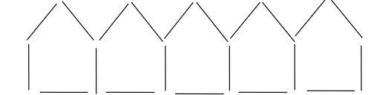
- How many toothpicks will be required to build a row of 20 such toothpick houses?
- How many such toothpick houses can be built, if 200 toothpicks are available?
- Write an algebraic expression for the number of toothpicks required to build a row of $n$ such toothpick houses.

Q2. Joel spends ½ of his monthly income on food and rent, ¼ of his income on clothing and 1/12 on entertainment. He saves the rest, which is $500. What is his monthly income?

Q3. Arthur can paint a wall in 3 hours and Chris can paint the same wall in 2 hours. If they work together, how long does it take to paint the wall?

Q4. A cookie recipe calls for 2 cups of flour. The only measuring cup Ramon has is ¾ cup. Write an expression to show how many of the ¾ measuring cup he needs.

Q5. Maarten had a basket of eggs. He gave half of them to his father. Then his friend took two to make some cookies. After that, he gave 1/3 of what was left to his neighbor. Assume he started with $x$ eggs. Write an expression to show how many eggs he gave to his neighbor.

Q6. Maarten had a basket of eggs. He gave half of them to his father. Then his friend took two to make some cookies. After that, he gave 1/3 of what was left to his neighbor and then he made an omelet with four eggs. If he was then left with a half dozen eggs, how many eggs did he start with?

