0006 Understand relations and functions
- Distinguish between relations and functions using a variety of representations.
Q1. 1. Function 2. Relation 3. Function
Q2. No, it’s not a function
Q3. Relation
Q4. Function
Q5. 1. Function 2. Relation 3. Function
Q6. 1. Function 2. Relation 3. Relation

- Analyze various representations (e.g., tabular, algebraic, graphic) of functions with respect to their characteristics (e.g., domain, intercepts, maxima and minima).
Q1. $x≠5$
Q2. $x≠-6$
Q3.$x≠5$ and $x≠-2$
Q4.$x≠2$ and $x≠-1$
Q5.$x≠8$
Q6.$x≠3$ and $x≠-3$
Q7.$x>1$
Q8. $x>-3$
Q9. Domain: $-3≤x<0$, range: $\{-3, -2, -1\}$
Q10. Domain: $(-∞, ∞)$, range: $[0,∞)$
Q11. Domain: $(-∞,0)∪(0,∞)$, range: $(-∞,0)∪(0,∞)$
Q12. Slope: $-\frac{1}{2}$, y-intercept: 7
Q13. x-int: -2, -1, 2, y-int: -4
Q14. x-int: -1, 1, y-int: 1, max: y = 1, no minimum as the function is going to negative infinity
Q15. x-int: -7, -1, y-int: -1, no maximum as the function is approaching but never reaching to 1, min: y = -5
Q16. x-int: -5, -3, -1, 1, 3, 5 y-int: 2, max: y = 2, min: y = -2
Q17. Increasing: $[-10, -3)$, decreasing: $[-3, 4]$
Q18. The function is consistent on $(-∞,0)$
Q19. C
Q20. 1. y-axis 2. None 3. None 4. None 5. x-axis
Q21. 1. None 2. Odd 3. None 4. Even 5. Odd 6. None

- Translate between representations of graphs, tables, and real-world situations or equations.
Q1. 51.47 inches
Q2. 1350 calories
Q3. He should use SkateWorld and he will save $4.
Q4. $0.046 per day, on average, the price goes up by $0.046 per day in those 5 days
Q5. -$0.01 per day, on average, the price goes down by $0.01 per day in those 7 days
Q6. $0 per day, on average, the price stays the same in those 7 days
Q7. 1. Wednesday 2. $15℉$ 3. $-2.5℉ per day$
Q8. 1. $y= -\frac{1}{4}x+\frac{29}{2}$ 2. 9.5%
Q9. 21
Q10. 14
Q11. 7
Q12. Month 6
Q13. $y= -\frac{15}{16}x+\frac{1455}{8}$, 126 (round up from 125.625)
Q14. 36
Q15. $25π$
Q16. $\sqrt{3}$

- Identify the effects of transformations such as f(x + k), f(x) + k, and k(f(x)) on the graph of a function.
Q1. 1. Shift the graph 5 units down 2. Reflect the graph w.r.t. y-axis 3. shift the graph 4 units to the right

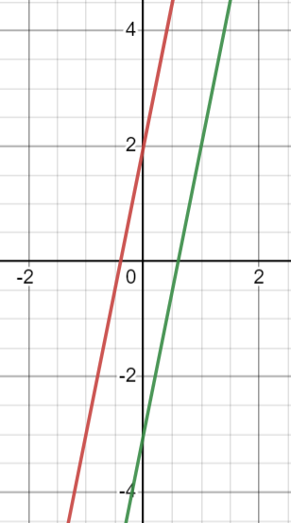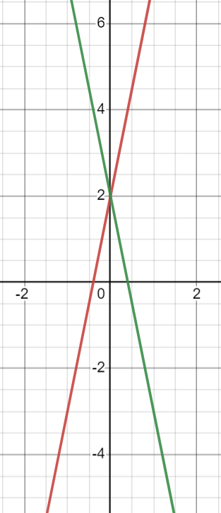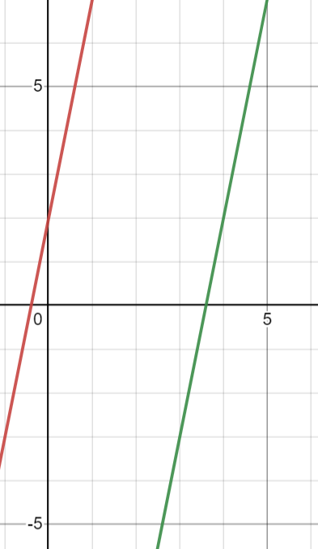

Q2. Firstly, shift the graph 4 units to the left; secondly, stretch the graph vertically by a factor of 2; lastly, shift the graph 2 units up.
Q3. Firstly, shift the graph 4 units to the right; secondly, stretch the graph vertically by a factor of 2; lastly, shift the graph 2 units down.
Q4. Firstly, shift the graph 4 units to the right; secondly, shrink the graph vertically by a factor of 1/2; lastly, shift the graph 2 units up.
Q5. Firstly, shift the graph 4 units to the right; secondly, stretch the graph vertically by a factor of 2; thirdly, reflect the graph w.r.t. the x-axis; lastly, shift the graph 2 units up.

Q6. The purple graph is the answer
1. 2.
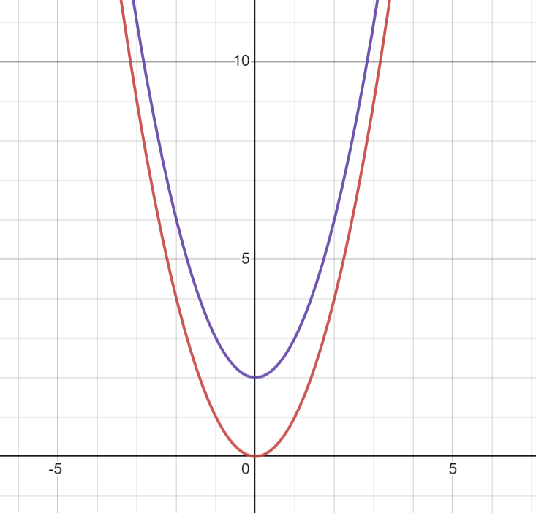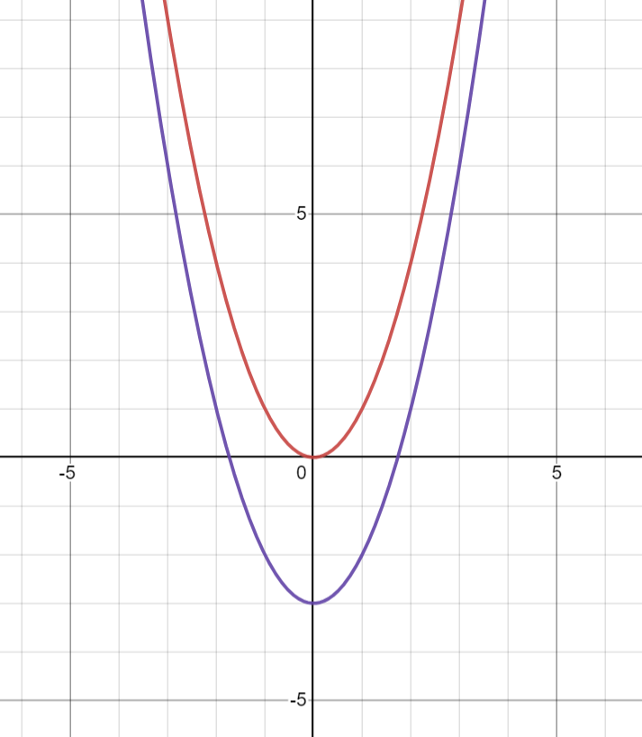

3. 4.
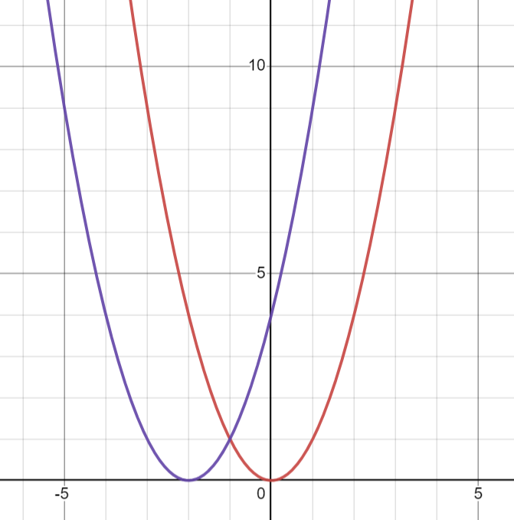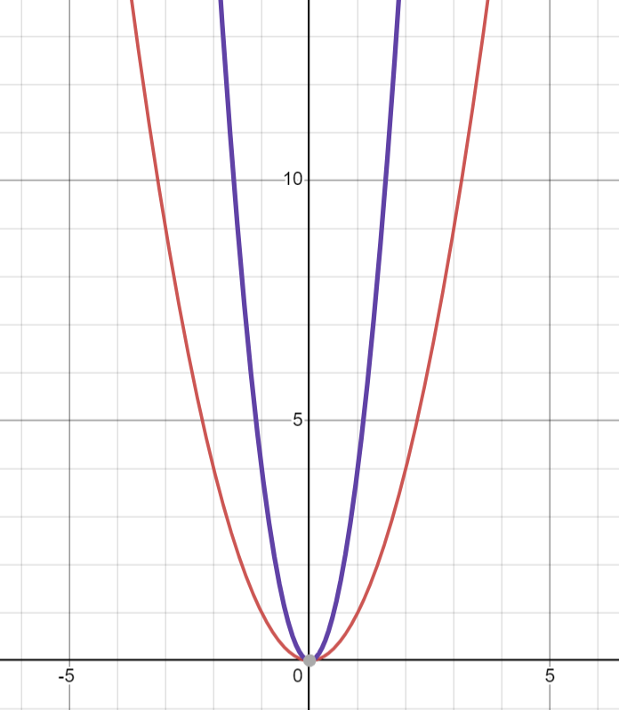

5. 6.
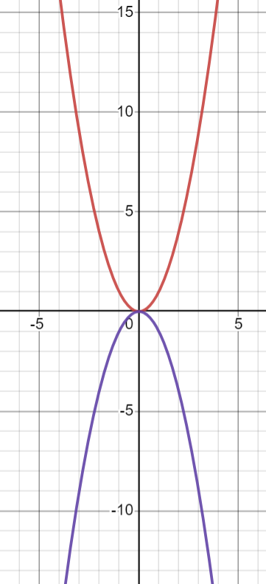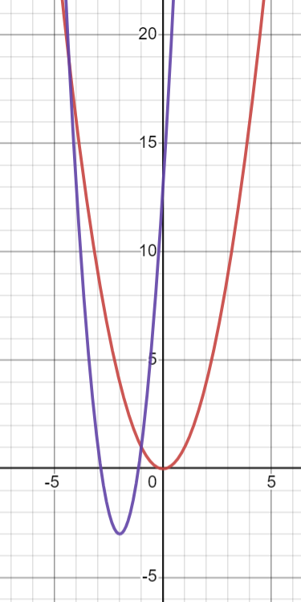

Q7. $y=\sqrt{x}+1$
Q8.$y=\sqrt{x+1}$
Q9.$y={-2(x-5)}^{2}+2$

- Identify patterns of change in proportional, linear, inversely proportional, quadratic, and exponential functions and the types of real-world relationships that these functions can model.
Q1. Linear
Q2. Inversely proportional
Q3. Proportional
Q4. Quadratic
Q5. Exponential
Q6. $y=-5x+2$
Q7. $y= x(8-x)$, the maximum is 16
Q8. $A=(24-2w)∙w$, the maximum is 72
Q9. $I=A-P=P{\left(1+\frac{r}{n}\right)}^{nt}-P=1000{\left(1+\frac{0.02}{12}\right)}^{12\left(2\right)}-1000=40.78$
Q10. $I=A-P=Pe^{rt}-P=1000e^{0.02\left(2\right)}-1000=40.81$
Q11. $y=y_{0}k^{x}=20{\left(1.2\right)}^{x}$ and $y\left(30\right)=20{\left(1.2\right)}^{30}=4747.526$

- Identify expressions, equations, or functions that model specific situations.
Q1. (a)20 (b)49 (c)5+4(n-1)
Q2. $\frac{1}{2}x+\frac{1}{4}x+\frac{1}{12}x+500=x$ x = 3000
Q3. $\frac{1}{\frac{1}{3}+\frac{1}{2}}=\frac{6}{5}=1.2$ hours
Q4. $\frac{2}{\frac{3}{4}}$
Q5. $\frac{1}{3}(x-\frac{1}{2}x-2)$
Q6. $x-\frac{1}{2}x-2-\frac{1}{3}\left(x-\frac{1}{2}x-2\right)-4=6$ x = 34

