0003 Understand ratios and proportional relationships
- Represent fractions and arithmetic operations on fractions using a variety of models (e.g., number lines, area models, diagrams).

Q1. Use the diagram below to answer the question that follows.
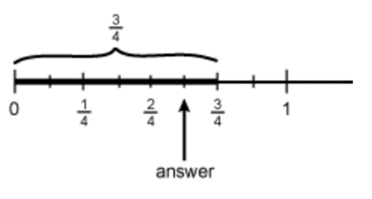
The number line shows the best models for which of the following fraction computation problem? (This question is from ILTS study guide, http://www.il.nesinc.com/Content/STUDYGUIDE/IL_SG_SRI_202.htm#obj3)
- $\frac{5}{6}×\frac{3}{4}$
- $\frac{3}{4}-\frac{5}{8}$
- $\frac{5}{8}÷\frac{1}{8}$
- $\frac{3}{4}-\frac{5}{6}$

Q2. The number line below shows the best model for which of the following fraction computation problem?
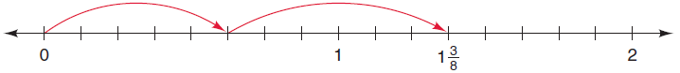
- $\frac{5}{8}×\frac{6}{8}$
- $\frac{5}{8}-\frac{6}{8}$
- $\frac{5}{8}÷\frac{6}{8}$
- $\frac{5}{8}+\frac{6}{8}$

Q3. The number line below shows the best model for which of the following fraction computation problem?

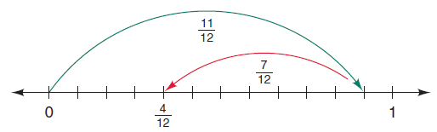
- $\frac{11}{12}×\frac{7}{12}$
- $\frac{11}{12}-\frac{7}{12}$
- $\frac{11}{12}÷\frac{7}{12}$
- $\frac{11}{12}+\frac{7}{12}$

Q4. Construct an area model to compare $\frac{3}{4}$ and $\frac{2}{5}$

Q5. The fraction bar model below shows the best model for which of the following fraction computation problem?
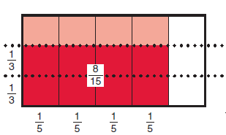
- $\frac{1}{3}×\frac{1}{5}$
- $\frac{2}{3}×\frac{4}{5}$
- $\frac{1}{3}÷\frac{1}{5}$
- $\frac{2}{3}÷\frac{4}{5}$

Q6. Use the fraction model bar provided below to perform the operation, $\frac{2}{5}+\frac{1}{3}$
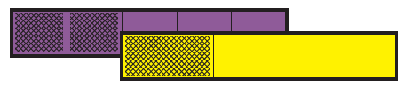

Q7. Construct an area model to perform the operation, $\frac{1}{2}-\frac{1}{6}$

Q8. Use the following diagram to perform the operation, $\frac{1}{3}×15$


Q9. Construct an area model to perform the operation, $\frac{4}{5}÷\frac{2}{3}$

- Apply properties of number operations to perform operational procedures with fractions, including the use of equivalent fractions.

Q1. Which property does the following diagram illustrate?
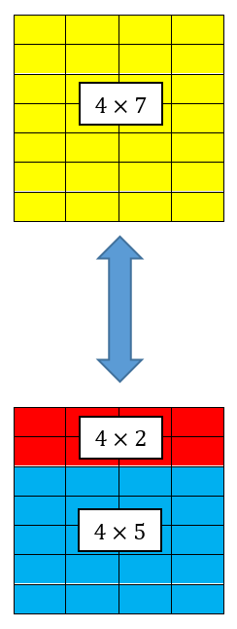
A. Commutative Property
B. Associative Property
C. Distributive Property
D. Identity Property

Q2. Are these two fractions equivalent, $\frac{22}{30}$ and $\frac{16}{20}$ ?

Q3. Use the commutative property to evaluate the following expression, $\frac{2}{3}+ \frac{5}{9}+\frac{4}{9}-\frac{1}{3}+2$

Q4. Use the commutative property to evaluate the following expression, $\frac{1}{2}×\frac{5}{9}×\frac{2}{3}×\frac{11}{5}$

Q5. Simplify the following expression, $\frac{1}{2}+(x-\frac{1}{3}+y)$

Q6. Use the distributive property to evaluate the following expression, $210×(\frac{1}{2}+\frac{2}{3}-\frac{3}{5}+\frac{6}{7})$

Q7. Evaluate the following expression, $\frac{1}{2}×\frac{5}{9}-\frac{3}{5}×\frac{7}{4}+\frac{2}{3}×\frac{11}{6}$

Q8. Evaluate the following expression, $\frac{1}{2}÷\frac{4}{9}-\frac{3}{2}÷\frac{4}{7}+\frac{3}{8}×\frac{22}{3}$

Q9. Evaluate the following expression, ${\left(\frac{3}{4}-\frac{13}{12}\right)}^{2}-{\left(\frac{1}{2}\right)}^{3}$

- Solve problems using fractions, ratios, rates, and proportional relationships.

Q1. Linda uses 1/2 of her monthly income for rent and other fees, 1/4 for grocery and 1/12 for entertainment. By the end of the month, she has $300 left. What is her monthly income?

Q2. A 15 feet tall tree can cast a shadow of 12 feet, at the same time, a person is standing right next to the tree. His height is 6 feet, how long will his shadow be?

Q3. It takes Josh 3 hours to paint a wall and it takes Matt 5 hours to paint the same wall. If they work together, how long will it take to paint the wall?

Q4. Jason is making a gallon of lemonade. The recipe requires 5 cups of sugar. However, Jason only has ¾ measuring cup. How many of the ¾ measuring cups does Jason need to measure 5 cups of sugar?

Q5. The difference of two numbers is $\frac{7}{5}$. If one number is $\frac{3}{4}$, what are the two possibilities for the other number?

Q6. A pie chart shows that $\frac{2}{5}$ of the students from a certain school prefer online learning. If the school has 300 students, how many students prefer online learning?

Q7. Jason’s lemonade recipe requires $1\frac{3}{4}$ cups sugar, 8 cups water, $1\frac{1}{5}$ cups lemon juice. How much lemonade can his recipe produce?

Q8. Property taxes in a particular community are calculated on an amount equal to 70% of the market value of the property. In this community, the tax rate for this year is $30 per $1,000 of taxable value. If a homeowner's property tax bill is $5,250, what is the market value of the home? (This question is from ILTS study guide, http://www.il.nesinc.com/Content/STUDYGUIDE/IL_SG_SRI_202.htm#obj3)
- Represent how quantities vary together in a proportional relationship, using tables, double number lines, and tape diagrams.

Q1. The diagrams below show the relationships on sugar, water and lemon juice needed to make lemonade. If you wish to use 5 cups of water, how much lemon juice do you need?

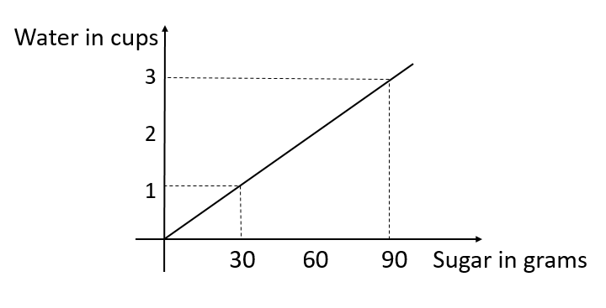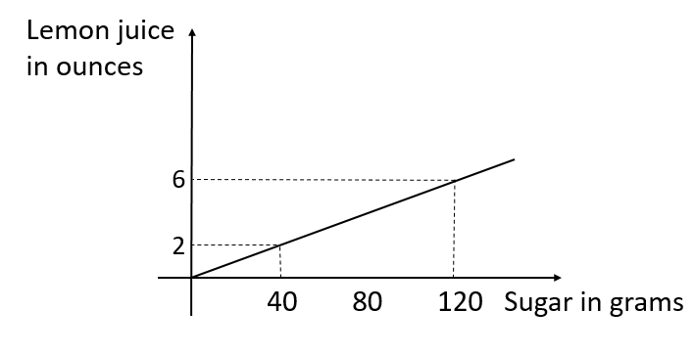

Q2. The table below shows the proportional relationship between gallons of gas and the total price. What is the constant of variation, $k$?
Gallons of gas | Price
1 | $4.99
2 | $9.98
3 | $14.97
4 | $19.96
5 | $24.95

Q3. The table below shows the proportional relationship between gallons of gas and the total price. What is the proportional function? Use $x$ for the gallons of gas and $y$ for the total price.
Gallons of gas | Price
1 | $4.99
2 | $9.98
3 | $14.97
4 | $19.96
5 | $24.95

Q4. The table below shows the proportional relationship between gallons of gas and the total price. Find the missing value $a$.
Gallons of gas | Price
1 | $4.99
2 | $9.98
3 | $14.97
4 | $19.96
5 | $24.95
… | …
$$a$$ | $39.92

Q5. It takes Ramon 3 hours to paint 2 walls. Assume he paints with a constant speed, complete the double number lines diagram below and find how long it takes to paint 10 walls.
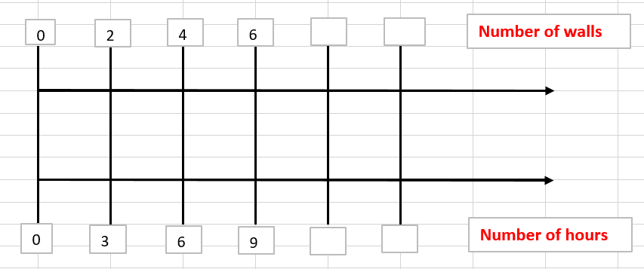

Q6. Use the double number lines diagram below to find a proportional function. Use $x$ for number of walls and $y$ for number of hours.
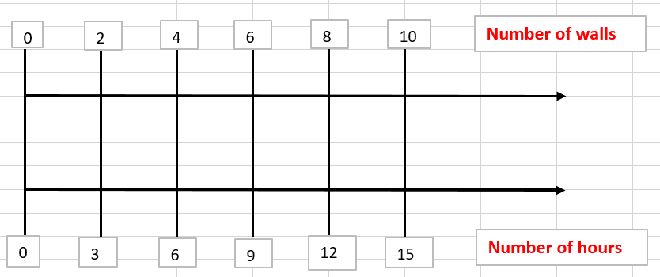

Q7. The tape diagram below shows the ratio of green and red paint in a certain mixture. Use the tape diagram to complete the table below.
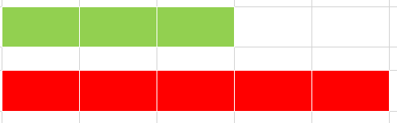
Green Paint | Red Paint
3 | 5
9 | ?
? | 30

Q8. The tape diagram below shows the ratio of green and red paint in a certain mixture. Based on the ratio, how much green paint is needed, if you plan to use 45 red paint?

- Analyze the relationships between fractions, terminating decimals, and nonterminating decimals.

Q1. Which of the following number is irrational?
A. $\frac{2}{3}$
B. $\sqrt{4}$
C.$\sqrt{5}$
D. $11.5$

Q2. Convert $2.3$ to a fraction.

Q3. Convert $2.3\overline{6}$ to a fraction.

Q4. Convert $2.\overline{12}$ to a fraction.

Q5. Convert $0.\overline{123}$ to a fraction.

Q6. Convert $\frac{1}{11}$ to a decimal and decide whether it’s terminating or nonterminating.

Q7. Convert $\frac{5}{8}$ to a decimal and decide whether it’s terminating or nonterminating

- Select or analyze instructional and assessment activities, methods, or strategies that use appropriate instructional materials or technology and allow students to develop understanding of mathematical practices, concepts, and skills. (SKIPPED)

