0003 Understand ratios and proportional relationships.
- Represent fractions and arithmetic operations on fractions using a variety of models (e.g., number lines, area models, diagrams).
Q1 A
Q2 D
Q3 B
Q4
X | X
X | X
X | X
X | X

X represents $\frac{2}{5}$ and the shaded area represents $\frac{3}{4}$.
Hence, $\frac{3}{4}$ is larger, as it has 7 more extra blocks compared to $\frac{2}{5}$.
Q5 B
Q6
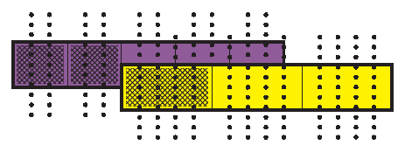
$$\frac{6}{15}+\frac{5}{15}=\frac{11}{15}$$
Q7
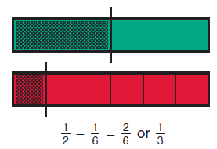

Q8
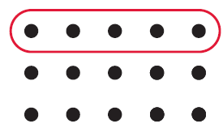
$$\frac{1}{3}×15=5$$
Q9
$$\frac{4}{5}$$
$$\frac{2}{3}$$
X | X | X | X | X
X | X | X | X | X

There is one group of $\frac{2}{3}$ inside of $\frac{4}{5}$, with a reminder of $\frac{2}{10}$, or $\frac{1}{5}$.

- Apply properties of number operations to perform operational procedures with fractions, including the use of equivalent fractions.
Q1 C
Q2 no
Q3 $3\frac{1}{3}$ or $\frac{10}{3}$
Q4 $\frac{11}{27}$
Q5 $\frac{1}{6}+x+y$
Q6 299
Q7 $\frac{9}{20}$
Q8 $\frac{5}{4}$
Q9 $\frac{1}{72}$

- Solve problems using fractions, ratios, rates, and proportional relationships.
Q1 $1800
Q2 4.8 feet
Q3 $\frac{15}{8}$ hours, or 1.875 hours
Q4 $6\frac{2}{3}$ times, or 6.67 times
Q5 $\frac{43}{20}$ and $-\frac{13}{20}$, or 2.15 and -0.65
Q6 120
Q7 $10\frac{19}{20}$ cups, or 10.95 cups
Q8 $250,000

- Represent how quantities vary together in a proportional relationship, using tables, double number lines, and tape diagrams.
Q1 7.5 ounces lemon juice
Q2 $4.99
Q3 $y=4.99x$
Q4 $a=8$
Q5
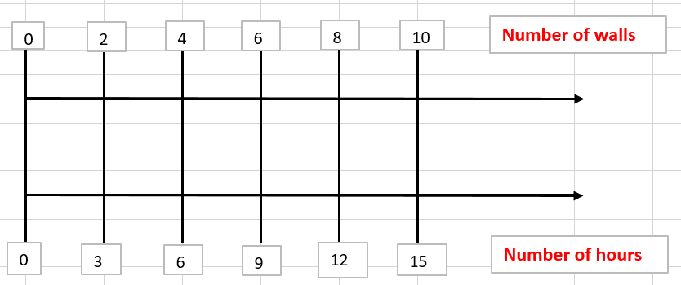
It takes Ramon 15 hours to paint 10 walls.
Q6 $y=1.5x$
Q7
Green Paint | Red Paint
3 | 5
9 | 15
18 | 30

Q8 27

- Analyze the relationships between fractions, terminating decimals, and nonterminating decimals.
Q1 C
Q2 $\frac{23}{10}$
Q3 $\frac{71}{30}$
Q4 $\frac{70}{33}$
Q5 $\frac{123}{999}$
Q6 $0.\overline{09}$, nonterminating
Q7 $0.625$, terminating

