0002 Understand college statistics
- Construct, identify, or interpret frequency distributions, histograms, box plots, and cumulative frequency tables and associated graphs.

Q1. A survey asked 25 people how many times they go to the gym per week, and the result is shown below. Construct a frequency table and a cumulative frequency table for the following data set.
2 2 2 2 2 2 3 3 3 3 4 4 4 4 4 5 5 5 5 5 5 7 7 7 7

Q2. A survey asked 25 people how many times they go to the gym per week, and the result is shown below. How many people go to the gym exactly 5 times per week?
Value | Frequency
2 | 8
3 | 3
4 | 2
5 | 7
7 | 5

Q3. A survey asked 25 people how many times they go to the gym per week, and the result is shown below. How many people go to the gym exactly 5 times per week?
Value | Cumulative Frequency
2 | 8
3 | 11
4 | 13
5 | 22
7 | 25

Q4. A survey asked 25 people how many times they go to the gym per week, and the result is shown below. How many people go to the gym at most 5 times per week?
Value | Frequency
2 | 8
3 | 3
4 | 2
5 | 7
7 | 5

Q5. A survey asked 25 people how many times they go to the gym per week, and the result is shown below. How many people go to the gym at most 5 times per week?
Value | Cumulative Frequency
2 | 8
3 | 11
4 | 13
5 | 22
7 | 25

Q6. A survey asked 25 people how many times they go to the gym per week, and the result is shown below. How many people go to the gym at least 5 times per week?
Value | Frequency
2 | 8
3 | 3
4 | 2
5 | 7
7 | 5

Q7. A survey asked 25 people how many times they go to the gym per week, and the result is shown below. How many people go to the gym at least 5 times per week?
Value | Cumulative Frequency
2 | 8
3 | 11
4 | 13
5 | 22
7 | 25

Q8. A survey asked 25 people how many times they go to the gym per week, and the result is shown below. How many people go to the gym 4 or 5 times per week?
Value | Frequency
2 | 8
3 | 3
4 | 2
5 | 7
7 | 5

Q9. A survey asked 25 people how many times they go to the gym per week, and the result is shown below. How many people go to the gym 4 or 5 times per week?
Value | Cumulative Frequency
2 | 8
3 | 11
4 | 13
5 | 22
7 | 25

Q10. A survey asked 25 people how many times they go to the gym per week, and the result is shown below. What proportion of people go to the gym 2 or 3 times per week?
Value | Frequency
2 | 8
3 | 3
4 | 2
5 | 7
7 | 5

Q11. Construct a histogram for the following data set.
2 2 2 2 2 2 3 3 3 3 4 4 4 4 4 5 5 5 5 5 5 7 7 7 7

Q12. A student in a probability class rolled a six-sided die 1,000 times. A histogram of the results is shown below. What is the shape of the distribution?
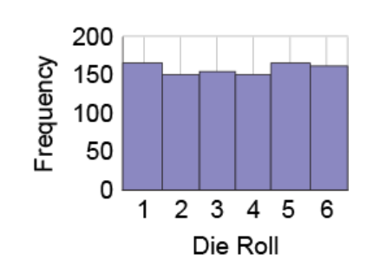

Q13. A bookstore took an inventory of the prices of its books and created a histogram to show the results. What shape does the distribution have?
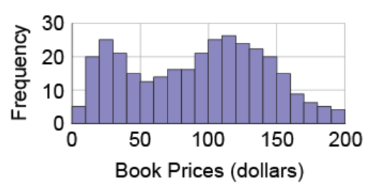

Q14. The author of a book wants to know what price his book is being sold for. He gets the price from all the bookstores in a city and creates a histogram of the results. What is the shape of the distribution?
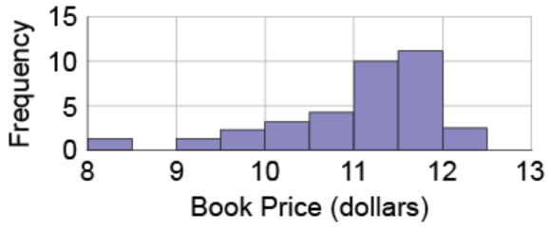

Q15. Selected runners from a marathon were asked how many miles they could run before they started to feel tired. The results are shown in the following histogram. How many of those runners could run greater than 5.5 and less than 7.5 miles before they started to feel tired?
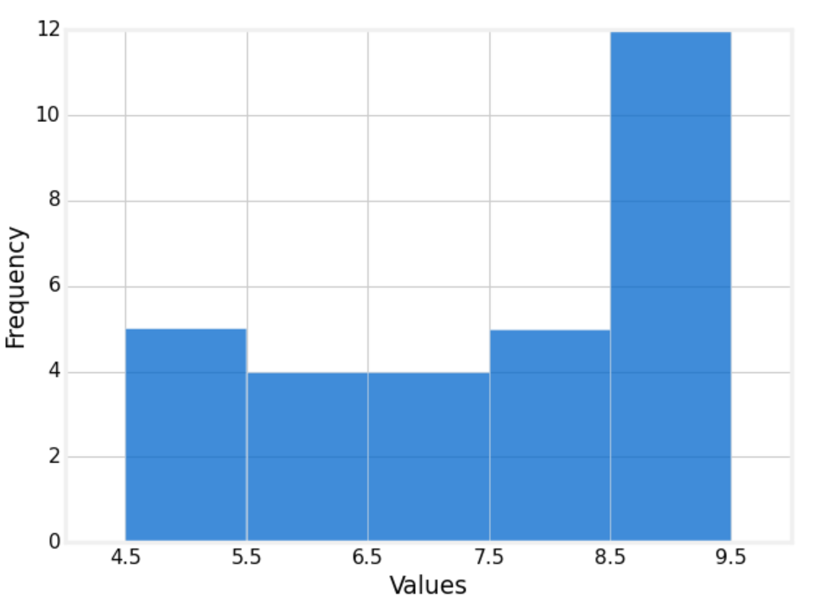

Q16. Find the five-number summary for the following data set.
2 2 2 2 2 2 3 3 3 3 4 4 4 4 4 5 5 5 5 5 5 7 7 7 7

Q17. Construct a box plot for the following data set.
2 2 2 2 2 2 3 3 3 3 4 4 4 4 4 5 5 5 5 5 5 7 7 7 7

Q18. The data show the number of named storms each year for the last 40 years. Construct and analyze a dot plot for the data.
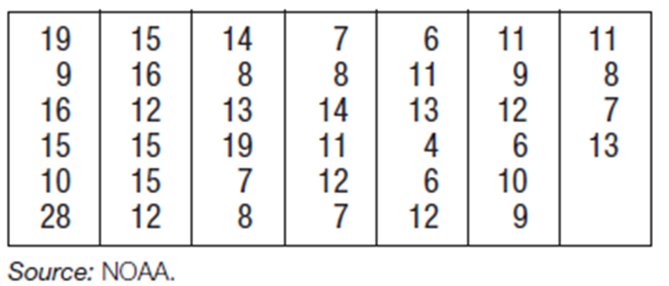

Q19. Present the data in a stem-and-leaf plot.
15 58 37 20 27 36 36 56 57 29 51 28 29 58 55

Q20. Based on the following bar graph, how many people take the bus to work?
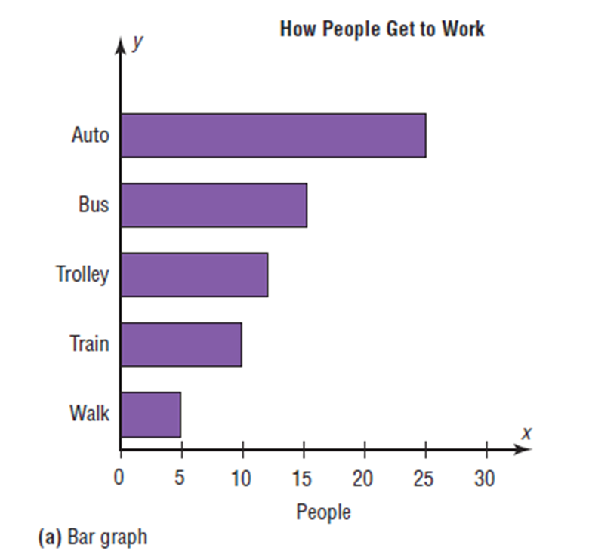

Q21. Horace is trying to improve at golf. So, he keeps track of the number of total rounds he has played over time. The line graph below shows the data. How many rounds did Horace play from week 1 to 3?
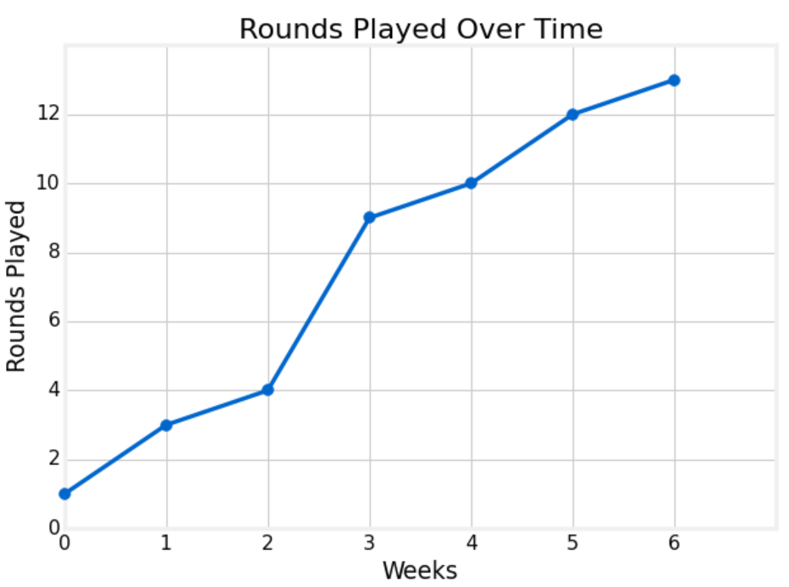

- Identify, calculate, or interpret measures of central tendency (e.g., mean, median) and dispersion (e.g., interquartile range, standard deviation).

Q1. Find the mean of the following data set.
2 2 2 2 2 2 3 3 3 3 4 4 4 4 4 5 5 5 5 5 5 7 7 7 7

Q2. Mr. McDevitt plans to see the performance of his students in a math quiz, by finding the mean. 25 students took the math quiz and he found the mean to be 78.2, however, when calculating the mean, he made a mistake by entering 59 for one student, instead of 89. What is the actual mean of the math quiz?

Q3. Find the mean of the frequency table below.
Value | Frequency
2 | 8
3 | 3
4 | 2
5 | 7
7 | 5

Q4. Mr. King finds the mean height of all 12 students in his statistics class to be 66.0 inches. Just as Mr. King finishes explaining how to get the mean, Daniel walks in late. Daniel is 67.3 inches tall. What is the mean height of the 13 students in the class?

Q5. A professor has recorded exam grades for 10 students in his class, but one of the grades is no longer readable. If the mean score on the exam was 81 and the mean of the 9 readable scores is 84, what is the value of the unreadable score?

Q6. Find the median of the following data set.
2 2 2 2 2 2 3 3 3 3 4 4 4 4 4 5 5 5 5 5 5 7 7 7 7

Q7. The median for the given set of six ordered data values is 30.5. What is the missing value x?
12 21 x 41 50

Q8. Find the mode of the following data set.
2 2 2 2 2 2 3 3 3 3 4 4 4 4 4 5 5 5 5 5 5 7 7 7 7

Q9. The following table represents student’s favorite ice cream flavor. Determine the mode.
Strawberry | Chocolate | Chocolate | Mint chocolate chip
Cookies and cream | Cookies and cream | Strawberry | Vanilla
Vanilla | Strawberry | Chocolate | Cookies and cream
Strawberry | Mint chocolate chip | Vanilla | Vanilla
Strawberry | Cookies and cream | Chocolate | Cookies and cream

Q10. Josh wants to analyze his survey about people’s favorite ice cream flavors. He learned from his statistics class that there are three measures for central tendency, mean, median, and mode. Which one will be the most appropriate for the ice cream flavor?
- mean
- median
- mode

Q11. Find the midrange of the following data set.
2 2 2 2 2 2 3 3 3 3 4 4 4 4 4 5 5 5 5 5 5 7 7 7 7

Q12. Find the range of the following data set.
2 2 2 2 2 2 3 3 3 3 4 4 4 4 4 5 5 5 5 5 5 7 7 7 7

Q13. A student's median score on three tests is 87. The mean of the student's scores is 89, and the range is 6. Which of the following scores could be one of the student's other two test scores? (a sample question from ILTS Study Guide, http://www.il.nesinc.com/Content/STUDYGUIDE/IL_SG_SRI_202.htm#obj2 )
- 85
- 86
- 90
- 93

Q14. Find the interquartile range of the following data set.
2 2 2 2 2 2 3 3 3 3 4 4 4 4 4 5 5 5 5 5 5 7 7 7 7

Q15. Check the following data set for outliers.
5, 6, 12, 13, 15, 18, 22, 50

Q16. Find the sample variance of the following data set.
2 3 5 9 11 18

Q17. Find the sample standard deviation of the following data set.
2 3 5 9 11 18

Q18. Which of the following data set has a larger spread?
- 2, 3, 3, 5, 5, 5, 8, 9, 9, 10
- 15, 17, 29, 33, 50, 69, 71, 72, 75, 88
- 2, 3, 5, 7, 11, 13, 17, 19, 23, 29
- 101, 101, 102, 102, 103, 103, 104, 104, 104, 104

- Model and solve problems using the concept of expected value.

Q1. The probability distribution table for a random variable X is shown below. Find the expected value.
x | P(x)
0 | 0.5
1 | 0.1
2 | 0
3 | 0.3
4 | 0.1

Q2. Find the expected value for the event of rolling a standard six-sided die.

Q3. Suppose you pay $2 to play a game with two fair coins at a casino. There are two cases for you to win. If you flip the coins and get two heads, you win $5. If you flip the coins and get two tails, you win $3. What is the expected value of the game? Do you think it’s a fair game to play?

Q4. One thousand lottery tickets are sold at $1 each for a color television valued at $350. What is the expected value of the gain if you purchase one ticket?

Q5. Suppose a life insurance company sells a $290,000 one-year term life insurance policy to a 21​-year-old female for $280. The probability that the female survives the year is 0.999529. Compute and interpret the expected value of this policy to the insurance company.

Q6. Consider a set S = {1, 2, 3, 4, 5} and $P\left(x\right)=\frac{x- 1}{10}$, where x is an element of S. Calculate E(S).

Q7. A random variable X has the following probability distribution, with E(X) = 3. Find the values for both a and b.
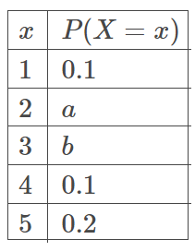

- Demonstrate knowledge of the probability distributions (e.g., normal, uniform, binomial) that random variables generate.

Q1. Find the mean for the following normal probability distribution.

Q2. Which of the following cases does not create a uniform probability distribution?
A. Flip a fair coin
B. Roll a fair six-faced die
C. Take a guess on how the weather looks like tomorrow
D. Draw a card from a standard 52-card deck

Q3. Construct a discrete probability distribution for tossing three coins.

Q4. Construct a probability distribution table for the event of rolling a standard six-sided die.

Q5. Determine if the following table is a discrete probability distribution.
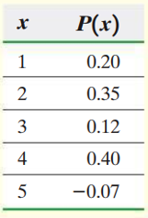

Q6. Determine if the following table is a discrete probability distribution.
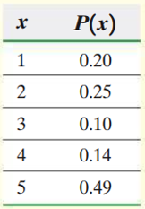

Q7. Determine if the following table is a discrete probability distribution.
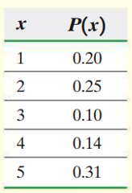

Q8. If a fair coin is flipped 5 times, use the binomial probability formula to find the probability of getting exactly 3 heads?

Q9. If a fair coin is flipped 5 times, what is the probability of getting at least 3 heads?

Q10. If a fair coin is flipped 4 times. Find the mean and standard deviation of the number of heads that will be obtained.

- Demonstrate knowledge of the sampling distribution of sample means and sample proportions.

Q1. Determine $μ_{\overline{x}}$ and $σ_{\overline{x}}$ from $μ=50$, $σ=3$, and $n=100$

Q2. Decide whether the following statement is true or false.
If the original variable is normally distributed, then the distribution of the sample means of that variable will also be normally distributed, for any size n.

Q3. The average height of male high school students is 68 inches. Assume the variable is normally distributed and the standard deviation is 3 inches. If 20 male high school students are randomly selected, find the probability that the mean of their height will be greater than 70 inches.

Q4. The average height of male high school students is 68 inches. Assume the variable is normally distributed and the standard deviation is 3 inches. If 20 male high school students are randomly selected, find the probability that the mean of their height will be less than 67 inches.

Q5. The average height of male high school students is 68 inches. Assume the variable is normally distributed and the standard deviation is 3 inches. If 20 male high school students are randomly selected, find the probability that the mean of their height will be between 67 inches and 70 inches.

Q6. A survey of 925 college students were asked whether they feel stressed from schoolwork. 715 students responded “yes”. Obtain a point estimate for the proportion of college students who feel stressed from schoolwork.

Q7. Which of the following sampling distribution is normal?
- $n=10$, $p=0.2$
- $n=20$, $p=0.2$
- $n=30$, $p=0.1$
- $n=50$, $p=0.5$

Q8. Determine $σ_{\hat{p}}$ from $n=200$, and $p=0.3$

Q9. According to a survey, 86% of college students feel stressed from schoolwork. Suppose that we obtain a random sample of 100 college students and determine whether they feel stressed from schoolwork. Find the mean and the standard deviation of the sampling distribution of the sample proportion.

Q10. According to a survey, 86% of college students feel stressed from schoolwork. Suppose that we obtain a random sample of 100 college students and determine whether they feel stressed from schoolwork. What is the probability that at least 80% of them feel stressed from schoolwork?

Q11. According to a survey, 86% of college students feel stressed from schoolwork. Suppose that we obtain a random sample of 100 college students and determine whether they feel stressed from schoolwork. What is the probability that less than 80% of them feel stressed from schoolwork?

- Demonstrate knowledge of confidence intervals and hypothesis testing for single population means and proportions.

Q1. Decide whether the following statement is true or false.
As the level of confidence increases, the margin of error for the population proportion decreases.

Q2. Decide whether the following statement is true or false.
As the size of the random sample increases, the margin of error for the population proportion decreases.

Q3. Decide whether the following statement is true or false.
To construct a confidence interval about the​ mean, the population from which the sample is drawn must be approximately normal.

Q4. A survey of 925 college students were asked whether they feel stressed from schoolwork. 715 students responded “yes”. Obtain a 90% confidence interval for the proportion of college students who feel stressed from schoolwork.

Q5. Suppose you want to estimate a proportion with a 3% margin of error and 95% confidence. How many individuals should be in your sample?

Q6. If the lower bound is 16 and the upper bound is 26, determine the point estimate of the population mean and margin of error for the confidence interval.

Q7. A simple random sample of size 20 is drawn from a population that is normally distributed. The sample mean is 110 and the sample standard deviation is 10. Construct a 98% confidence interval about $μ$.

Q8. Decide whether the following statement is true or false.
If we reject the null hypothesis when the statement in the null hypothesis is true, we have made a type I error.

Q9. For the null and alternative hypotheses below, determine the tail type.
$H_{o}: μ≥5$ and $H_{a}: μ<5$

Q10. For the null and alternative hypotheses below, what parameter is being tested?
$H_{o}: μ≥5$ and $H_{a}: μ<5$

Q11. If a researcher wishes to prove that, the drug they developed can help people lose more than 5 pounds per week, what will be the tail type for the hypothesis testing?

Q12. A medicine company claims that 80% of people using their drug will lose more than 5 pounds in the first week. A researcher wishes to test this claim and asked 60 randomly selected people if they have lost more than 5 pounds in the first week, 50 responded yes. What is the test statistic for this data?

Q13. For the null and alternative hypotheses below, which of the following graph shows the critical region?
$H_{o}: μ≥5$ and $H_{a}: μ<5$
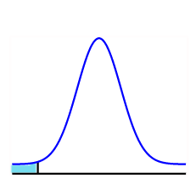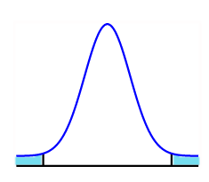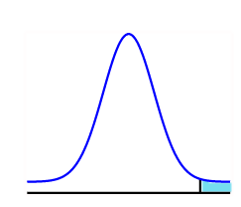
A B C
- Identify, calculate, or interpret correlation coefficients and regression equations.

Q1. Which of the following case can produce data sets with a negative slope?
- The time you are absent from a class and the grade you receive.
- The length of your hair and the amount of shampoo you use.
- The amount of product sells and the profit.
- The temperature change and the utility cost of the air conditioner.

Q2. For the graph below, determine whether the linear correlation is positive or negative.
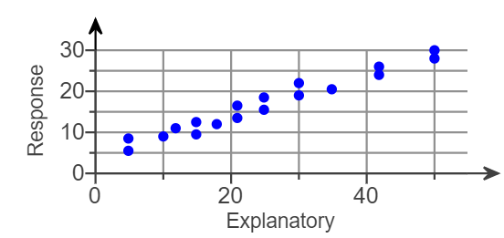

Q3. For the graph below, select the best choice for the linear correlation coefficient.
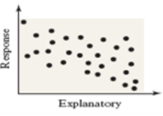
- r = 0
- r = -1
- r = 0.005
- r = -0.043

Q4. For the graph below, select the best choice for the linear correlation coefficient.
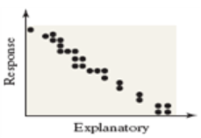
- r = 0
- r = -1
- r = -0.995
- r = -0.043

Q5. Which of the following scatter plot matches r = 0.975?
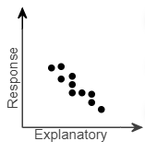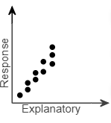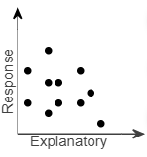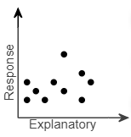
A B C D

Q6. The table below shows the number of workers absent versus the number of defective parts in a factory. Construct a scatter plot.

Number of workers absent | Number of defective parts
3 | 15
5 | 22
0 | 7
1 | 12
2 | 20
6 | 30

Q7. The table below shows the number of workers absent versus the number of defective parts in a factory. Find the linear correlation coefficient r.

Number of workers absent | Number of defective parts
3 | 15
5 | 22
0 | 7
1 | 12
2 | 20
6 | 30

Q8. The scatter plot below shows the average cost of a designer jacket in a sample of years between 2000 and 2015. The least-squares regression line modeling this data is given by $\hat{y}= -4815+3.765x$. Interpret the y-intercept of the least-squares regression line. Is it feasible?

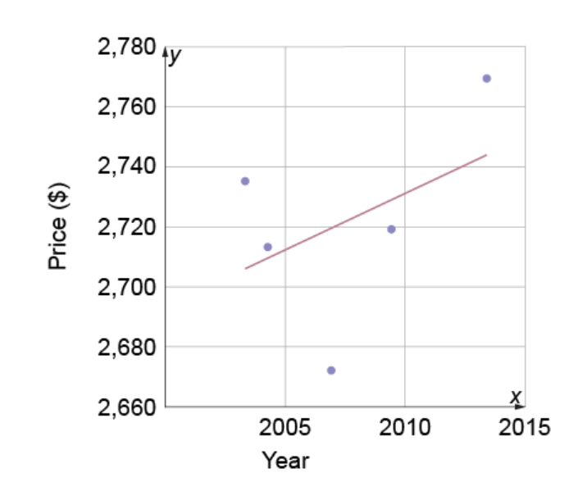

Q9. The table below shows the number of workers absent versus the number of defective parts in a factory. Find the least-squares regression line.

Number of workers absent | Number of defective parts
3 | 15
5 | 22
0 | 7
1 | 12
2 | 20
6 | 30

