0002 Understand college statistics.
- Construct, identify, or interpret frequency distributions, histograms, box plots, and cumulative frequency tables and associated graphs.
Q1
Value | Frequency | Cumulative Frequency
2 | 6 | 6
3 | 4 | 10
4 | 5 | 15
5 | 6 | 21
7 | 4 | 25

Q2 7
Q3 9
Q4 20
Q5 22
Q6 12
Q7 12
Q8 9
Q9 11
Q10 44%
Q11

Q12 uniform
Q13 bimodal
Q14 left-skewed
Q15 8
Q16 min = 2, Q1 = 2.5, Q2 = 4, Q3 = 5, max = 7
Q17
Min = 2
Q1 = 2.5
Q2 = 4
Q3 = 5
MaX = 7
Q18
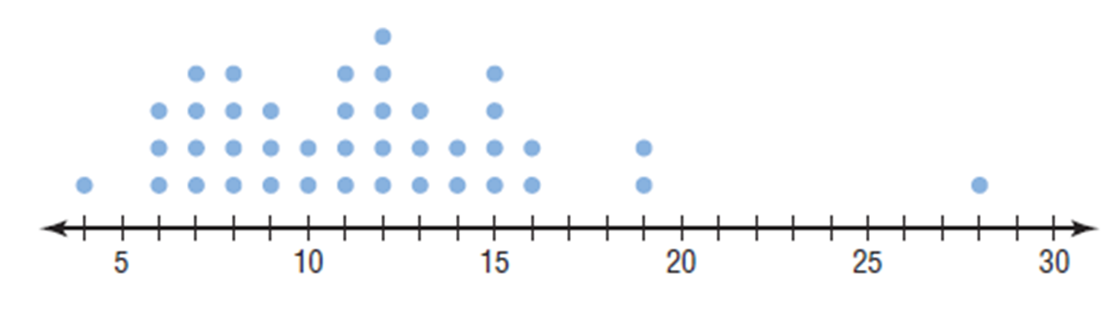
The number of named storms each year mainly ranged from 6 to 16 in the past 40 years. However, in one specific year, there were 28 named storms, which might be an outlier.
Q19
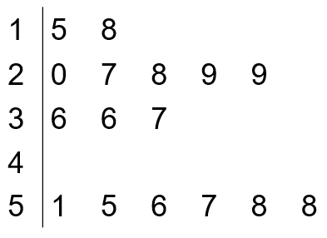
Q20 15
Q21 6

- Identify, calculate, or interpret measures of central tendency (e.g., mean, median) and dispersion (e.g., interquartile range, standard deviation).
Q1 4.08
Q2 79.4
Q3 4.12
Q4 66.1
Q5 54
Q6 4
Q7 30.5
Q8 2 and 5
Q9 Strawberry, and cookies and cream
Q10 C
Q11 4.5
Q12 5
Q13 D
Q14 2.5
Q15 50 is an outlier
Q16 36
Q17 6
Q18 B

- Model and solve problems using the concept of expected value.
Q1 1.4
Q2 3.5
Q3 0
Q4 -$0.65, a person would, on average, lose $0.65 on each lottery ticket
Q5 $143.41, the company is expected to make $143.31 on every 21-year-old female
Q6 4
Q7 a = b = 0.3

- Demonstrate knowledge of the probability distributions (e.g., normal, uniform, binomial) that random variables generate.
Q1 The mean for curve 1 is 0 and the mean for curve 2 is 1
Q2 C
Q3
Number of Heads x | Probability P(x)
0 | $$\frac{1}{8}$$
1 | $$\frac{3}{8}$$
2 | $$\frac{3}{8}$$
3 | $$\frac{1}{8}$$

Q4
Outcome x | Probability P(x)
1 | $$\frac{1}{6}$$
2 | $$\frac{1}{6}$$
3 | $$\frac{1}{6}$$
4 | $$\frac{1}{6}$$
5 | $$\frac{1}{6}$$
6 | $$\frac{1}{6}$$

Q5 It’s not a discrete probability distribution, because P(5) = -0.07
Q6 It’s not a probability distribution, because the sum of P(x) column is not equal to 1
Q7 It’s a probability distribution, because $0≤P(x)≤1$ and $\sum_{x=1}^{x=5}{P\left(x\right)=1}$
Q8 0.3125
Q9 0.5
Q10 $μ_{x}=np=4∙\frac{1}{2}=2$ and $σ_{x}= \sqrt{np(1-p)}= \sqrt{4∙\frac{1}{2}∙(1-\frac{1}{2})}=1$
- Demonstrate knowledge of the sampling distribution of sample means and sample proportions.
Q1 $μ_{\overline{x}}=μ=50$ and $σ_{\overline{x}}= \frac{σ}{\sqrt{n}}=\frac{3}{\sqrt{100}}=0.3$
Q2 True
Q3 $z= \frac{\overline{x}-μ_{\overline{x}}}{\frac{σ}{\sqrt{n}}}=\frac{70-68}{\frac{3}{\sqrt{20}}}≈2.98$, and the probability that the mean of their height will be greater than 70 inches is 0.14%.
Q4 $z= \frac{\overline{x}-μ_{\overline{x}}}{\frac{σ}{\sqrt{n}}}=\frac{67-68}{\frac{3}{\sqrt{20}}}≈-1.49$, and the probability that the mean of their height will be less than 67 inches is 6.81%.
Q5 93.05%
Q6 $\hat{p}= \frac{x}{n}=\frac{715}{925}≈77.30\%$
Q7 D
Q8 $σ_{\hat{p}}= \sqrt{\frac{p(1-p)}{n}}= \sqrt{\frac{0.3(1-0.3)}{200}}≈0.03$
Q9 mean = 0.86, standard deviation = 0.03
Q10 $z= \frac{0.80-0.86}{0.03}= -2$, and the probability that at least 80% of them feel stressed from schoolwork is 97.72%.
Q11 $z= \frac{0.80-0.86}{0.03}= -2$, and the probability that less than 80% of them feel stressed from schoolwork is 2.28%.

- Demonstrate knowledge of confidence intervals and hypothesis testing for single population means and proportions.
Q1 false
Q2 true
Q3 false
Q4 $\hat{p}=\frac{715}{925}=0.77$
Lower Bound: $\hat{p}- z_{\frac{α}{2}}∙\sqrt{\frac{\hat{p}\left(1-\hat{p}\right)}{n}}=0.77-1.645∙\sqrt{\frac{0.77∙0.23}{925}}=0.75$
Upper Bound: : $\hat{p}+ z_{\frac{α}{2}}∙\sqrt{\frac{\hat{p}\left(1-\hat{p}\right)}{n}}=0.77+1.645∙\sqrt{\frac{0.77∙0.23}{925}}=0.79$
So the 90% confidence interval for population proportion is between 0.75 and 0.79.
Q5 $n= \hat{p}\left(1-\hat{p}\right){\left(\frac{z_{\frac{α}{2}}}{E}\right)}^{2}=0.5\left(0.5\right){\left(\frac{1.96}{0.03}\right)}^{2}=1068$
Q6 point estimate of the population mean = 21, the margin of error for the confidence interval = 5
Q7 $α=0.02, n=20$, so $t_{\frac{α}{2}}=2.539$
Lower Bound: $\overline{x}-t_{\frac{α}{2}}∙\frac{s}{\sqrt{n}}=110-2.539∙\frac{10}{\sqrt{20}}≈104.3$
Upper Bound: $\overline{x}+t_{\frac{α}{2}}∙\frac{s}{\sqrt{n}}=110+2.539∙\frac{10}{\sqrt{20}}≈115.7$
So the 98% confidence interval for the population mean is between 104.3 and 115.7.
Q8 true
Q9 left-tailed
Q10 population mean
Q11 right-tailed
Q12 $z= \frac{\hat{p}-p}{\sqrt{\frac{p(1-p)}{n}}}= \frac{0.8333-0.8}{\sqrt{\frac{0.8(1-0.8)}{60}}}=\frac{0.0333}{0.0516}≈0.65$
Q13 A

- Identify, calculate, or interpret correlation coefficients and regression equations.

Q1 A
Q2 positive
Q3 D
Q4 C
Q5 B
Q6
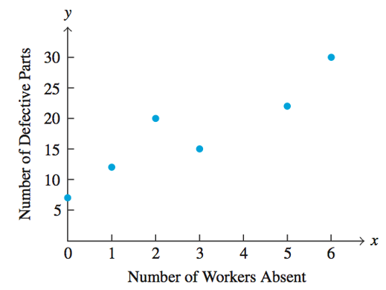
Q7
$$r= \frac{n\left(\sum{xy}\right)-\left(\sum{x}\right)\left(\sum{y}\right)}{\sqrt{n\left(\sum{x^{2}}\right)-{\left(\sum{x}\right)}^{2}}\sqrt{n\left(\sum{y^{2}}\right)-{\left(\sum{y}\right)}^{2}}}$$
$$= \frac{6\left(387\right)-\left(17\right)\left(106\right)}{\sqrt{6\left(75\right)-{\left(17\right)}^{2}}\sqrt{6\left(2002\right)-{\left(106\right)}^{2} }}≈0.922$$
Q8 y-intercept is -4815. It is not feasible, because a product cannot have a negative cost.
Q9
$$m= \frac{n\left(\sum{xy}\right)-\left(\sum{x}\right)\left(\sum{y}\right)}{n\left(\sum{x^{2}}\right)-{\left(\sum{x}\right)}^{2}}≈3.23$$
$b= \frac{\sum{y}-m\left(\sum{x}\right)}{n}≈8.52$

Hence, the equation is y = 3.23x + 8.52

