0001 Understand calculus

- Demonstrate knowledge of factoring techniques, solving polynomial equations, and performing operations with rational and radical expressions.

  - Let
$$f\left(t\right)=\frac{t^{2}-14t+40}{t^{3}-4t^{2}+6t-24}.$$
Which of the following are root(s) of$f(t)$?
    - $t=10$
    - $t=4,10$
    - $t = -\sqrt{6},10,4$
    - $f(t)$has no roots

  - Which of the following values of $x$ satisfies the equation
$$\frac{x^{2}-5x}{x-5}=1$$
    - $x=5$ only
    - $x=1, 5$
    - $x=1$ only
    - No Solution

  - $\sqrt{6x-36}=x-6$

What value(s) of $x$ satisfy the equation above?
    - $x=6$
    - $x=12$
    - $x=6, 12$
    - No Solution

  - The graph of a polynomial function $f(x)$ has roots$x=-3,0,5$. Which of the functions could define$f$?

    - $f\left(x\right)=(x+3)(x-5)$
    - $f\left(x\right)=x(x+3)(x-5)$
    - $f\left(x\right)=x(x-3)(x+5)$
    - $f\left(x\right)=(x-3)(x+5)$

  - What is the area of a rectangle with a length $3x+2,$ and a width of $x-1?$

    - $4x-1$
    - $3x^{2}-2$
    - $3x^{2}+x-2$
    - $3x^{2}-x-2$

  - Determine the value of $c$ so that the function $g\left(x\right)=x^{4}+cx^{2}+81$ has root$x=3$.

    - $c=-9$
    - $c=-18$
    - $c=9$
    - $c=18$

  - Solve $\sqrt{d+16}=\sqrt{d}-\sqrt{8}$

    - $d=4$
    - $d=16$
    - $d=2$
    - No Solution

  - Suppose
$$\frac{7x^{2}+59x-36}{x+9}=Ax+B$$

Find the sum $A+B$

- 4
- 3
- 11
- -3

- Demonstrate knowledge of different representations (e.g., tabular, algebraic, graphic) of polynomial, radical, and rational functions and circles; how to find horizontal and vertical asymptotes; and how to find points of intersection of curves.

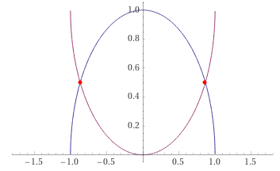
Let $f(x) =\sqrt{\left(1-x^{2}\right)} and g(x) = 1-\sqrt{\left(1-x^{2}\right)}$(see figure above). Where do$f,g$intersect?
    - $-\frac{1}{2} ,\frac{1}{2};$
    - $\frac{3}{4} , -\frac{3}{4};$
    - $-\frac{\sqrt{5}}{2} ,\frac{\sqrt{5}}{2}$;
    - $-\frac{\sqrt{3}}{2} , \frac{\sqrt{3}}{2}$

  - Which set of statements is true for the function
$$f\left(x\right)=\frac{x^{2}}{x^{2}-9}$$

- $f(x)$ has no minimum,
- $f(x)$has a vertical asymptote at$x=-3$and$x =3,$
- $f(x)$has no horizontal asymptote.

    - ii is true;
    - i, ii are true;
    - i, iii are true;
    - None of the above

  - What is the equation of a circle centered at the origin with radius 5

    - $x^{2}+y^{2}=25$
    - $x^{2}+y^{2}=5$
    - $x^{2}+y^{2}=\sqrt{5}$
    - ${(x-5)}^{2}+{(y-5)}^{2}=25$

  - Find the center $(h,k)$ of the circle given by the equation

$$x^{2}+4x+y^{2}-20y+79=0$$

    - $\left(h,k\right)=(2, 10)$
    - $\left(h,k\right)=(-2, -10)$
    - $\left(h,k\right)=\left(2, -10\right)$
    - $\left(h,k\right)=(-2, 10)$

  - Use the graph to determine the equation of the circle

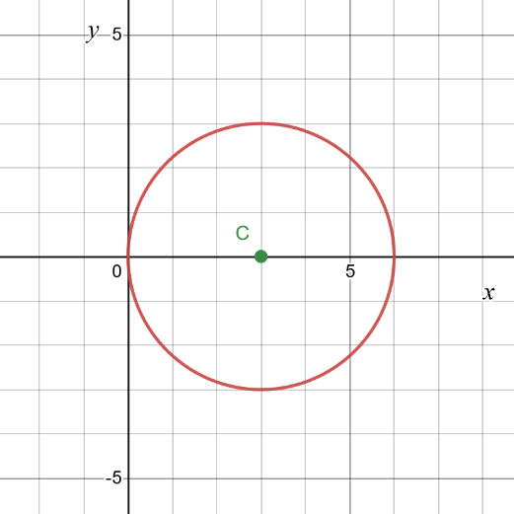

    - ${(x-3)}^{2}+y^{2}=9$
    - ${(x-3)}^{2}+y^{2}=3$
    - $x^{2}+{(y-3)}^{2}=9$
    - $x^{2}+{(y-3)}^{2}=3$

  - The monthly sales, $S$, for a car company is given by the function
$$S\left(x\right)=\frac{300x}{40+6x}$$

Where $x$ is the monthly expenses and is given in thousands of dollars. The graph of $S(x)$ is shown below.

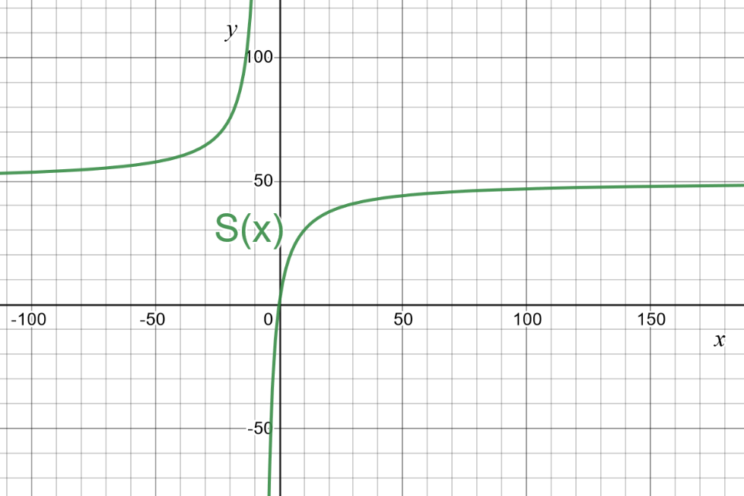

Which statement best describes the monthly sales of the company as x increases?

- The car company can expect to make no less than $50,000 in sales a month, no matter how much they spend on advertising for that month
- The car company can expect to make no more than $50,000 in sales a month, no matter how much they spend on advertising for that month
- The car company will make $50,000 in sales if they continue to spend money in advertising
- Not enough information provided.

  - A park is in the shape of a circle that is represented by the equation$x^{2}+y^{2}=225$. The park was designed to have a circular fountain at the center; concentric with the park and represented by the equation $x^{2}+y^{2}=81.$ Determine the area of the park that does not contain the fountain

    - The area of the park that does not contain the fountain is $6π.$
    - The area of the park that does not contain the fountain is $36π.$
    - The area of the park that does not contain the fountain is $12π.$
    - The area of the park that does not contain the fountain is $144π.$

  - Determine the equation of the line that intersects the parabola
$$y=x^{2}-8x-12$$
Exactly once if the line has a slope of$-4$.

    - $y=-4x-28$
    - $y=-4x-64$
    - $y=-4x-8$
    - $y=-4x-16$

- Apply the properties of limits to functions and their graphs.
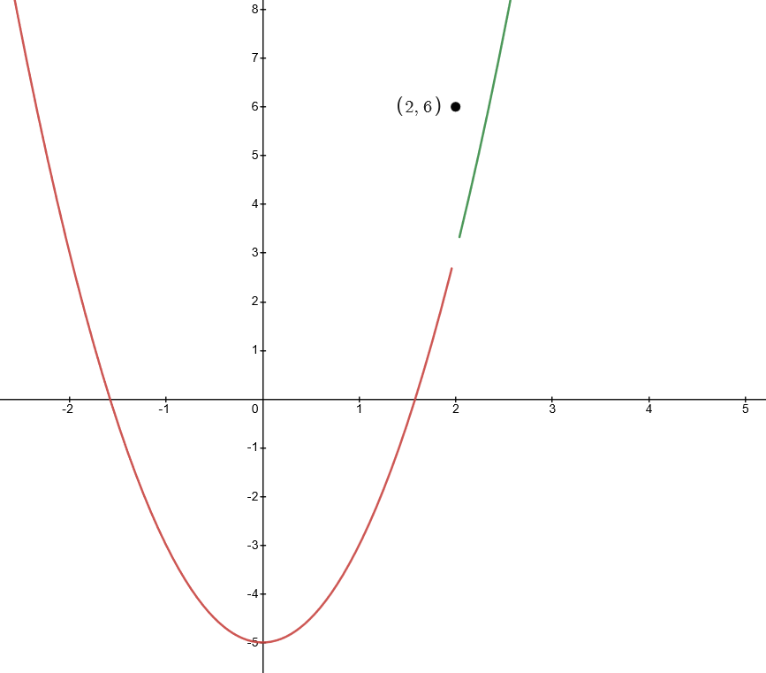
  - What is$\lim_{x→2}{f(x)}$?
    - $\lim_{x→2}{f(x)}=6$,
    - $\lim_{x→2}{f\left(x\right)=3}$,
    - $\lim_{x→2}{f(x)}=2$
    - The limit does not exist.

  - Let $f(x)$ be a piecewise defined function, where $K$ is a constant,

$$f\left(x\right)=\left\{\begin{aligned}K^{2}x+18K, \text{if }&x≥3 \\ -27, \text{if} &x<3\end{aligned}\right.$$

Determine the value(s) of $K$ such that $\lim_{x→3}{f(x)}$ exists.
    - $K=-9, 9$
    - $K=-3$ only
    - $K=-3,3$
    - $K=-9$ only

  - Consider the function $f(x)$ with following properties:

- $f(x)$ is continuous on the intervals$\left(-∞,-1\right), \left(-1, 4\right), (4,+∞)$.
- $\lim_{x→-1^{-}}{f(x)}=-∞$
- $\lim_{x→-1^{+}}{f(x)}=+∞$
- $\lim_{x→4}{f(x)}≠f(4)$

Which of the following could be the graph of$f(x)$?

    - 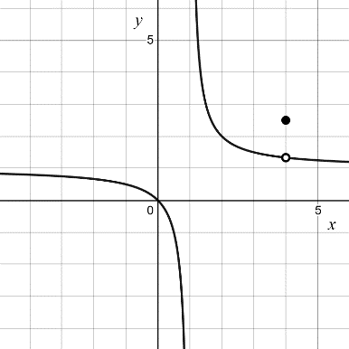
    - 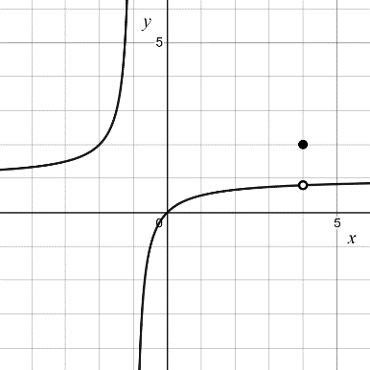
    - 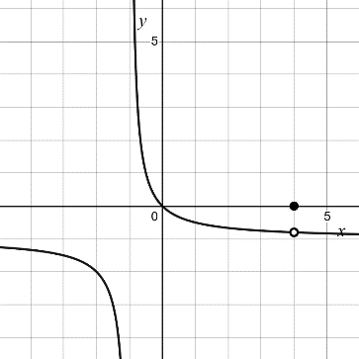
    - None of the above

  - Evaluate the limit.
$$\lim_{x→-1}{\frac{2}{x+1}}$$
    - $0$
    - $-∞$
    - $+∞$
    - The limit does not exist.

  - Evaluate the limit.
$$\lim_{x→3}{ \frac{x^{2}-9}{x-3}}$$
    - 0
    - 1
    - 6
    - The limit does not exist

  - Which of the following limits is correct for calculating the derivative of
$$f\left(x\right)=3x^{2}+5$$

    - $\lim_{h→0}{\frac{3x^{2}+h+5-(3x^{2}+5)}{h} }$
    - $\lim_{h→0}{\frac{3x^{2}+5-(3{(x+h)}^{2}+5)}{h} }$
    - $\lim_{h→0}{\frac{3{(x+h)}^{2}+5-(3x^{2}+5)}{h} }$
    - $\lim_{h→0}{\frac{3({x+h)}^{2}+5-3x^{2}+5}{h} }$

  - Evaluate the limit.
$$\lim_{x→8}{\frac{\sqrt{x+8}-4}{x-8}}$$

    - $1$
    - $\frac{1}{20}$
    - $\frac{1}{8}$
    - The limit does not exist

- Apply the concept of continuity to functions and their graphs.

  - Determine the type of discontinuity for the function
$$f\left(x\right)=\frac{x^{2}-16}{x+4}$$
    - $x = -4$ is a removable discontinuity,
    - $x =-4$is a jump discontinuity
    - $x = 4$is a removable discontinuity,
    - $x = 4$is a jump discontinuity.

  - On which intervals is the domain of the function pictured below, continuous?
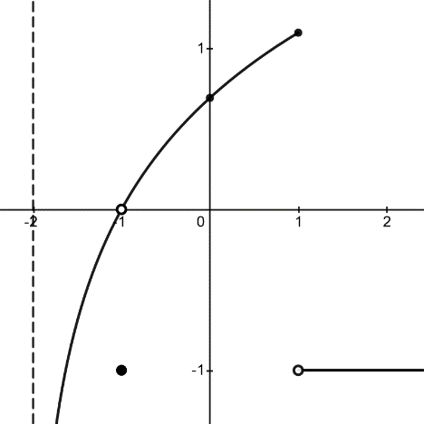

    - $\left(-2, 1\right)∪(1,+ ∞)$
    - $\left(-2, -1\right)∪(-1, 1)∪(1,+ ∞)$
    - $\left(-∞,+ ∞\right)$
    - $\left(-∞, -1\right)∪(-1, 1)∪(1, +∞)$

  - Using the graph in problem 2 identify the type of discontinuity (if any) at $x=1$

    - Infinite Discontinuity
    - Removable Discontinuity
    - Jump Discontinuity
    - The function is continuous at $x=1$

  - Let $h\left(t\right)$ be the function
$$h\left(t\right)=\frac{3}{t^{4}+3}$$

For what values of $t$ is the function $h$ continuous?

    - $\left(0, +∞\right)$
    - $\left(-∞,-\sqrt[4]{3}\right)∪(-\sqrt[4]{3},+∞)$
    - $\left(-∞,-\sqrt[4]{3}\right)∪\left(-\sqrt[4]{3},0\right)∪(0,+∞)$
    - The function is continuous for all values of $t$

  - Let$g\left(x\right)=x-\left|e^{x}-x^{2}\right|$, where$-1≤x≤3$. Where is the function continuous?

    - Continuous at $x=0$
    - Continuous at $x=1$
    - Continuous at $x=2$
    - Continuous on the interval $\left[-1, 3\right]$

  - Let $a$be the real number such that the function $f(x)$ is continuous for every$x$. Evaluate $f\left(2\right).$
$$f\left(x\right)=\left\{\begin{aligned}a^{2}x+2a, x<2 \\ {-ax}^{2}+a^{2}-9, x≥2\end{aligned}\right.$$

    - $f\left(2\right)=-5$
    - $f\left(2\right)=-3$
    - $f\left(2\right)=12$
    - $f\left(2\right)=24$

  - Suppose $f\left(x\right)$is a continuous function. Let $f\left(-3\right)=4$ and$f\left(2\right)=7$. Which of the following statements does the Intermediate Value Theorem guarantee for some real number$c$?

    - $f\left(c\right)=1$for at least one $c$between $4$and $7$
    - $f\left(c\right)=5$for at least one $c$between $-3$and $2$
    - $f\left(c\right)=5$for at least one $c$between $4$and $7$
    - $f\left(c\right)=1$for at least one $c$between $-3$and $2$

  - Suppose$g\left(x\right)=e^{-x}+x^{3}-2$. Does the function have at least one root on the interval$\left[-2, 2\right]?$ Justify.

    - By the intermediate value theorem, since $g\left(x\right)$is continuous on the closed interval $\left[-2, 2\right]$, and $f\left(-2\right)<0$and $f\left(2\right)>0,$ then the function has at least one root on the interval $\left[-2, 2\right].$
    - By the intermediate value theorem, since $g\left(x\right)$is not continuous on the closed interval $\left[-2, 2\right]$, and $f\left(-2\right)<0$and $f\left(2\right)>0,$ then the function does not have one root on the interval $\left[-2, 2\right].$
    - By the intermediate value theorem, since $g\left(x\right)$is continuous on the closed interval $\left[-2, 2\right]$, and $f\left(-2\right)>0$and $f\left(2\right)<0,$ then the function has at least one root on the interval $\left[-2, 2\right].$
    - By the intermediate value theorem, since $g\left(x\right)$is continuous on the closed interval $\left[-2, 2\right]$, and $f\left(-2\right)>0$and $f\left(2\right)<0,$ then the function does not have at least one root on the interval $\left[-2, 2\right].$

- Apply the rules of derivatives for finding tangent lines, slopes, rates of change, velocity and acceleration, marginal analysis, and increasing and decreasing functions.

  - Let$a$be the constant acceleration of an object. If$a>0$which graph could represent the velocity of the object?

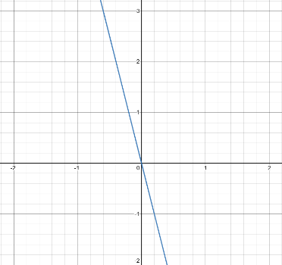

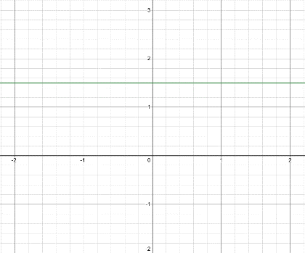
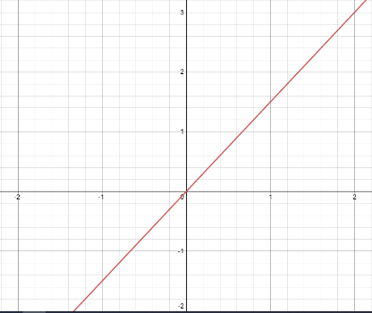

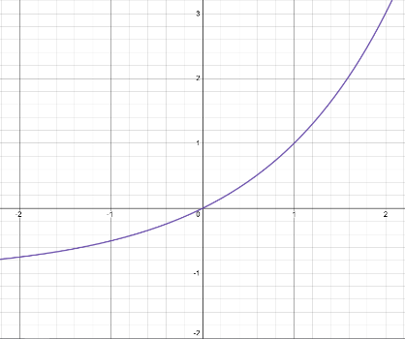

  - Given the function$f\left(x\right)$. Evaluate$f'(6)$.

$$f\left(x\right)=ax^{3}+3bx^{2}+3cx+d$$

    - $f^{'}\left(6\right)=72a+36b+3$
    - $f^{'}\left(6\right)=108a+36b+3c$
    - $f^{'}\left(6\right)=216a+27b+18$
    - $f^{'}\left(6\right)=36a+18b+3c$

  - Find the value $c$such that $p\left(x\right)={\left(x^{2}-cx+c\right)}^{2}$has a horizontal tangent line at $x=2$

    - $c=4$
    - $c=-4$
    - $c=1$
    - $c=-1$

  - Find the equation of the tangent line to $f\left(x\right)=3x^{2}-π^{4}$ when $x=-5$

    - $y=\left(75-π^{4}\right)x$
    - $y=\left(-30-4π^{3}\right)x-20π^{3}-π^{4}-75$
    - $y=-30x-π^{4}-75$
    - None of the above

  - Let $g\left(t\right)=t^{4}-8t^{2}+1.$Determine, if any, the $x$-values where $g(t)$ exhibits a minimum or maximum.

    - $\text{Minimum at }x=-2, 2; \text{No Maximum}$
    - $\text{Minimum at }x=0; \text{Maximum at} x=-2, 2$
    - $\text{No Minimum; Maximum at }x=-2, 2$
    - $\text{Minimum at }x=-2, 2; \text{Maximum at} x=0$

  - Pictured below is the graph of velocity,$v(t)$ of a particle with respect to time. On what interval(s) is the position function of the particle, decreasing?

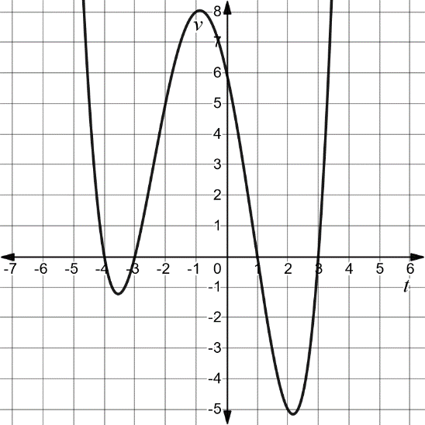

    - The position function is decreasing on the intervals $\left(-4,-3\right)\text{ and } (1,3)$
    - The position function is decreasing on the intervals $\left(-∞,4\right)\text{ and }\left(-3, 1\right)\text{ and }(3, +∞)$
    - The position function is decreasing on the interval $\left(-∞,0\right)$
    - The position function is not decreasing on any interval.

  - A consumer electronics company hired a mathematician to calculate their marginal profit. The mathematician found that the functions, in terms of units sold $x$, for revenue, $R\left(x\right),$and cost, $C\left(x\right),$were the following:

$$R\left(x\right)=2x^{3}+90x^{2}-75$$
And
$$C\left(x\right)=5\left(8x^{2}+18\right)$$

Find the marginal profit if the company produces and sells $50$units.

    - The marginal profit is: $\$500,015$
    - The marginal profit is: $\$2,500$
    - The marginal profit is: $\$20,000$
    - The marginal profit is: $\$42,750$

- Apply concepts of differential calculus to model real-world situations.
HOUSE

  - You plan to make a garden enclosed in a rectangular wooden barrier. The garden area is to measure 50 sq ft. What is the least amount of barrier you need to enclose the garden if your home protects one side of the garden? (see drawing)
    - 20 ft.
    - 30 ft.
    - 10 ft.
    - 15 ft.

- Demonstrate knowledge of the properties of exponential and logarithmic functions, graphs, and derivatives.

  - The natural logarithm function has a base of

    - 10
    - $e$
    - 2
    - None of the above

  - For which function does the slope of the tangent line at any point equal the value of the function at that point.

    - $\ln\left(x\right),$
    - $\log_{2}\left(x\right),$
    - $e^{x},$
    - $\sqrt{x}$

  - Differentiate the function.

$$f\left(t\right)=e^{{\left(at\right)}^{2}}+e^{at}+1$$

    - $f^{'}\left(t\right)=a(2te^{{\left(at\right)}^{2}}+e^{at})$
    - $f^{'}\left(t\right)={2e}^{(a{t)}^{2}}+e^{at}$
    - $f^{'}\left(t\right)=a(2e^{{\left(at\right)}^{2}}+e^{at})$
    - $f^{'}\left(t\right)={(at)(ate}^{{\left(at\right)}^{2}}+e^{at})$

  - Find an equation of the tangent line for the function $g\left(x\right)=e^{-x^{2}}$at the point $(1,\frac{1}{e} )$.

    - $y=\frac{2}{e}x+3e$
    - $y= -2ex-e$
    - $y=\frac{1}{e}x-\frac{3}{e}$
    - $y=-\frac{2}{e}x+\frac{3}{e}$

  - Evaluate $f^{'}\left(e^{\frac{1}{2}}\right)$ for the function$f\left(x\right)=ln⁡(x^{2}+3)$.

    - $f^{'}\left(e^{\frac{1}{2}}\right)=\frac{2}{e+3}$
    - $f^{'}\left(e^{\frac{1}{2}}\right)=\frac{1}{e+3}$
    - $f^{'}\left(e^{\frac{1}{2}}\right)=\frac{2e^{\frac{1}{2}}}{e+3}$
    - $f^{'}\left(e^{\frac{1}{2}}\right)=\frac{2e^{\frac{1}{2}}}{\ln\left(e+3\right)}$

  - Find the absolute maximum (if any) of the function $P\left(x\right)=x^{2}e^{x}$ on the closed interval$[-4, -1]$.

    - $P\left(x\right)$ has an absolute maximum at $x=-2$
    - $P\left(x\right)$ has an absolute maximum at $x=-4$
    - $P\left(x\right)$ has an absolute maximum at $x=-1$
    - $P\left(x\right)$ has an absolute maximum at $x=-\frac{3}{2}$

  - The population of a city, $y$, is given by the equation

$$y=y_{0}e^{kt}$$

Where $k$ is a constant, $t$ is measured in years, and $y_{0}$ is the initial population. If the population doubles every 12 years, what is the value of $k$?

- $k=2\ln{2}$
- $k=\frac{\ln{2}}{12}$
- $k=\frac{\ln{12}}{2}$
- $k=2\ln{12}$

  - The graph of an exponential function is shown below

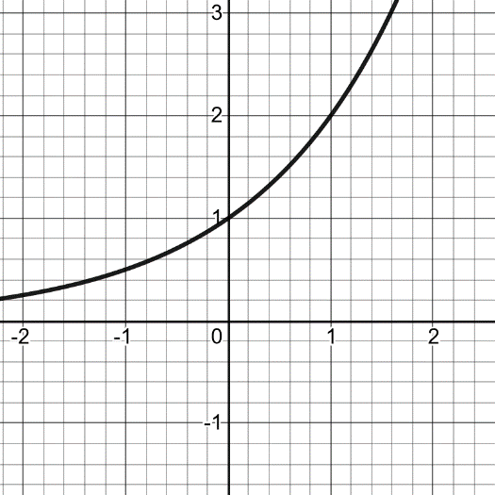

Which of the following graphs is the inverse of the function shown above?

- 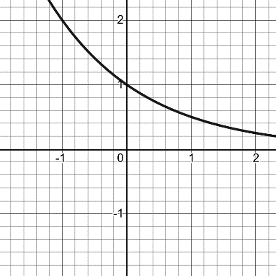
- 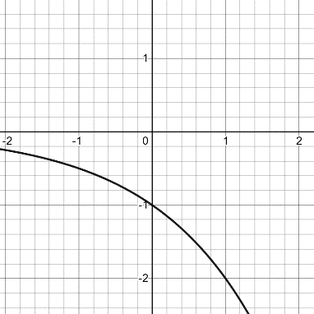
- 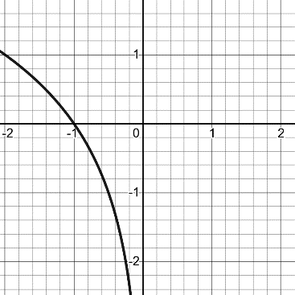
- 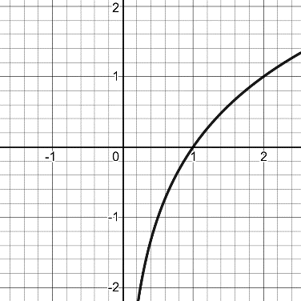

- Demonstrate knowledge of integration and basic antiderivatives and how to interpret integration as the area under a curve.

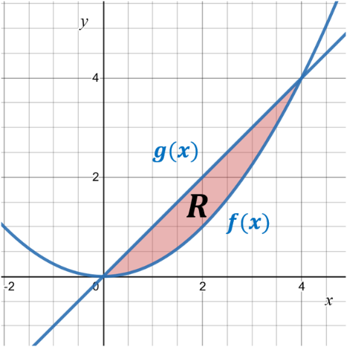
  - Using the figure above, which integral correctly demonstrates the area of the shaded region$R$?

    - $\int_{0}^{4}{f\left(x\right)-g\left(x\right)dx}$
    - $, \int_{0}^{4}{\frac{g\left(x\right)}{f\left(x\right)}dx}$
    - $\int_{0}^{4}{f\left(x\right)+g\left(x\right)dx}$
    - $\int_{0}^{4}{g\left(x\right)-f\left(x\right)dx}$

  - Find the antiderivative of the function $f\left(x\right)=8x^{3}-e^{3x}+π^{5}$

    - $F\left(x\right)=32x^{4}-e^{3x}+π^{6}+C$
    - $F\left(x\right)=2x^{4}-{\frac{1}{3}e}^{3x}+π^{5}x+C$
    - $F\left(x\right)=2x^{4}-3e^{3x}+C$
    - $F\left(x\right)=24x^{2}-3e^{3x}+{5π}^{4}+C$

  - Given $\int_{0}^{1}{g\left(x\right)dx=4}$ and$\int_{0}^{2}{g\left(x\right)dx=-1}$. Find

$$\int_{1}^{2}{g(x)dx}$$

    - $\int_{1}^{2}{g\left(x\right)dx}=5$
    - $\int_{1}^{2}{g\left(x\right)dx}=3$
    - $\int_{1}^{2}{g\left(x\right)dx}=-5$
    - $\int_{1}^{2}{g\left(x\right)dx}=-3$

  - Let

$$F\left(x\right)=\int_{x^{2}}^{5}{\cos\left(t\right)dt}$$

Determine $F'(x)$

- $F^{'}\left(x\right)=sin\left(5\right)-sin\left(x^{2}\right)$
- $F^{'}\left(x\right)=\cos\left(5\right)-\cos{(x^{2})}$
- $F^{'}\left(x\right)=-2x\cos{(x^{2})}$
- $F^{'}\left(x\right)=-2x\sin\left(x^{2}\right)$

  - Evaluate

$$\int_{-2}^{1}{-\frac{1}{x^{2}}dx}$$

    - $\frac{3}{2}$
    - $-\frac{1}{2}$
    - $\frac{1}{2}$
    - This integral does not converge.

  - Consider the function $f(x)$ graphed below.

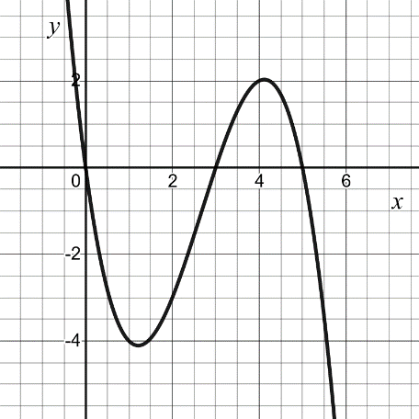

Which is the correct order of the integrals from least-to-greatest?

- $\int_{3}^{3}{f\left(x\right) dx≤\int_{3}^{4}{f\left(x\right) dx≤\int_{0}^{5}{f\left(x\right) dx≤\int_{0}^{3}{f\left(x\right) dx}} }}$
- $\int_{0}^{3}{f\left(x\right) dx≤\int_{0}^{5}{f\left(x\right) dx≤\int_{3}^{3}{f\left(x\right) dx≤\int_{3}^{4}{f\left(x\right) dx}} }}$
- $\int_{0}^{3}{f\left(x\right) dx≤\int_{3}^{3}{f\left(x\right) dx≤\int_{0}^{5}{f\left(x\right) dx≤\int_{3}^{4}{f\left(x\right) dx}} }}$
- $\int_{0}^{5}{f\left(x\right) dx≤\int_{0}^{3}{f\left(x\right) dx≤\int_{3}^{3}{f\left(x\right) dx≤\int_{3}^{4}{f\left(x\right) dx}} }}$

  - Find the area of the shaded region between the functions $f\left(x\right)=e^{-x}$ and $g\left(x\right)=e^{x}$ on the interval$-1≤x≤1$.

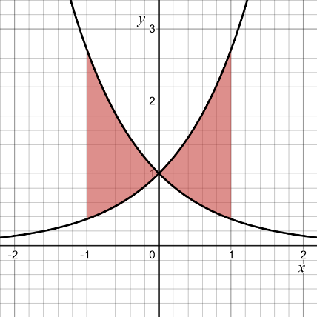

    - $\frac{2\left(e^{2}-1\right)}{e}$
    - $\frac{2(1-e^{2})}{e}$
    - $\frac{2 {\left(e - 1\right)}^{2}}{e}$
    - $\frac{2\left(e^{2}+1\right)}{e}$

- Optimization

- Find the maximum value of the product $x×y$ subject to $x+y=8$.
  - 20
  - 16
  - 8
  - None of the above
- What is the largest possible area for a rectangle with perimeter $100 ft$?
  - $100 ft^{2}$
  - $625 ft^{2}$
  - $2,500 ft^{2}$
  - $10,000 ft^{2}$

- A right triangle has hypotenuse of $5 in$. What is the largest possible area of this triangle?
  - $\frac{5\sqrt{2}}{2} in^{2}$
  - $\frac{25}{4} in^{2}$
  - $\frac{25}{2}in^{2}$
  - $25 in^{2}$
- A 10-foot ladder rests against a horizontal wall. The bottom of the starts to slip away from the wall at a speed of 1 foot per second. How fast is the top of the ladder falling when the bottom of the ladder is 6 feet away from the wall?
  - $0.25 ft/sec$
  - $0.50 ft/sec$
  - $0.75 ft/sec$
  - $1.00 ft/sec$
- For a certain triangle, the height is always three times the length of the base. If the height is decreasing at a rate of 2 in/sec, at what speed is the base decreasing?
  - $\frac{1}{3}in/sec$
  - $\frac{2}{3}in/sec$
  - $\frac{3}{2}in/sec$
  - $2 in/sec$
- For a certain triangle, the height is always three times the length of the base. The height of the triangle is decreasing at a rate of 2 in/sec. How quickly is the area decreasing when the height of the triangle is 6 inches?
  - $2 in^{2}/sec$
  - $3 in^{2}/sec$
  - $6 in^{2}/sec$
  - $12 in^{2}/sec$

