On the Faculty and Advising tab in My Services choose the Faculty Grade Entry.
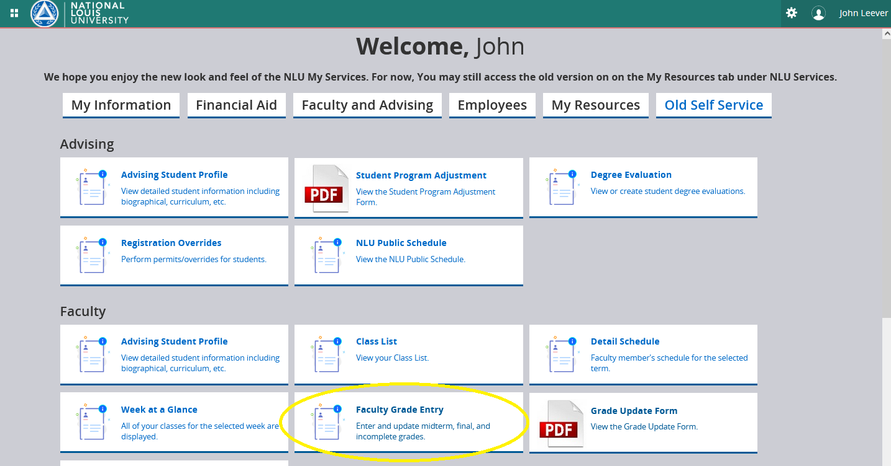
Enter the grade of “I” in the final grade field for the student.
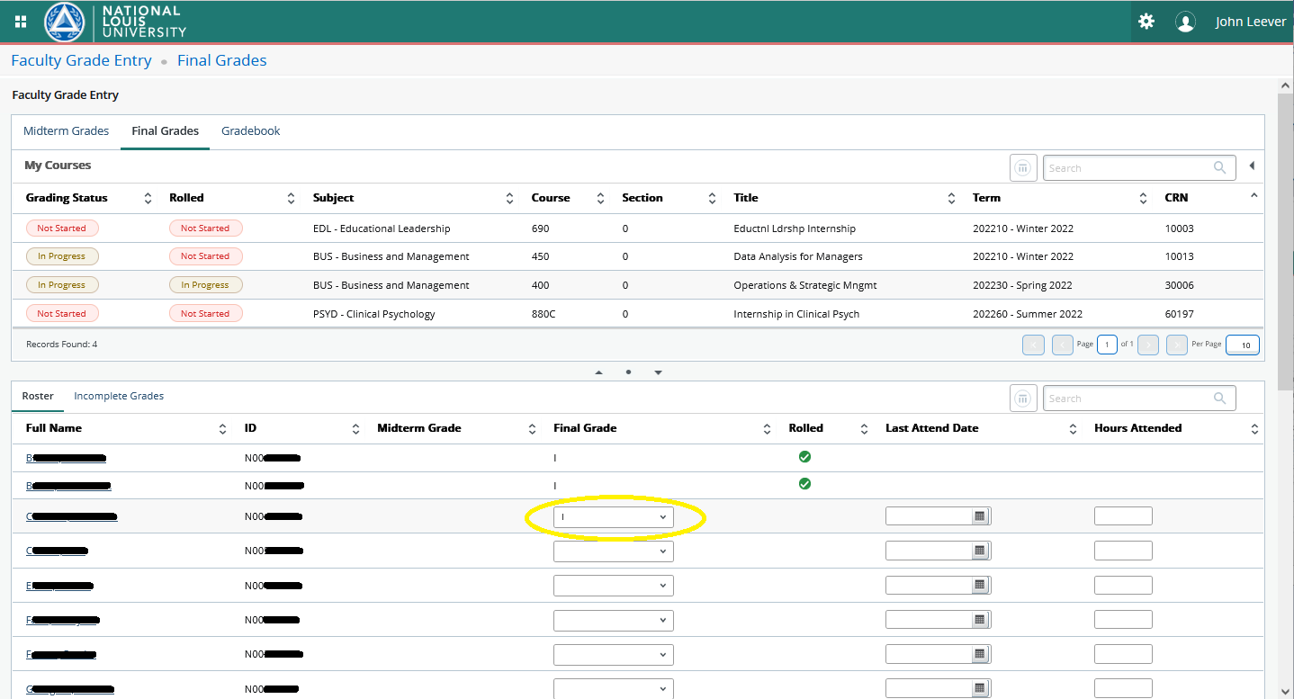

After choosing the grade of “I” the page will automatically open the “Incomplete Grades” tab. On the Incomplete Grades tab you will see all students who have a grade of “I”. You now can choose the “Incomplete Final Grade” and the “Extension Date” for all students that do not have a green check in the “Rolled” column.
- Incomplete Grades
- Grade: The grade of “I” the student is receiving.
- Incomplete Final Grade: The “Incomplete Final Grade” is the grade the student will receive if the grade is not updated by the “Extension Date”.
- Extension Date: Date the grade needs to be changed by.
