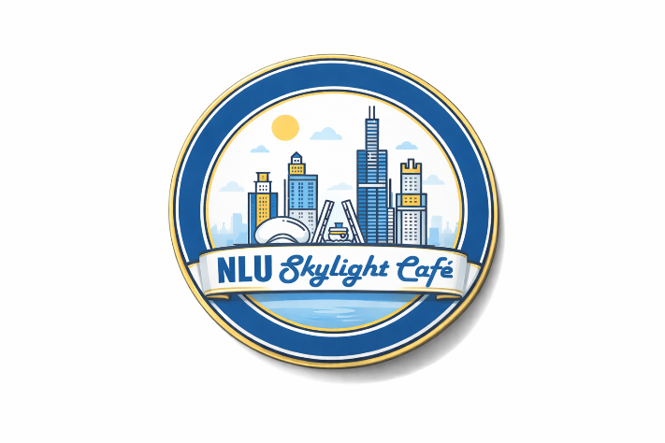

Due to large events scheduled for the 12th floor event space the Skylight Café will be closed on the following days.
We apologize for any inconvenience and we hope to see you on our open days in the Spring Term: Monday – Friday 11:00AM – 1:00PM

April 29th , April 30th, May 1st
May 13th, May 14th, 15th
June 23rd, 24th, 25th

Thank you
Skylight Café

